- Port Overview
- Port Information
- Key Routes
- Description & contacts of key Companies
- Discharge Rates & Terminal Handling Charges
- Port Handling Equipment
- Port Security

SOUTH SUDAN Malakal River Port

Waterways Assessment – Malakal Upper Nile State

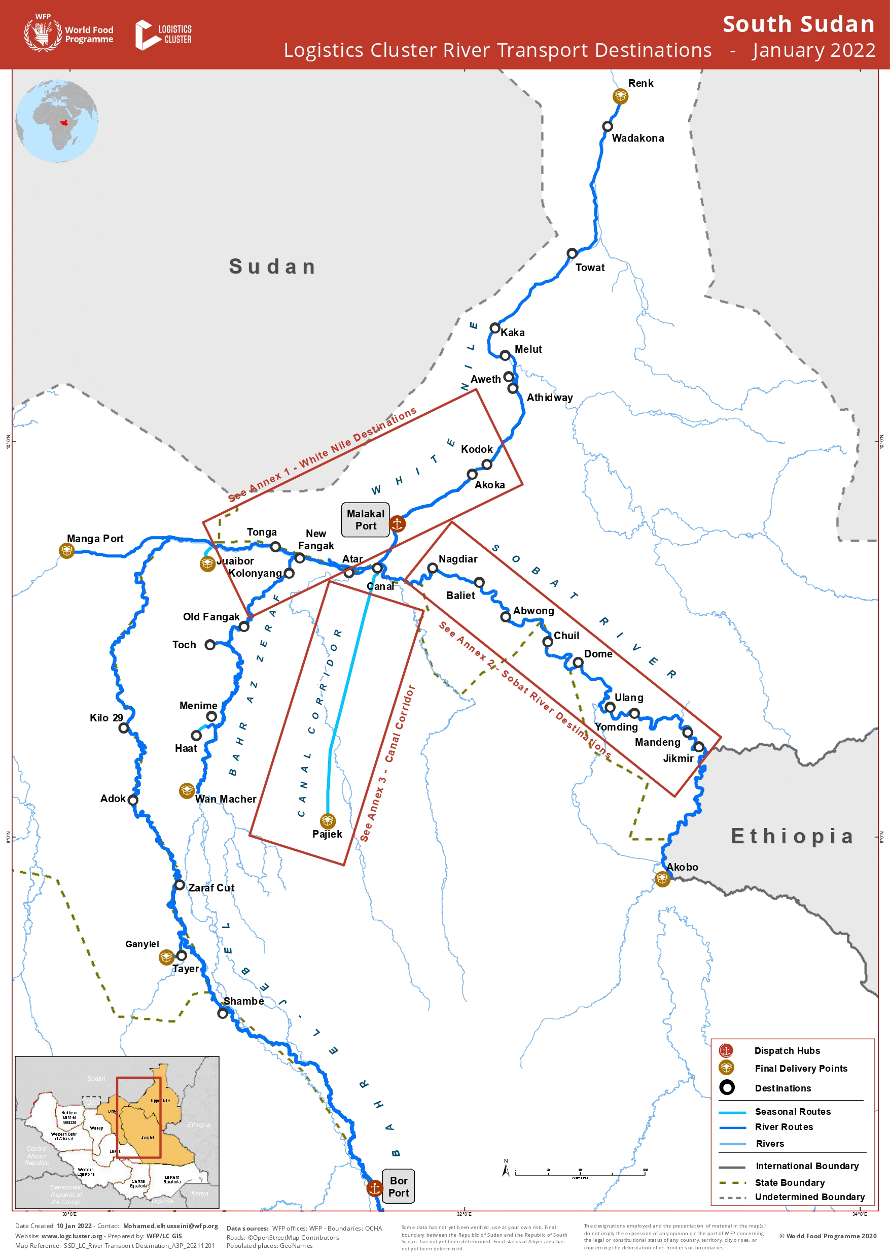

The White Nile flows through South Sudan, and the country has access to approximately 1,573 KMs of navigational waterways starching from Juba in the South to Kosti in the North Sudan via Malakal and from Bentiu in the West through Sobat River to Akobo on the Ethiopian border to the East. The Nile is accessible throughout the year, although the water levels fluctuate during the rainy and dry seasons in some areas, reducing the cargo-carrying capacity of barges/boats with operators loading vessels according to seasonal draft. The river is the only reliable transport link between the country's southern, central, and northern areas. River tributaries, such as Bahr Az Zeraf and Canal Corridor, are also navigable during the rainy season.

Standard barges take around 400 MT during the rainy season, but sometimes, the river is navigable with 300 MT in the dry season. Some barge and powerboat operators provide passengers’ transport services along the river with significant ports of Malakal, Wau Shilluk, Kodok, Melut, Kaka, Wadakona, Renk, and Geger to the north which are easily accessible riverbanks. To the east along Sobat River, several riverbanks serve as docking points and to the south. Most river ports are accessible riverbanks from which porters can load and offload cargo. Loading and offloading facilities, including handling equipment, remain a challenge.
Port Overview
Malakal Riverport is a government-managed main port located between Latitude 9.540595 and Longitude 31.644587, and it has a concrete pier of approximately 300 M in length. Loading and unloading of barges/boats is being managed by porters, which are organised in a union, and rates are negotiated. Humanitarian organisations provide mobile cranes only for their cargo. Malakal port is vital due to its geographical location, where humanitarian and other commercial cargo can be transhipped onto smaller vessels for onward delivery along the White Nile tributaries through the east, west, and north of the main river. The port is operational five days a week, with cargo boats arriving through the Sobat River – which stretches between Malakal and Nassir, the Bahr Az Zeraf River between Malakal and Wan-Machar, and the Canal corridor between Malakal and Pajiek, which is seasonal. Juba-Bor from the South and northern locations such as Wau Shilluk, Kodok, Melut, Kaka, Wadakona, and Renk. Passenger transport is mainly by powerboats and spaces allocated in barges by operators. Security is a major concern with the lack of police rescue boats, fire safety, fencing, and security lights, though there is a presence of security personnel to provide day/night security. Storage facilities at the port remain a challenge, with old ones needing improvement and no port handling equipment.

Port Information

Port Location and Contact
Country | South Sudan
Province or District | Malakal, Upper Nile State
Nearest Town or City  with Distance from Port | Malakal  Km: 0
Port's Complete Name | Malakal River Port
Latitude | 9.540595
Longitude | 31.644587
Managing Company or Port Authority | Government
Management Contact Person | Atem Chol Kur, +211915071686
Nearest Airport and Airlines with Frequent International Arrivals/Departures | Malakal Airport, Road (State & Interstate)

Key Routes
Key Route Information
Domestic / International
 | From: Malakal  To: Bor | From: Malakal  To: Renk | From: Malakal  To: Akobo
Total Distance (km) | 774 | 326 | 505
Width (m) | N/A | N/A | N/A
River Flow  (m³ / second) | Average flow is approximately 924 M³/s with an average peak of approximately 1218 M³/s and minimum average flow of 609 M³/s. | Average flow is approximately 924 M³/s with an average peak of approximately 1218 M³/s and minimum average flow of 609 M³/s. | Sobat river one of the biggest tributaries of the White Nile with an average flow of 412 M3/s and an average peak & minimum flow of 680 M³/s and 99 M³/s.
Seasonal Effects | Peak river flow of upper White Nile Basin above Malakal occurs between July & December | Peak river flow of upper White Nile Basin above Malakal occurs between July & December | Water levels reduces between March and June.
Maximum Weight and  Size of Vessels | Standard 400 MT for barges, certain areas 300 MT depending on water levels.  Barge and boat services | Standard 400 MT for barges, certain areas 300 MT depending on water levels.  Barge/Boat services | Boat services, 50 – 200 MT
Regular Traffic  Passenger / Cargo | Passengers/cargo | Passengers/cargo | Passengers/cargo
Companies Operating  Along the Route | B&S Group, Keer Marine for river, Jodak, Internet International, Nile Barges, Gieth, Tonga, MCBU, Northgate, Transway, Gamo Engineering, Inter Links | B&S group of Co, Keer Marine, Internet Int, Nile Barges, Gieth, Tonga, MCBU, Northgate, Transway, Gamo Engineering, Inter- Link Inc, Jodak, Mango tree | Internet International, Gieth, Tonga, MCBU, Northgate, Transway, Gamo Engineering, Inter Link Inc, Sharow Trading, Abilities Company Ltd, Leudier General Trading.
Security Concerns | Yes, various security checkpoints present along, and operators use national security personnel/convoy leaders on barges/boats occasionally to help them navigate. | Yes, various security checkpoints present along, and operators use national security personnel/convoy leaders on barges/boats occasionally to help them navigate. | Yes, various security checkpoints present along, and operators use national security personnel/convoy leaders on barges/boats occasionally to help them navigate.
Main Ports | Bor, Shambe, Adok, Malakal | Malakal, Wau Shilluk, Kodok, Melut, Kaka, Wadakona, Renk, Geger | Nasser, Akobo

Description and Contacts of Key Companies
The main barge and boat companies operating on South Sudan waterways are B&S Group, Internet International, Jodak, Nile Barges, Keer Marine, Inter-Link Inc, Leudier general trading, Transway Transporters & Logistics, Abilities Company Ltd, Malakal Commercial Boat Co Ltd. These companies performs both cargo and passengers’ transportation for commercial and humanitarian purposes.

Discharge Rates and Terminal Handling Charges
Discharge rates and terminal handling charges are not fixed but determined by forces of demand and supply in the market. Sometimes it is negotiable between the operators (unions) and the port authorities.

Berthing Specifications
Type of Berth | Quantity | Length  (m) | Maximum  Draft (m) | Comments
Conventional Berth | N/A | N/A | N/A | Not available
Container Berth | N/A | N/A | N/A | Not available
Silo Berth | N/A | N/A | N/A | Not available
Berthing Tugs | N/A | N/A | N/A | Not available
Water Barges |  |  |  | Available
No berths available.
General Cargo Handling Berths
Cargo Type | Berth Identification
Imports - Bagged Cargo | N/A
Exports - Bagged Cargo | N/A
Imports and Exports - RoRo | N/A
Other Imports | N/A

Port Handling Equipment
Cargo handling at the port is mostly done by porters who are organized in a union for both loading and offloading. Mobile cranes belonging to humanitarian organizations are available only for humanitarian cargo.

Equipment | Available | Total Quantity and Capacity Available | Comments on Current Condition and Actual Usage
Dockside Crane | No
Container Gantries | No
Mobile Cranes | Yes | One, 3.5 MT | Owned by UN agencies
Reachstacker | No
RoRo Tugmaster (with Trailer) | No
Grain Elevator with Bagging Machines | No
Transtainer | No
Forklifts | No

Container Facilities
Not available
Facilities | 20 ft | 40 ft
Container Facilities Available | N/A | N/A
Container Freight Station (CFS) | N/A | N/A
Refrigerated Container Stations | N/A | N/A
Other Capacity Details | N/A | N/A
Daily Take Off Capacity  (Containers per Day) | N/A | N/A
Number of Reefer Stations  (Connection Points) | N/A | N/A
Emergency Take-off Capacity | N/A | N/A
Off take Capacity of Gang Shift  (Containers per Shift) | N/A | N/A

Port Security
There is presence of security personnel at the port during day and night. Lack of police boats for rescue, floatation devices, security lights, fire safety equipment, and damaged fence remained a main challenge at the port. There were plans for fence, storage facilities, and office improvement if port authority secured budget from national government.

Security
ISPS Compliant | Yes
Current ISPS Level  (Level 1 = Normal, Level 2 = Heightened, Level 3 = Exceptional) | Level 3
Police Boats | No
Fire Engines | No

