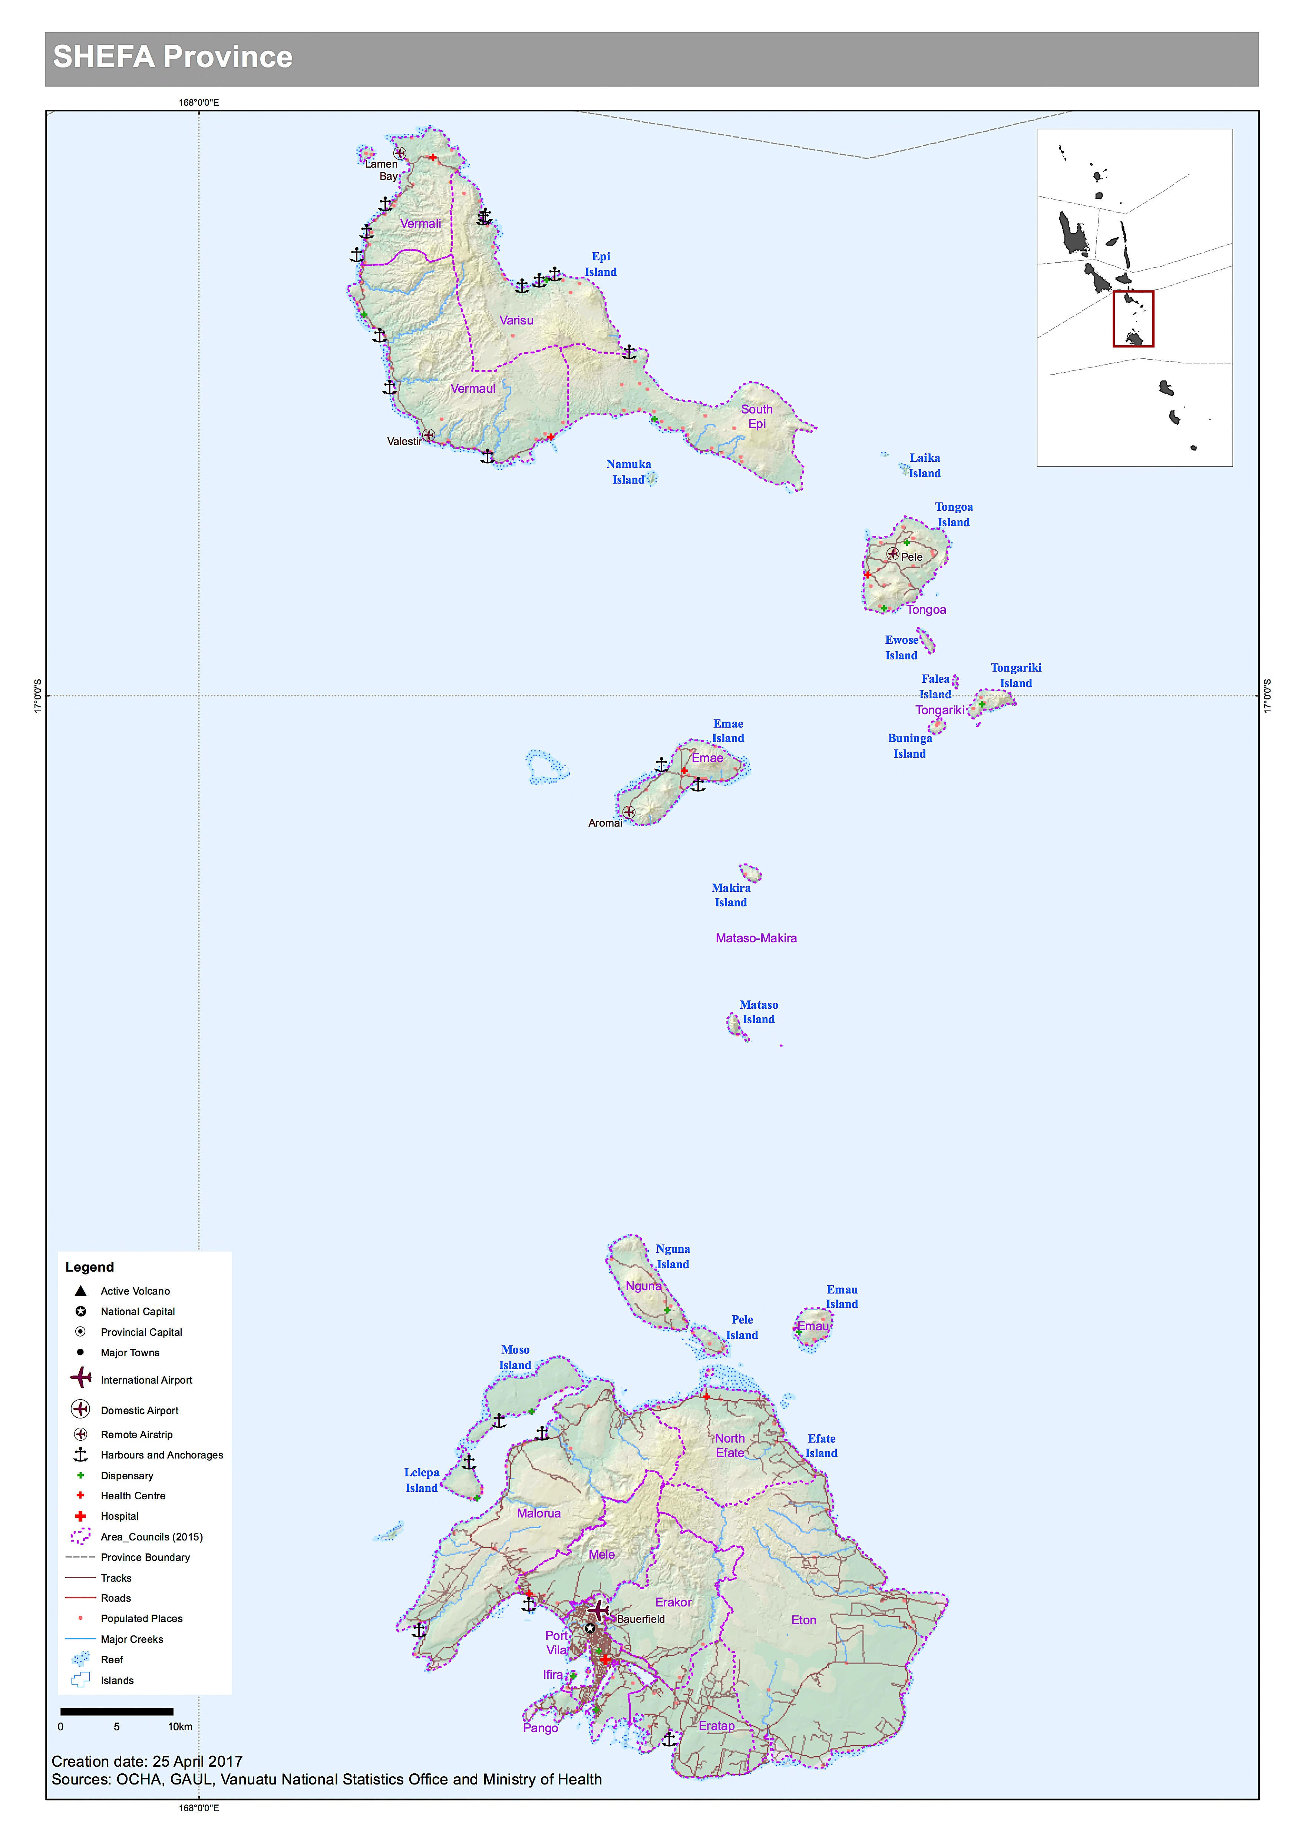Shefa Disaster and Logistics context.
Port Vila in Efate is the primary logistics hub for Vanuatu and the location for National Government of Vanuatu Ministries. It has the largest population in Vanuatu.

The following is the draft 2016 mini census data for Shefa, awaiting final validation:

Province |  | Area Council | Sex
 |  |  | Male |  | Female | Not stated |  | Total population | HH | hh size
Shefa | vermali |  | 983 | 1032 |  |  | 0 | 2015 | 374 | 5.4
Shefa | vermaul |  | 687 | 696 |  |  | 0 | 1383 | 284 | 4.9
Shefa | varisu |  | 757 | 745 |  |  | 24 | 1526 | 351 | 4.3
Shefa | south epi |  | 735 | 672 |  |  | 0 | 1407 | 233 | 6.0
Shefa | north tongoa |  | 725 | 735 |  |  | 42 | 1502 | 351 | 4.3
Shefa | tongariki |  | 499 | 464 |  |  | 1 | 964 | 214 | 4.5
Shefa | makimae |  | 546 | 510 |  |  | 0 | 1056 | 224 | 4.7
Shefa | nguna |  | 820 | 810 |  |  | 0 | 1630 | 382 | 4.3
Shefa | emau |  | 344 | 341 |  |  | 0 | 685 | 152 | 4.5
Shefa | malorua |  | 1348 | 1224 |  |  | 9 | 2581 | 532 | 4.9
Shefa | north efate |  | 1414 | 1423 |  |  | 0 | 2837 | 571 | 5.0
Shefa | mele |  | 2450 | 2489 |  |  | 0 | 4939 | 850 | 5.8
Shefa | port vila |  | 19929 | 19228 |  |  | 71 | 39228 | 7,643 | 5.1
Shefa | ifira |  | 503 | 527 |  |  | 2 | 1032 | 169 | 6.1
Shefa | pango |  | 1136 | 1171 |  |  | 0 | 2307 | 463 | 5.0
Shefa | erakor |  | 4105 | 4028 |  |  | 1 | 8134 | 1,546 | 5.3
Shefa | eratap |  | 3855 | 3562 |  |  | 7 | 7424 | 1,466 | 5.1
Shefa | eton |  | 1111 | 1002 |  |  | 4 | 2117 | 405 | 5.2

There is an International airport located 8 km from the international wharf and 6km from the National Disaster Management Office, where disaster response operations are coordinated from. All of the major Humanitarian response partners still have headquarters based in Port Vila, although many are winding back resources considerably after funding for TC Pam (2015) recovery ends this year.

As the National Disaster Management Office resides in Efate, a Provincial Disaster Office has not been built here, however there are considerations of establishing the Shefa Provincial HQ on Epi, to focus on Provincial government matters. If so, a Provincial Disaster Officer will be appointed and a PDO office constructed.
Provincial Disaster Officer | Secretary General | Planning Officer
Not appointed yet | Michel Kalworai sg@shefa.vu  546-3952 | Ian Kalsuak iankalsuak@shefa.vu  535-5974

Port Vila is more developed and has western infrastructure and housing. Electricity, mobile coverage and internet are good in the Port Vila region. This is not indicative of the rest of the island however, particularly to the north. Many dwellings have no electricity, running water and poor communications and is representative of a large area of Efate, who relies on local crops, and access to water. There are many communities from other islands who move to Efate and own no land. These communities can be quite vulnerable in times of disaster.

The more developed style of housing in the Port Vila area, can mean buildings are more affected by cyclones and earthquakes than traditional built houses. Particularly if not built to cyclone standards.
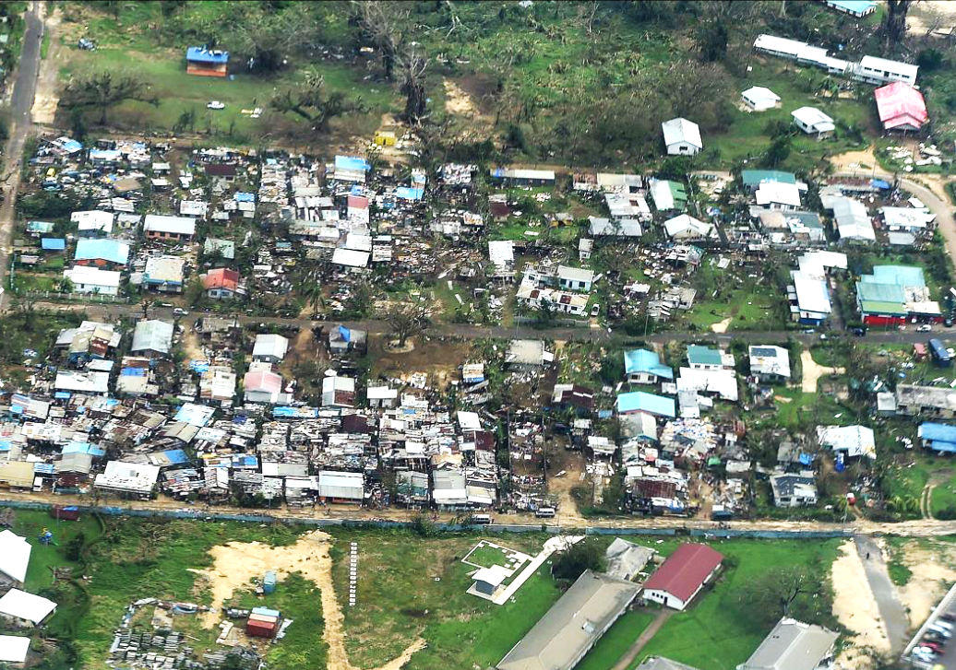
Photo: Aerial shot of Port Vila area post TC Pam with destruction of houses not built to cyclone standard.

There is a paved ring road around the island. Following heavy rain and cyclones, the roads can be cut in several places, isolating villages. This occurred in TC Pam and the recent Category 2 TC Cook in 2017. Many areas are prone to flooding, with over 1000 people requiring voluntary evacuation during TC Cook. The Mainstreaming Disaster Risk Reduction project modelling predicted the flood zones in the Mele catchment area of Mele, Prima, Blacksands and Tagabe. Eratap, Pango and Teoma also had minor flooding requiring relocation of people, and should be included in future flood modelling.

There are several inhabited small islands within the Port Vila area that are only a few minutes boat ride away: Iririki, Ifira, Erakor, Hideaway. Tsunami poses the biggest treat to these islands. To the north are the inhabited islands of Moso and Lelepa. These are a 15 – 20 minute boat ride across Havannah bay. Cyclones and drought have impacted the area but close proximity to Efate means these communities can cope better than other others in the Shepherds region.
The Shepherd Islands are a series of islands starting at the north of Efate up to Malampa province. Most of the islands have limited infrastructure. The smaller ones don’t have roads and have limited solar capacity and only one or two accessible entries through the reef to the villages. There are small airstrips on Emae, Tongoa and Epi. Travel to the other islands is by boat only.

Cyclones floods, earthquakes, tsunamis and drought occur and the combination of TC Pam (2015), El Nino drought (2016) and TC Cook (2017) have resulted in failed back to back crops, and water shortages for the past few years on some islands.

Matasso is quite vulnerable due to its arid low lying area between two high hills. The people were relocated after TC Pam. A lack of livelihood means most of the community aged between late teens to late 50’s leave to work in Port Vila, providing for remaining family. This further impacts as shelter and gardens cannot be restored well, evident during the El Nino assessment late 2016. Families were still living in tarpaulin emergency patched housing from TC Pam, and further shelter, and food assistance was coordinated by NDMO. The question of future sustainability on the island has been raised.
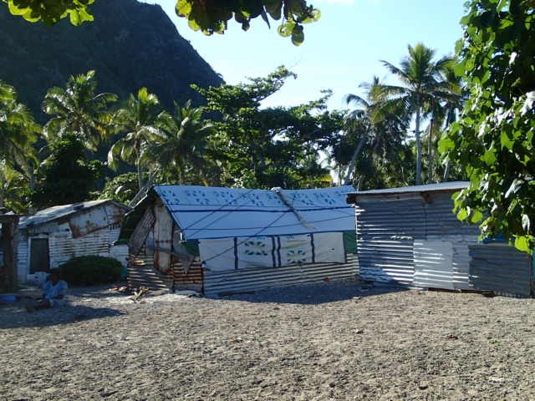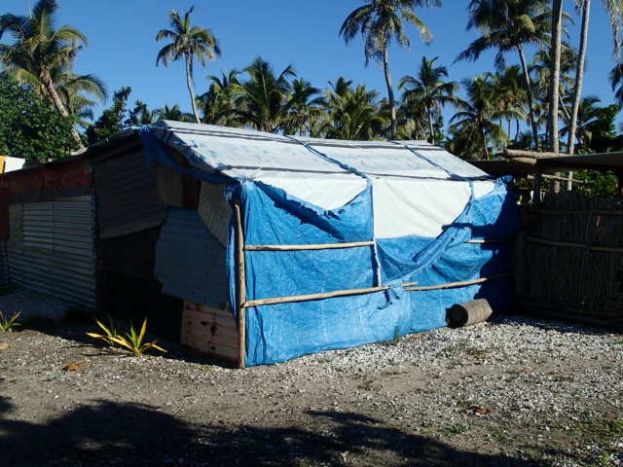
Photo 1 and 2. The low arid ground between the mountains where Matasso village is located, with tarpaulin patched housing 15 months after TC Pam.

Efate

Air Transport

Bauerfield airport is the only airport in Efate and services both international and domestic flights.

Airport Name | Coordinates | Capacity | Runway Type
Bauerfield International | Lat S 17 41 57  Long E 168 19 11 | Daily flights  737 to 767 aircraft, C17 under load restriction.  Upgrade end of 2018 will enable 787, and airbus 350 capacity. | Asphalt  2,600 m x 45 m

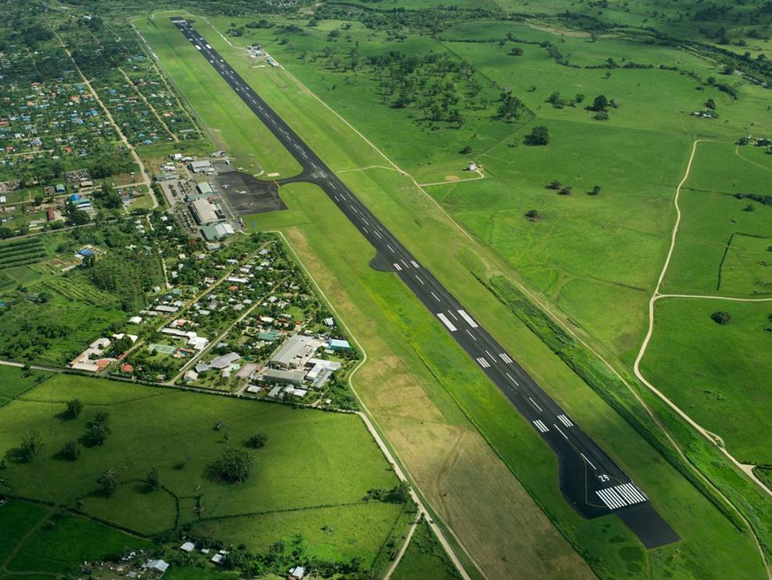

Civil Aviation is responsible for the regulatory arrangements of the airport, including the registering of Foreign aircraft. This is a requirement for any internatioanl aircraft who will remain in Vanuatu over a month.
Civil Aviation Department, Ministry of Infrastructure and Public Works Utilities
Tel.: +678 22819
Fax: +678 23783
Email: civav@vanuatu.com.vu

Airport Vanuatu Limited manages the operations of the airport. This includes approval of non scheduled flights for emergency assistance. The AVL has all the information and links for applications approvals, terminal services and logistics agencies.

Airports Vanuatu Limited| Bauerfield International Airport
PO Box 131, Port Vila, Vanuatu, SW Pacific
EXT: 125 | Tel (+678) 25111 | Mobile: (+678) 5547402
gmops@airports.vu | www.airports.vu

International flights

There are 7 airlines operating scheduled flights and connecting Vanuatu to 5 countries within the South West Pacific region.

• Air Vanuatu

• Virgin Australia

• Air New Zealand

• Solomon Airlines

• Fiji Airways

• Air New Guinea

• Air Calin (New Caledonia)

Domestic and charter airlines.

Operator | Model | Pax | Payload (Kg) | Gross  Max (kg) | Rates Vt | Contact
Air Vanuatu | Fly to all islands  Domestic freight  PV to Santo  PV to Tanna  PV to Norsup Tanna to PV  TAnna to Santo |  |  |  | 131/kg  118/kg  107/kg  131/kg | Passenger  139  20200  Cargo  PORT VILA  22308  domestic.cargo@airvanuatu.com  SANTO  37565  cargo.pekoa@airvanuatu.com
Air Taxi  charter | BN2A Islander | 9 | 750 |  | 95,000/ hr | Meliana  5544206  info@airtaxivanuatu.com
 | Cessna 207 | 6 | 600
 | Cessna 206 | 5 | 500
 | Cessna 206 | 5 | 500
Unity Airlines  charter | Piper Chieftan | 9 | 850 |  |  | Tony  24475/  7744475  unity-airlines@vanuatu.com.vu
 | BN2A Islander | 8 | 650 |  | 80,000/ hr
 | BN2A Trilsander | 9 | 1300
Bel Air | BN2A Islander  Shefa, Sanma, Penama, Malampa, (Gaua – only in Torba; No service to Tafea) | 9 | 650 |  |  | Norma  29983  5551290  7741753  airways@belair.vu
Air Safari | GA8 Airvan | 8 | ? |  |  | Matthew  Nastasia  7745207  5545207  7745206  5545206  flights@airsafaris.vu
Vanuatu Helicopter | AS350BA Squirrel  Medical evac capability  Robinson R66  Robinson R44 Clipper ll | 4  4  3 | 600 (120 knots)  450 (120 knots)  400 (100 knots) | 2100  1225  1134 | 157,500/hr  135,000vt/hr | Andy  25022  77 44106  772 4354  sat phone  00 881 6 314 50545  00 881 6 224 33055  00 881 6 314 48861  info@vanuatuhelicopters.com  andy@vanuatuhelicopters.com  http://www.vanuatuhelicopters.com/vanuatu-robinson-R44-robinson-R66-__I.7373
Melanesian Air | BN2 Islander | 9 | 650  (5hrs fly time) |  |  | +678 7112388  Atu Finau
 | Aztec | 5
Medivac Private  (not available until July 2017)  Medivac Drs and nurses in Vila | State of the art medical equipped aircraft with direct vital sign equipment linked to Australian hospitals. | 2 pax  and medstaff |  |  |  | +678 7112388  Atu Finau

Sea transport

There are two international ports at Port Vila, Main wharf and Lapetasi Wharf. (previously International wharf and Star wharf). Lapetasi wharf will begin operations in October 2017.

Port and marine procedures | Stevedoring
Port Vila Port and Marine Department  Phone : +678 22339  Fax : +678 22475 | Ifira Wharf and Stevedoring  Russell Mitchell  (678) 25 478  Mob: (678) 5567722  Fax: (678) 25934  Email:gm@ifira.com.vu  Manu Laban  Ph 5552 109  Email: opsuper@ifra.com.vu

Main wharf

Main wharf is the current port for cargo ships, cruise ships and tankers. It has one berth only. Cruise ships get priority and all other ships must sit at anchorage wait until the passenger ship departs. This results in delays for cargo offload and transport.

Conventional Berth | 1 | 280m  Long | 10.5m deep along side | Main wharf shears off to around 20m

Main wharf will be the dedicated Cruise ship wharf in 2018, once Lapetasi wharf is fully operational. There are plans to turn the current breakbulk/LCL cargo wharehouse into a Cruise ship terminal and market place.

No fuel pumping infrastructure was built into the Lapetasi wharf so Main wharf will also receive tankers. They will give way to the Cruise ships util they depart.

Lapetasi wharf

Lapetasi will transition as the dedicated cargo wharf for both International and domestic ships, commensing October 2017.

Customs and Ifira Wharf Stevedoring will move offices onsite to the International area, Biosecuirty will remain at the Main wharf.
International berth
Main wharf
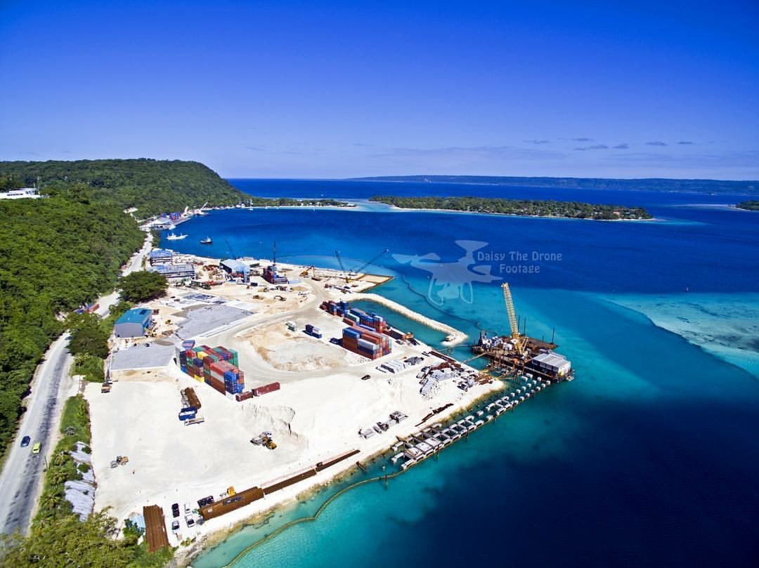
Photo: Lapetasi wharf, with Main wharf in the background
Domestic berth
International shipping

International Berth | 1 | 200m long | 13m deep along side | salent features give capacity for ships 250m LOA

There will 34 reefer sites and capacity to handle 30,000 TEU’s per annum with a 10 day dwell time. Take off capacity per day is approximately 300 containers.

IWS has two reef stackers, forklifts and two side loader trucks that carry 20 and 40 foot containers. Ships must come geared with their own cranes to offload cargo. There are no gantries or mobile cranes on the wharf.

Inter- island shipping.

Domestic Berth | 1 | 130m x 20m | 13m deep along side | salent features give capacity for ships 250m LOA

The following ships operate out of Port Vila.
Ship Name | Contacts | Capacity tonnage | Island route | Notes
MV Island Claws | 29222 |  | Paama
 | 7788510 |  | Ambrym
 | shippingandservices@belair.vu |  | Pentecost
 |  |  | Santo
LC Brisk/LC Tina | 7788712 |  | Paama | Weekly routine
 | Rebecca.jonas@silentworld.com.au |  | Ambrym | Vt 8000 per cubic
 |  |  | Pentecost | Vt 9000 per cubic
 |  |  | Ambae | Vt 9000 per cubic
 |  |  | Santo | Vt 9000 per cubic
LC Sarafenua | 24135 |  | Paama | Depending on cargo  Vt.8,000 per cubic  VT.90,000 in an hour (44 hours) charter
 | merinok@ifira.com.vu | 250 | Ambrym
 |  |  | Pentecost
 |  |  | Ambae
 |  |  | Santo
 |  |  | Malekula
Big Sista | 5683622 | Small | Epi | Weekly routine
 |  |  | Paama
 |  |  | Malekula
 |  |  | Malekula
 |  |  | Santo
Vanuatu Ferry | 26999 |  | Malekula | Weekly routine
 | 7762064 |  | Santo
 | 5907247 |  | Tanna | Once per month
 | contact@vanuatu-ferry.com
Vanuatu Cargo |  |  | Santo | Weekly routine
 |  |  | Malekula
 |  |  | Pentecost
 |  |  | Ambae
MV Lawilin (prev Moaika) | 7776079; 5456226 |  | Tanna | Weekly routine
 | lawilinshippingservices@gmail.com
MV Touaraken  1 | 29873 | Supercargo  600 | Tanna | Weekly routine
 | 5656689 |  | Erromango
 | mvtouaraken@gmail.com |  | Aneityum
 |  |  | Aniwa
 |  |  | Futuna
LC Touaraken 2 predominately PV- Tanna direct) | 7777926 |  | Tanna
MV Brooklyn/LC Freedom | 23745 / 7764964 / 5436689  Jinny 7118414 |  | Shepherd islands
 |  |  | Ambrym | Depending on cargo
 | searoadservices@gmail.com |  | Pentecost
 |  |  | Ambae
 |  |  | Santo
LC Urata | Alexi  5661111 | Super cargo | Shepherds group | Depending on cargo
Can be chartered | Uratashipping@gmail.com
 |  |  | Banks
MV Kawale | 36530 |  | & | Twice a year
 | mail@lcmstore.com |  | Torres Group
 | locm@vanuatu.com.vu
LC Tiwi traders  Can be chartered | 5722064 ; 5368267  tiwitrader2016@gmail.com | Super cargo | Tafea islands | Vt 8,000 per cubic
LC Valerie  Can be chartered | 22985/ Fax 23020 |  | Epi  Malekula  Santo
MV Lepati |  |  | Emae  Epi | Vt 400 per box
Epi Dream |  |  | Epi
LC Austrader | 5323849  dseule@lcasutrader.com.vu | 180T | All Tafea  Shepherds  All Malampa  All Penama
One People | 5631604 | 250T  170 pax | Tanna  Santo  Malekula | 8,500 vt/m3
LC Bejida | 25255  5952664  salinshippingservices@ | 52T | Tanna  Santo  Malekula,  Pentecost

Ports for Efate and surrounding islands.

Port Name | Location/Coordinates | Type
Efate
International Wharf  (SW) | 17.45.24.06S  168.17.54.07E | Wharf. Main port for Vanuatu.
Erakor jetty | 17.46.07 S  168.18.25E | Banana boat wharf for transport to Erakor island.
Iririki jetty | 17.44.30S  168.18.49E | Banana boat jetty for access to Iririki and Ifira islands.
Mele Bay | 17.41.32S  168.16.00E | Anchorage. Protected bay for large ships
Lelepa Landing | 17.36.32S  168.14.26E | Jetty for banana transport to Lelepa and Eratoka island.
Gideons landing | 17.34.40S  168.14.26E | Banana boat jetty for transport to SW side Moso Island.
Port Havannah  (NW) | 17.34.14S  168.15.10E | Anchorage. Protected area for yachts.
Moso Landing | 17.32.03S  168.17.27E | Banana boat jetty for transport to SE side of Moso island
Emua Landing | 17.32.11S  168.23.10E | Banana boat jetty for access to Pele, Nguna, Emao, and Shepherd island
Forari Wharf | 17.40.58S  168.32.59E | Wharf destroyed. Old manganese mine. Good anchorage for access to communities cut off in floods.

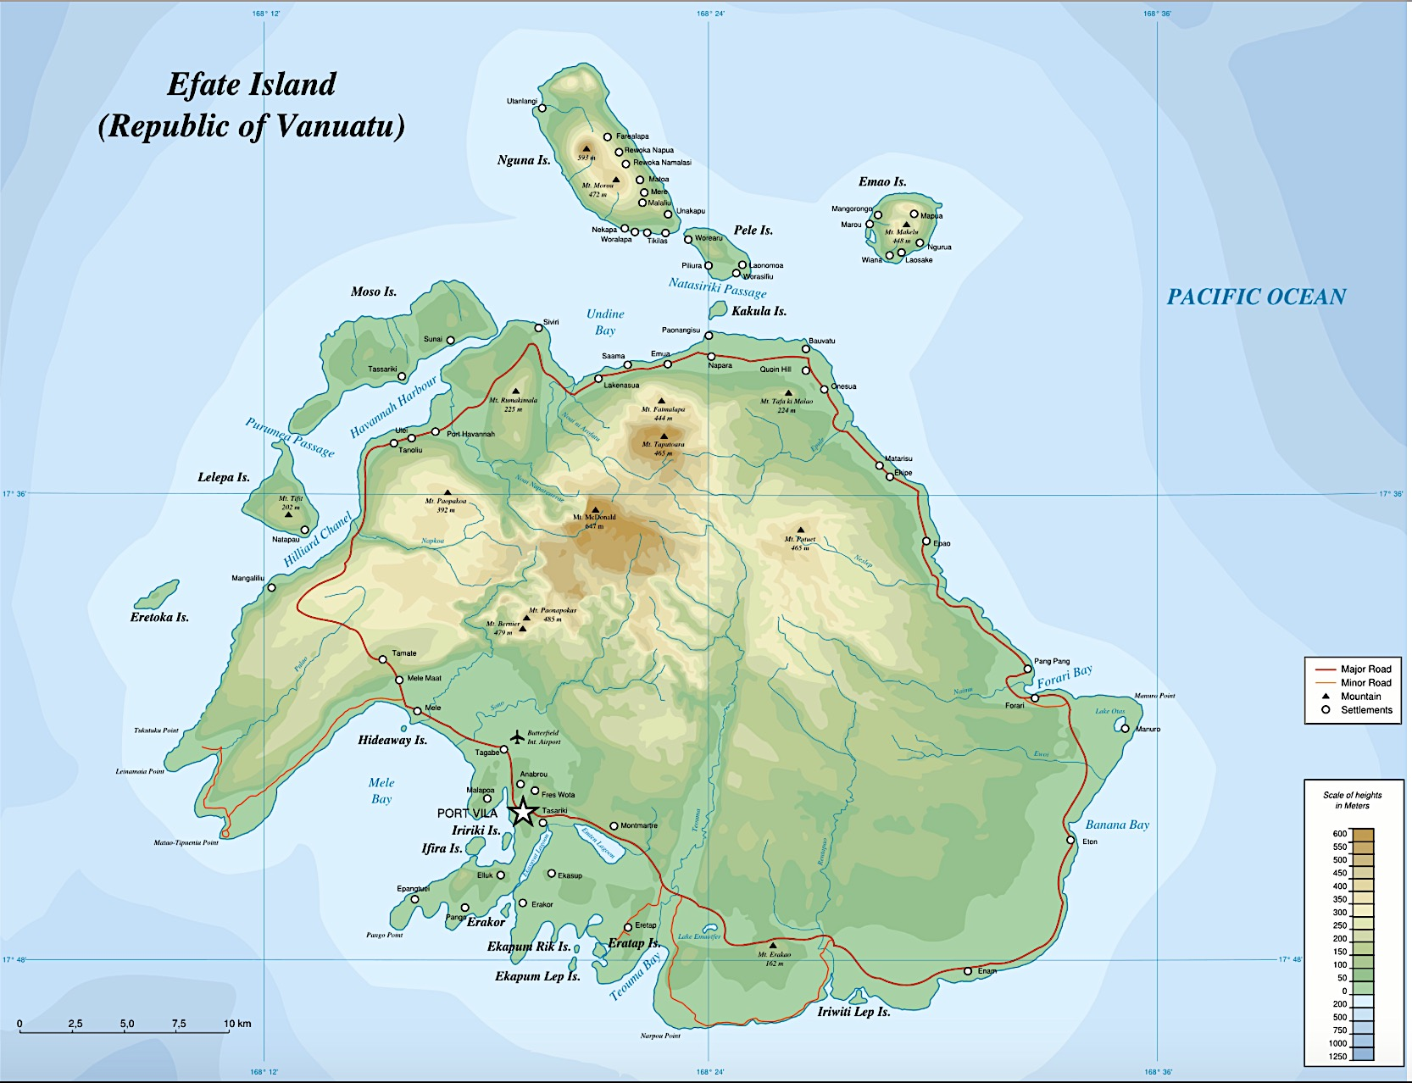
Road transport
A sealed ring road runs around the island of Efate. Heavy rains have washed away roads and bridges in several locations during cyclones and floods, making the roads temporarily impassible in a few places. This means small communities may be cut off by road.

One week after Category 2 TC Cook (that did not directly hit the island of Efate) the rivers were still across the roads in some locations, and public works had to fix the bridge at Ulei which was impassible.

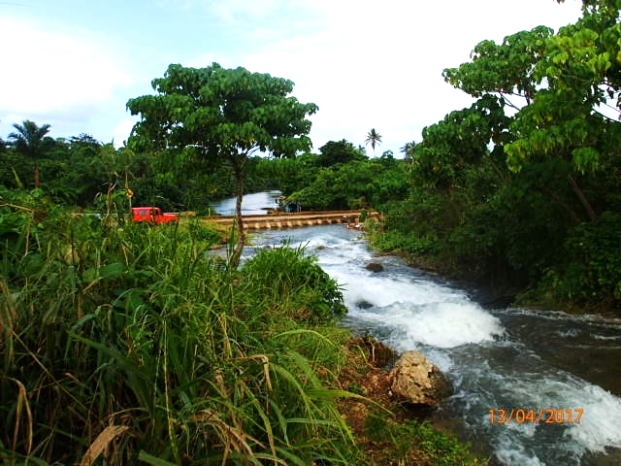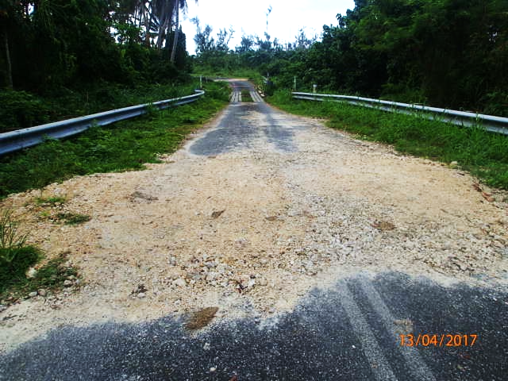
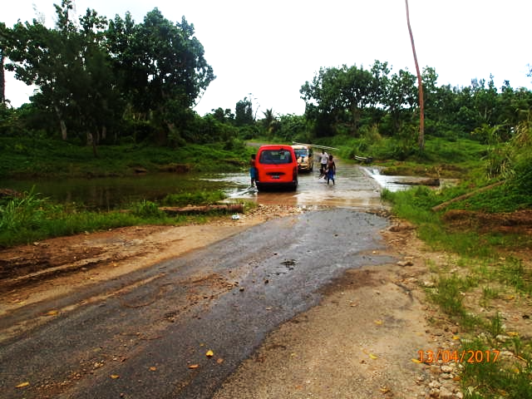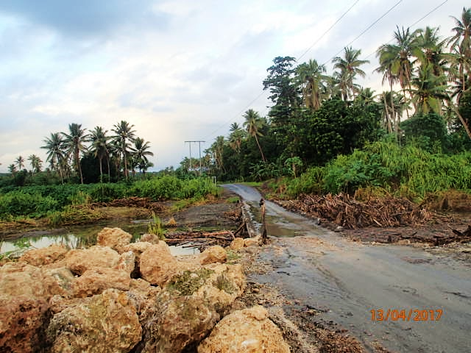

Photo: Efate ring road one week after TC Cook.

In the event of continued heavy roads or large cyclone, communities from Ulei to Eton are in threat of being cut off for several days. Forari Bay (E) Havannah Harbour (W) and Emua Landing (N) are options for shipping supplies to communities within this area.

Evacuation Centres
NDMO in partnership with IOM is currently reviewing the standards of evacuation centres in Vanuatu, and identifying those evacuation centres that meet the standards.

During TC Cook communities were flooded in the areas of Mele, Prima, Blacksands, Teouma, and Eratap. NDMO with the assistance of IOM and the VMF successfully evacuated approximately 1000 people to the following evacuation centres:

Eratap Council Hall | Pakarua Church, Agathis
Eratap Nasarian Church | AOG, Tebakor
Eratap School | Mommon Church N0 2
Muslim centre, Bladinier | Anglican Church, Tagabe
Enam, Pango | Epaoto Church, Freshwota 1
Wan Smol Bag, Tagabe | Epaoto School, Freshwota 1
Ohlen Fresh Win SDA

Emergency Storage
Emergency storage is difficult to find in Efate. NDMO has two MSU’s located at the office, two 40’foot containers and one 20’ foot container.

NGO’s currently have their own storage space for operations and prepositioned items.

WFP is working with NDMO to contruct a purpose built humanitarian warehouse for NGO’s to store prepositioned goods and for storage of surge relief items close to the wharf.

Shepherd Islands
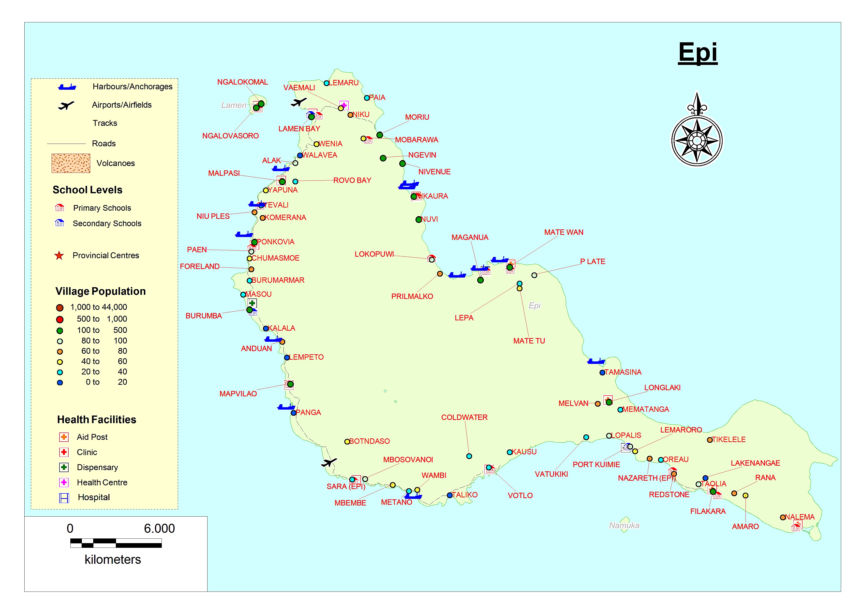
Only four of the Shepherd Islands have airstrips. Air Vanuatu and Belair service the islands.

Airport transport
Replace table and maps with logistics map when developed

Airport Name | Coordinates | Capacity | Runway Type
Laman Bay  (NW Epi) | Lat S 16 35 20  Long E168 09 10 | Y12, Twin otter, islander  Tue, Wed, Fri, Sat | 820m x 18m  Grass on soil/sand
Valesdir  (S Epi) | Lat S 16 48 04  Long E168 10 14 | Y12, Twin otter, islander  Tues, Wed, Fri, Sat | 1050m x 26m  Grass on coral/soil
Emae | Lat S 16 53 42  Long E168 20 20 | Islander  Mon, Wed, Thu, Fri | 785m x 30m  Grass on soil
Tongoa | Lat S 16 53 42  Long E168 32 40 | Islander  Mon, Tue ,Fri, Sat | 840m x 23m  Grass on Soil

Helicopter landing spots.

All islands have a football field where a helicopter could land.

Sea transport

The following ships routinely service the Shepherd islands, however any ship travelling North may be able to drop supplies on the way to their intended destination.

LC Freedom
MV Brooklyn
LC Urata
LC Austrader
LC Valery
MV Lepati
Lara Star

There

Port Name | Location/Coordinates | Type
Matasso
Matasso port | Lat: 17.15.35S  Long: 168.35.07E | Landing craft on the reef in low seas.
Makira
Makira port | Lat: 17.07.51S  Long: 168.25.43E | Landing craft on the beach.
Emae
Sulua  (NW) | Lat: 17.03.22S  Long: 168.22.10E | Landing craft. Main port used by cargo ships.
Worarana  (E) | Lat: 17.03.53S  Long: 168.23.44E | Landing craft. Protected bay for large ships. Best port to access Novo Borading school.
Marae | Lat: 17.02.18S  Long: 168.22.145E | Landing craft. Main port for large trucks and machinery.
Buninga
Buninga port | Lat: 17.01.08S  Long: 168.35.07E | Anchorage
Tongariki
Tongariki port | Lat: 17.00.37S  Long: 168.37.33E | Anchorage
Tongoa
Panita | Lat: 16.55.02S  Long: 168.53.31E | Landing craft
Ravenga | Lat: 17.53.02S  Long: 168.53.31E | Landing craft
Epi – Philip Meto to advise from TC Cook review
Laman Bay  (NW) | Lat. 16*35’23.06S  Long. 168*09’50.25E | Wharf- less than 20T ship. Main port for Epi.
Alak |  | Landing craft
Malpasi |  | Landing craft
Komerana |  | Anchorage
Rovoliu |  | Anchorage
Nelsons Bay  (SW) |  | Landing craft
Valesdir Port |  | Small wharf for banana boat.
Metano |  | Anchorage
Votlo (S) |  | Landing craft
Port Kuimie (S) |  | Landing craft
Tamasina (SE) |  | Landing craft
Maganua |  | Landing craft
Pril

Road transport
Fuel is 250vt -300vt/L.

Roads are located on the islands of Epi, Emae, Tongariki and Tongoa.

Epi
Road from Lamen Bay to Lokopuwi around North to east coast. Road is gravel and is 4WD accessible only.

Road from Lamen Bay around west coast to Votlo, South of island is gravel. The Vanuatu Climate Adpation Program (VCAP) has a road project and cement slabs have been laid at river crossings and on steep hills making the road more useable during heavy rains.

There are approximately fourteen 4WD trucks on the island. Three are based at Laman Bay. One at Nuvi (NE), one at Nikaura, Three at south Epi at Vilakara . Two trucks at Burumba, Three at Sara, (SW) One at Nelsons Bay.

Transport costs from Lamen Bay to Lokopui 8500vt. From Nui Ples to Vilikara south Epi 25,000vt. Votlo to Lamen Bay 16,000vt

Emae
Bush ring road from airport to all communities and the bigger anchorages.

There are six trucks on the island. One at the Health centre, one at Novo School. One at the airport privately owned. One at Marae. One at Makatea. One at Sangava.

Transport cost 2000vt for single trip. All day 15,000vt

Tongoa
Bush ring road from Airport to all big communities.

Major Evacuation centres

Epi
Epi High School
Rovo Bay Shefa district office.
Burumba High school.
Port Quime Junior Secondary School (JSS)

Emae
Novo school
Marae community hall and evacuation centre.

Tongoa
Nambangasale JSS
New governant church

Tongariki
Primary school

Buninga
Primary school

Makira
Community hall
Primary School

Matasso
Evacuation centre.

