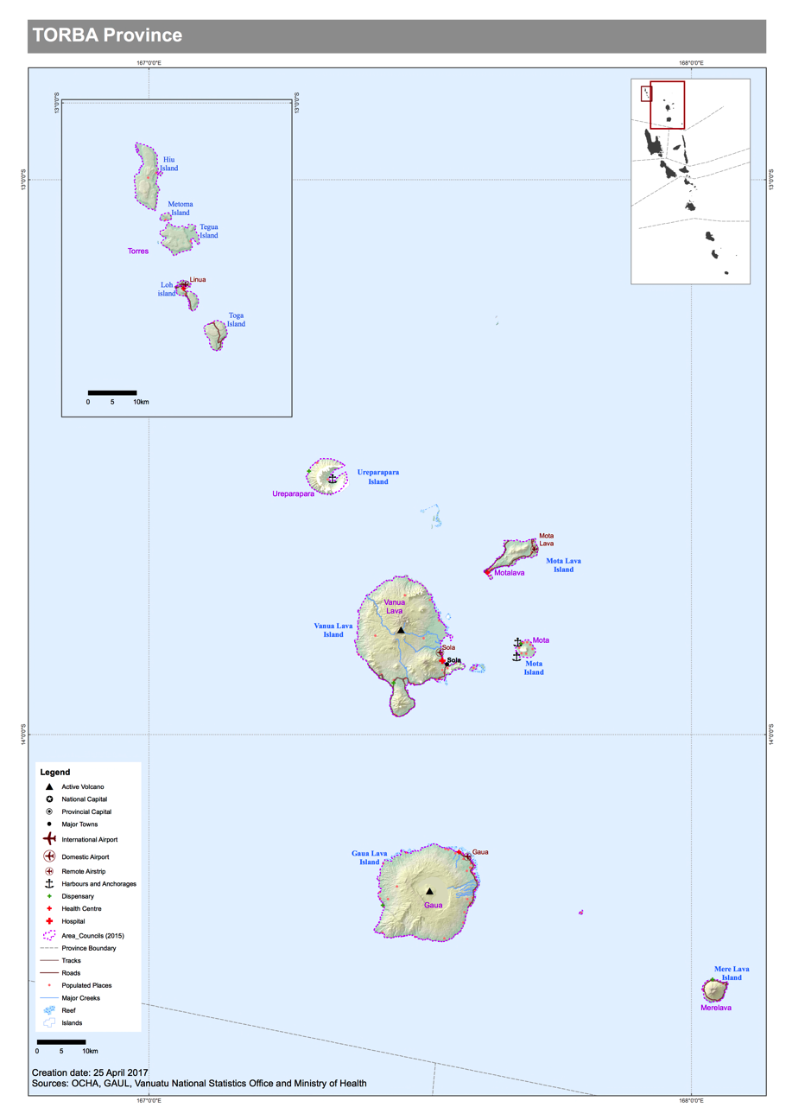

Disaster and logistics context.
Torba is the most Northern Province in Vanuatu. It contains many small islands and is split into two regions. The Torres region to the north and the Banks region to the south. Vanua Lava, Mota Lava and Guau in the Banks region are the largest populated islands in Torba.

The following is the draft mini census data from 2016:

Province | Area Council | Sex
 |  | Male | Female | Not stated | Total population | HH | hh size
Torba | torres | 504 | 517 | 1 | 1022 | 165 | 6.2
Torba | ureparapara | 239 | 217 | 0 | 456 | 90 | 5.1
Torba | motalava | 810 | 868 | 0 | 1678 | 344 | 4.9
Torba | vanua lava | 1625 | 1518 | 2 | 3145 | 610 | 5.2
Torba | mota | 362 | 320 | 0 | 682 | 148 | 4.6
Torba | gaua | 1318 | 1251 | 15 | 2584 | 492 | 5.3
Torba | merelava | 279 | 309 | 0 | 588 | 130 | 4.5

Following TC Donna in May 2017 which significantly damaged the Torres islands, an updated assessment of household numbers were taken as follows:

Island | Household numbers
Hui | 50
Metoma | 2
Tegua | 19
Toga | 64
Loh | 41
TOTAL | 176

Torba is affected by cyclones, drought, flooding, and earthquakes. There are two active volcanos in the area. One small one on Vanua Lava that last erupted in the 1940’s. The tremors and ash fall from the eruption affected the island as well as Mota and Mota Lava. The second volcano on Guau last erupted in 2009 and areas of the west side of the island were displaced to be the East side of the island for some time.

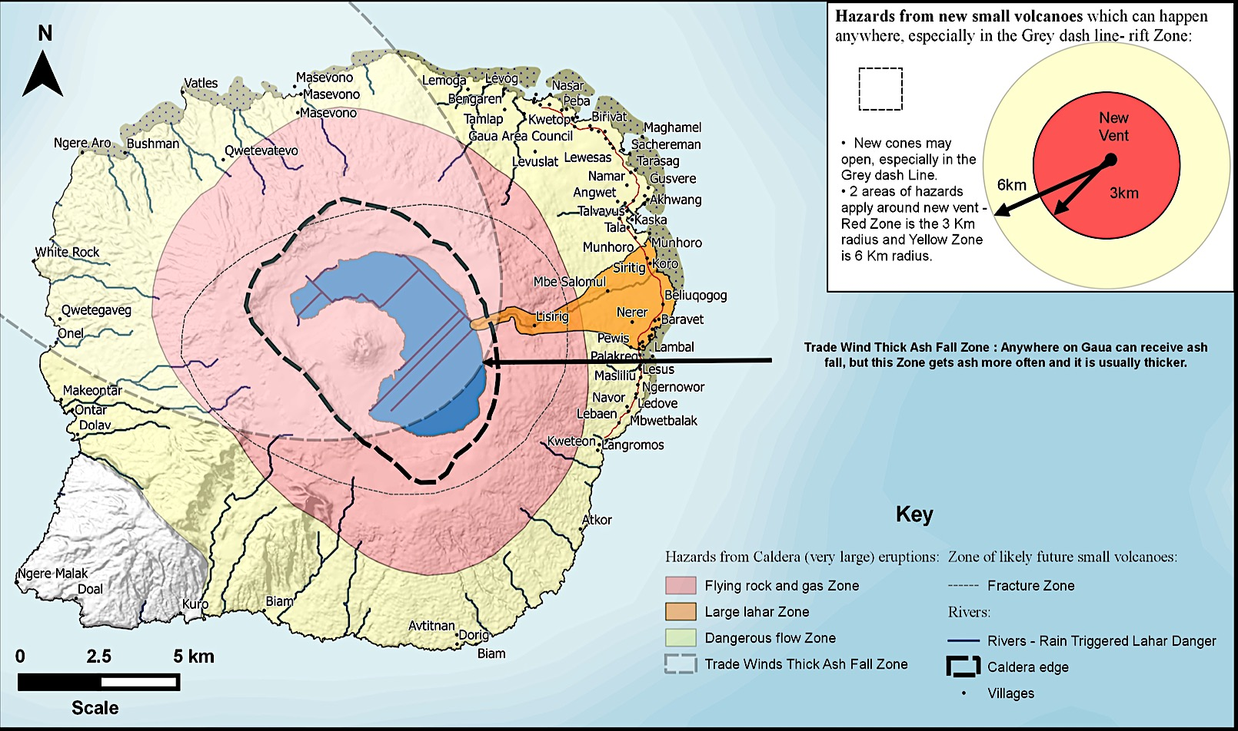

Torba was affected by drought during the El Nino phenomena in 2016. There are many food sources growing wild, but households gardens are not recovering well following the cyclone and drought. Income is commonly used to purchase store bought food such as rice and flour, supplemented by locally caught seafood. Ships captains advised that the stores provided to the Torba region per capita, were higher supply rates than most regions. Whilst programs are working on building food security in the region, emergency food distribution needs to be built into logistics and disaster plans in the interim.

Water shortages are also a problem for some islands such as Mota Lava and Meri Lava which rely soly on rain water harvesting. North East of Guau. Water distribution was required for the Torba Proince after TC Pam in 2015, and shortages compounded by EL Nino in 2016.

Jerry cans only were distributed to Torres to assist with water collection.

Coordination and communication
The Torba Provincial Government Headquarters is in Sola, Vanua Lava, and is the coordination point for managing a disaster in this region. It can be utilised as a small scale secondary logistics hub for emergency response in the Torba region. Electricity has been installed by Unelco in the Sola area.

Provincial Disaster Officer | Secretary General | Planning Officer
Fisher Young Dinh  fdinh@vanuatu.gov.vu  +(678) 22-699 +(678) 560-2661 +(678) 565-3161 | Reynold Surmat  rsurmat@vanuatu.gov.vu  776-5531 | 541-4192 | Michael Silona msilona@vanuatu.gov.vu  Ph 597-1276
Humanitarian Partners are working in the Province. The following is an extract from the November 2016 VHT 3W’s depicting the sectors humanitiarian organisaitons are working:

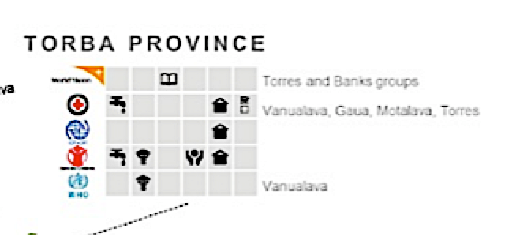

The airport capacity is extremely limited in this region, and rough seas hamper cargo ship and banana boat transport. For a large scale disaster affecting many islands, helicopter assistance will be required to distribute relief items in the early stages. Options could be from a large ship/barge at anchorage, or utilise Santo as a Primary Hub.

NDMO has constructed a Provincial Disaster Office next door to the Provincial headquarters office and Police Office. A Provincial Disaster Committee (PDC) has been established with strong involvement in preparedness by the Government Heads of Agencies. Community Disaster Committees have been established in most areas an include Chiefs, Womens Groups, Youth groups, and Church leaders.

There are no community radio broadcasting stations in the Torba region. Communications for disaster warnings (eg Cyclone, Tsunami, or increasing volvanic activity) is communicated through mobile phone to the CDC’s and area secretaries, down to island chiefs and village level, through existing community systems.

Disaster coordination, evacuation, and relief supplies can be coordinated through the CDC’s, which was proven successful in TC Pam for the Province. The areas that do not have CDC’s established yet must use the Chief of Church and Chief of Nasara (aka chief and church) system. Together they govern one community.

The Police assist with damage assessment, security and search and rescue.
Police are not present on every island. There are 4 men in Sola and one on Loh in Torres.
If extra security resources are required for food distribution on the islands they must be sourced from Santo.

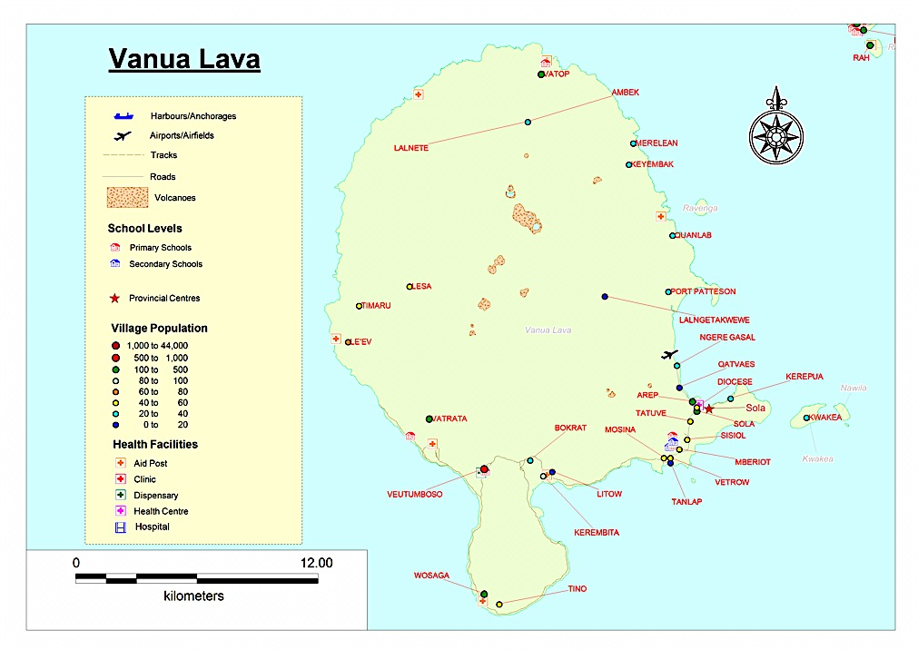

Air transport
Temporary map and table until logistics GIS map available

Airport Name | Coordinates | Capacity | Runway Type
Vanua Lava
Sola airport | Lat S 13 51 18  Long E 167 31 58 | 830m x 25m | Grass on soil
Mota Lava
Mota lava | Lat S 13 39 58  Long E 167 31 58 | 900m x 25m | Grass on coral
Guau
Guau | Lat S 14 14 13  Long E 167 35 15 | 980m x 22m | Grass on soil
Loh
Linau | Lat S 13 1940  Long E 166 38 16 | 850m x 25m | Grass on sand
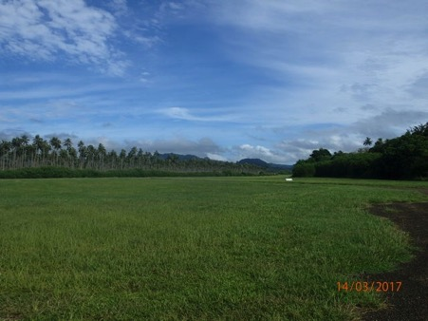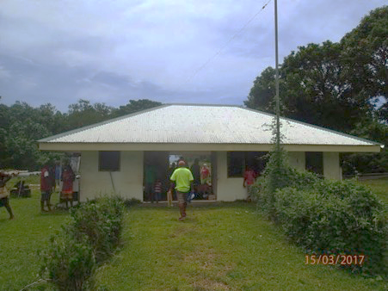
Photos: Sola airstrip and terminal

Air Vanuatu flies twin otter aircraft twice a week to service the Torba region. Flights are regularly subject to change and must be confirmed.

The VHF radio is not operational at Sola. Mobile phone is used by the check in agent for flight status and bookings. The airport is not manned unless there are flights.

The road to the airport is dirt and is only accessible by 4WD after heavy rains.

There is a helicopter landing spot close to the Provincial HQ on the sports field that can be used for emergencies.

There is a tiny makeshift runway on every island for the Flying Dr to land.
Dr Mark Turnbull ph 5512345

Sea Transport

International Ports
Sola in Vanua Lava is recognised as an International Port of Entry, mainly to accommodate yachts and touring vessels visiting Vanuatu. This may be useful in a large scale disaster to allow international assistance direct to the Torba region.

Customs has a VHF radio which operates on channel 16.
International vessels can enter Torba as port of entry. Police do Immigration.
Ships assisting with disaster can email Customs direct to find out process.
customsborder@vanuatu.gov.vu

The Customs website has the contact details and all forms to follow.
All ships must report to Sola as the port of entry first for clearance. Customs will asssit to coordinate with Bioseurity and Police to clear the ship.
tamatar@vanuatu.gov.vu (Richie tamata)

Inter-island shipping
There are several ships that service the Banks regions departing from Santo.

These incude:
MV El Karma
MV Keidi
MV Kawale (sudbidised by Van Gov)
MV Sabrina
MV Lara Star
LC Kalayara
LC Kiwi Trader
LC Urata
LC Mahalia 2
LC Roena

MV Kawale and MV Keidi are the only two ships that service the Torres region. MV Kawale is subsidised by the Vanuatu Government to ensure the Torres region has access to supplies and transport, even though the return trip freight and transport levels will be very small.

Local island travel
Travel between the islands is common by banana boat in calm waters. However the fuel costs make this an expensive option. Vanua Lava to Mota lava is approximately 45 minutes and a minimum of 15L of fuel each way, depending on conditions and motor size. At times when there is high swell or rough weather, banana boats cannot travel between the islands.

The cargo ships will allow locals onboard to travel between islands as they are offloading and picking up cargo. This is the more affordable option for travelling between the Torba islands.

Domestic ports and anchorages
Rough seas and weather can significantly impact the ability for ships to anchor and discharge. Ships may need to anchor in safe harbours and not be able to offload at certain ports if winds are in the wrong direction.

Temporary table until Logistics GIS maps are available. Philip to identify Torres landing sites on Google Maps to get the GPS coordinates.

Ports
Port Name | Location/Coordinates | Type
Vanua Lava
Sola | Lat S13 52 34,  Long E167 33 15 | Main port, Landing craft
Vureas Bay |  | Land on beach. Sanlang school. Field can be used as a helipad.
Mosina |  | Landing on beach (football field can be used for helipad.
Kerebeta |  | anchor with banana boat unload
Wasaga |  | landing craft on reef
Lion Bay |  | anchor and banana boat unload
Ambeck |  | landing craft on beach
Vatop |  | landing craft on beach
Lalnetak |  | Landing craft on beach.  NOTE: One of the best ports to shelter in cyclone season. Any wind direction
Port Patterson |  | landing craft
Qeso
Merelaen
Mota Lava
Nereniuman/Rah | Lat S13.52.30  Long E167.33.25 | landing craft on beach. (flying doctor aiport close by).  NOTE: cannot be used in Easterly winds/ rough seas.
Mota
Veverau |  | (Mission port)
Gog |  | anchorage
Mariu |  | anchorage
Lotawan |  | anchorage
Tuqetap |  | anchorage
Mariu |  | anchorage
Lotawan |  | anchorage
Tuqetap |  | anchorage
Ureparpara
Dives Bay |  | Muddy and mangroves. No landing. Not safe in North winds.
Lehali
Guau
Aver |  | Main port, landing craft
Kaska |  | landing craft
Lembal |  | anchorage
Ontar |  | anchoragae
Dolav |  | landing craft – close to second biggest school.
Lakona Bay |  | landing craft
Bushman Bay |  | anchorage
Dorig |  | anchorage
Beam |  | landing craft
Koro |  | landing craft
Merig
Merig |  | Main port
Merelava
Tasmat |  | (Mission port) – landing craft
Lequel |  | Anchorage
Aota |  | Landing craft. Airport for flying doctor. Helicopter landing spot.
TORRES – Philip Meto to update GIS points –google earth
Toga
Litau/Lietu |  | Clost to flying doctor aiport
Likwal – |  | landing craft on the reef.
Black rock - anchorage |  | anchorage
Loh
Loh Main port |  | anchorage
Luharigi |  | Landing craft
Rinuha |  | anchorage
Linua – airport close by |  | anchorage
Tegua
Lateu |  | anchorage
Metoma
Rival |  | anchorage
Hiu
Yakwana |  | Landing craft
Information obtained from Captain Brian Ford Hooker

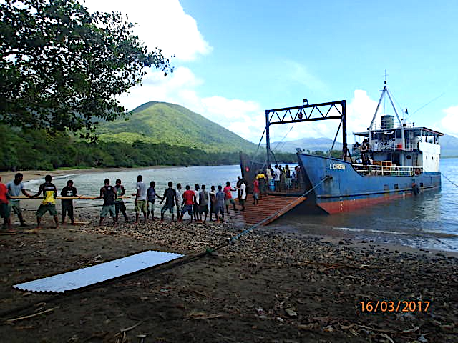
Photo: Unloading of LC Rowena at Sola Port. School children are assisting.

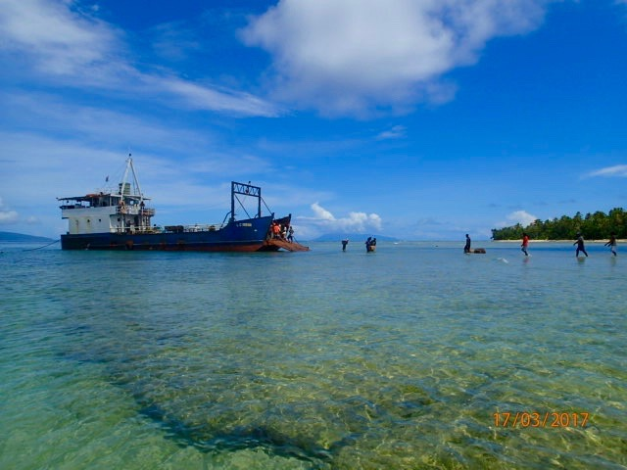

Photo: Port at Mota Lava. This is the only port on the island and cannot be used in rough seas or easterly winds.

Road Transport
Mota lava, Vanua Lava and Guau are the only islands with roads. Public Works advised
The Mossina to Vureas Bay road on Vanua Lava; and Kaska to Aworor on Guau is impassable after heavy rain. The road to the south east of Guau is not accessible during floods and storms as the river crosses road.

Public Works are located on each currently for the roads for development project. After the project is finished in 2018, Public Works will only be based in Vanua Lava. A mobile team in Santo will be established to cover other islands.

Transport availability
Public Works and the Provincial HQ have a truck ,and Unelco has a lorry with a small crane on the back.

Road transport is difficult to get in Sola. There are few trucks on Vanua Lava and the cost can be 500vt – 1000vt for a small trip.

There are only two trucks on Mota Lava to transport people and Cargo from the south where the only port is located, to the north villages where the only airport is located.

Transport Cost 2,500vt

See annex for transport availability /hire and rates, and mechanic details.

Fuel
The fuel costs are high at 250vt/litre. Many stores carry fuel in the Sola.

Garages/mechanics
Public works and Province work shop are the only garages for fixing vehicles on Vanua Alava.

Emergency communications
There is no community radio broadcasting in Torba.
HF radio is available at the Dept of Agriculture and Diosese in Sola. (Anglican church) Frequencies: 48550; 6935.

The airport and police radios in Sola were not working during assessment.

The CDC contact ist is attached.

Hospitals/ medical clinics
The flying doctor, known as Dr Mark, is currently the only doctor who services Torba, and flying doctor airstips have been developed on every island.

Qatvaes Mini hospital is on Vanua Lava located close to the airport. There is no doctor based there.

Bemisas is the Health Centre in Mota Lava has less than five beds.

Mataka Health Centre on Gaua, and the flying doctor (Dr Mark) has a clinic based on Guau.
Evacuation Centres.
The polulations on the islands is small, so community centres, schools and strong family houses are used.

The large Diocese on the top of the hill in Sola is a good evacuation centre for storms and tsunamis.

Emergency Storage
The PDO office has two rooms in Sola with storage capacity and Red Cross has storage space that could be utilised for emergency relief. There are two churches that could also be utilised for storage and distribution.

Pre-positioned NFI’s
The Red Cross have pre-positioned the following NFI’s in Sola, Vanua Lava:

Tarpaulin | 200
Hygiene Kits | 100
Jerry can 10L | 100
Sleeping Mats | 100
Mosquito net | 200
Shelter kits | 200
Kitchen set | 200
Blankets | 100
Solar Lanterns | 100

Locally available supplies
Shops
There are small shops only that sell multiple types of goods and fuel in small quantities. The community relies heavily on the ships for goods that cannot be locally produced/obtained. Money from copra production is often used to buy store bought food.

Locally grown food.
Torba relies on fishing as its major source of meat, and produce grown in community gardens.

The markets in Sola appeared to have very little available for purchase. Wild growing banana, pawpaw, coconut, and citris fruits appear plentiful, however the Department of Agriculture advised that the drought and cyclone resulted in food shortages.

Torba has suffered from compounding disasters that have caused food and water shortages. TC Pam in 2015, followed by extended El Nino related drought in 2016 meant crops have not grown well. Food security has been further threatened by TC Donna in 2017, which saw the crops in Torres destroyed. Food and water water relief had to be supplied to all households in the Torres.

Programs have been developed to plant more resistant crops to cyclone and drought, such as wild yam, taro. They have started planting crops more inland where there is a wind break to withstand cyclone.

Traditional practices of preserving breadfruit and nuts are also used.

Water
Mota Lava and Meri Lava rely on water harvesting only. So water needs to be shipped across from other islands by banana boat during drought and large scale devastation.
During the TC Pam and El nino period, water distributions were required from outside the region. A disaster plan has been created for drought to preserve water and the Department of Water is currently distributing 6000L water tanks to increase water harvesting capability to Vanua Lava, Mota Lava, and Guau.

Annex 1 – accommodation and transport availability and rates.

GUEST HOUSE
Name | Owner contact | No of BED ROOM | Room rate / Night
Leumurus Guesthouse | Fr. Luke Dini: 5973504 | 6 | 3000 VUV Meals included
Ulkel guesthouse | Moses Baet: 5693858 | 8 | 1500 VUV Meals excluded
Elizier Travelodge | Doreen Eldads: 5904364 | 7 | 2500 VUV Meals included
Captain Ian & Karen | Captain Ian & Karen | 4 | 2500 VUV/Meals included
MECHANIC
NAME | POSITION | QUALIFICATION | REMARKS
Godden Fanai | Provincial Chief Mechanic | Exerience over 20 years | Tel: 5979682
John Star | Provincial Mechanic | Experience over 10 years | Tel: 5969537
LAND TRANSPORT
NAME | CONTACT | DESTINATIONS (from - to) | PRICE (VUV)
Province truck | Luc Mol | Sola-Mosina | 1,000
 | Mobile: 5931801 | Sola- Airport | 500
 |  | Airport-Mosina | 1,500
Hudson Mumeg | Fredrick Din | Sola-Mosina | 500
 | Mobile: 5394412 | Sola- Airport | 1,000
 |  | Airport-Mosina | 1,500
Don Matamlele | Don | Sola-Mosina | 1,500
 | Mobile: 5351317 | Sola- Airport | 1,000
 |  | Airport-Mosina | 1,700
Jimmy Jones | Jimmy Jones | Sola-Mosina | 1,500
 | Mobile: 5351318 | Sola- Airport | 1,000
 |  | Airport-Mosina | 2,000
SEA TRANSPORT
BOAT | Description | Engine type | Remarks
Amos. Mobile#5394435 | 5 M Aluminium | 25Hp Tohatsu | 10 passengers + captain and crew
NAME OF BOAT | DESTINATIONS |  | PRICE (VUV) One Way
 | From | To
MV QUAT MATESALA | Sola | Mota | 12,000
 | Sola | Motalava (Neriningman) | 15,000
 | Sola | Motalava (Telvet) | 18,000
 | Sola | Qakea | 6,000
 | Sola | Port Patterson | 6,000
 | Sola | Kerepeta | 13,000
 | Sola | Wasaga | 17,000
 | Sola | Vureas | 18,000
 | Sola | Vatrata | 19,000
 | Sola | Leon Bay | 23,000
 | Sola | Round Vanualava | 26,000
 | Sola | Lessa | 20,000
 | Sola | Ambek | 19,000
 | Sola | Vatop | 15,000
 | Sola | Qeso | 12,000
 | Sola | Keyebak | 9,000
 | Sola | Quanlap | 10,000
 | Sola | Ureparapara Round | 32,000
 | Sola | Divers Bay | 30,000
 | Sola | Lehali | 30,000
 | Sola | Moi | 27,000
 | Sola | Losalava (Gaua) | 30,000
 | Sola | Kaska (Gaua) | 32,000
 | Sola | Merig | 33,000
 | Sola | Lembal | 35,000
 | Sola | Merelava | 45,000
NAME OF BOAT | DESTINATIONS |  | PRICE (VUV) One Way
 | From | To
PROVINCIAL BOAT | Sola | Mota | 13,000
 | Sola | Motalava (Neriningman) | 18,000
 | Sola | Qakea | 6,000
 | Sola | Port Patterson | 6,000
 | Sola | Kerepeta | 16,000
 | Sola | Wasaga | 21,000
 | Sola | Vureas | 26,000
 | Sola | Vatrata | 27,000
 | Sola | Leon Bay | 28,000
 | Sola | Round Vanualava | 32,000
 | Sola | Lessa | 25,000
 | Sola | Ambek | 21,000
 | Sola | Vatop | 18,000
 | Sola | Qeso | 15,000
 | Sola | Keyebak | 11,000
 | Sola | Quanlap | 8,000
 | Sola | Ureparapara Round | 43,000
 | Sola | Divers Bay | 38,000
 | Sola | Lehali | 38,000
 | Sola | Moi | 35,000
 | Sola | Losalava (Gaua) | 38,000
 | Sola | Kaska (Gaua) | 41,000
 | Sola | Merig | 48,000
 | Sola | Lembal | 57,000
 | Sola | Merelava | 57,000

