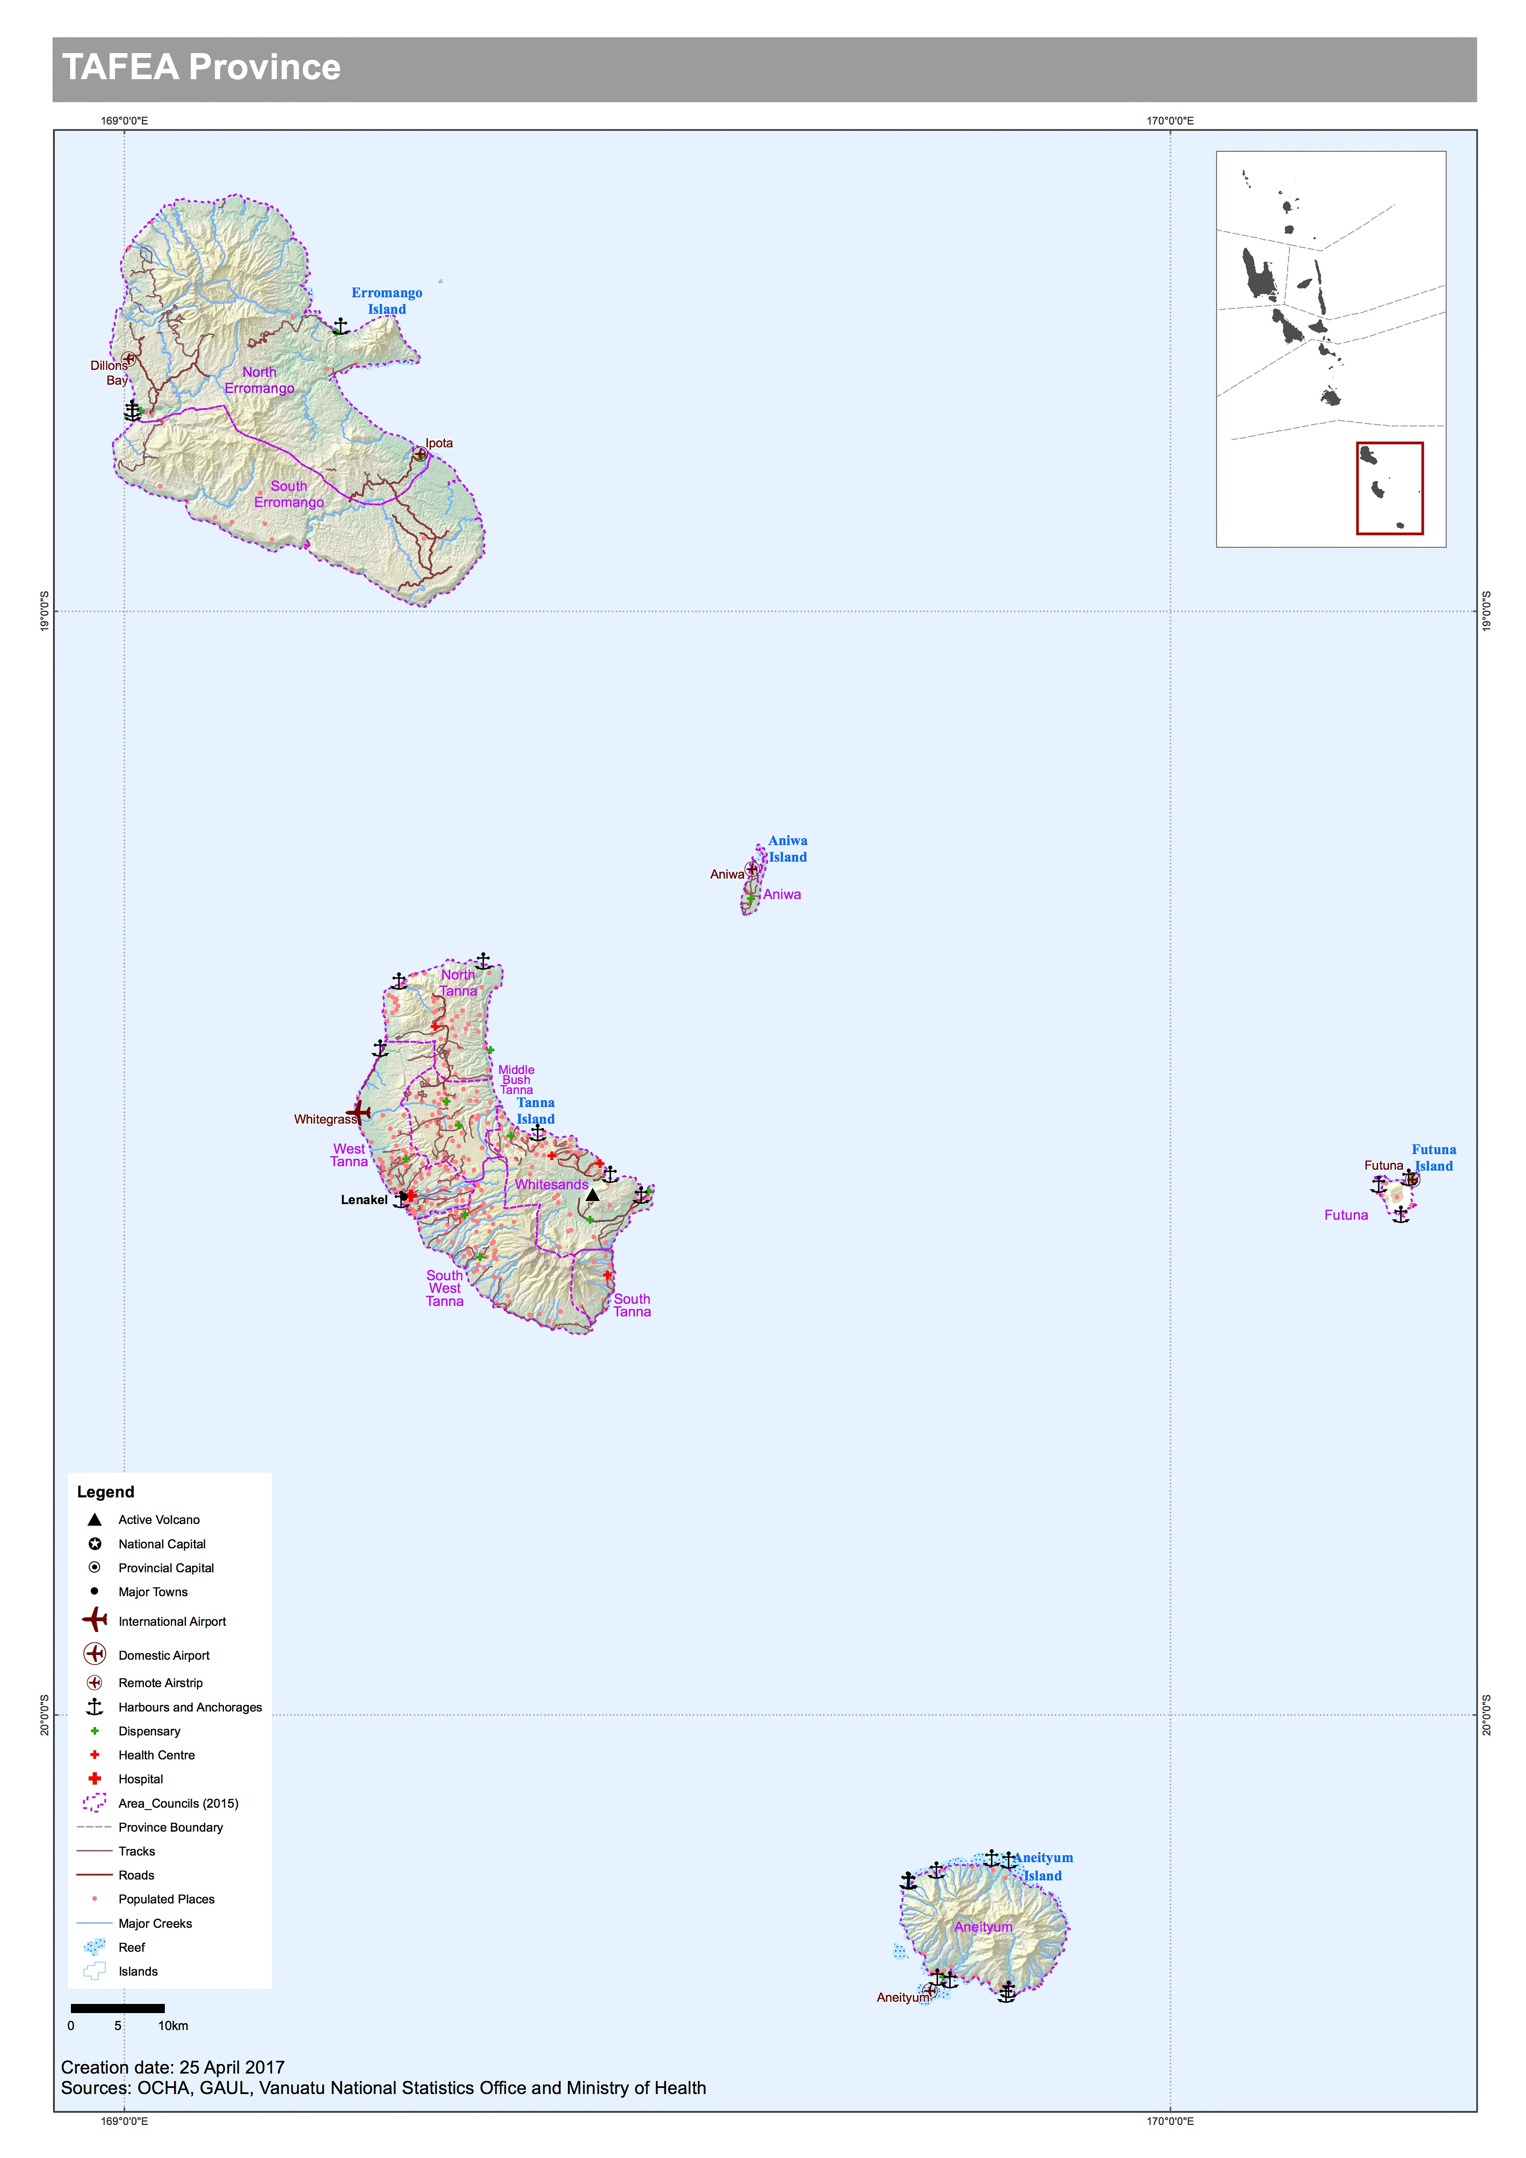

Disaster context.

Tafea is the most southern province of Vanuatu and consists of five islands. The provincial headquarters is located in Tanna, the most populated city on the islands.

Province | Area | Male | Female | Not stated | Population | HH’s | Ave HH
Tafea | north erromango | 774 | 751 | 0 | 1525 | 256 | 6.0
Tafea | south erromango | 281 | 303 | 0 | 584 | 101 | 5.8
Tafea | aniwa | 200 | 220 | 0 | 420 | 100 | 4.2
Tafea | north tanna | 2071 | 2156 | 1 | 4228 | 774 | 5.5
Tafea | west tanna | 4082 | 4167 | 10 | 8259 | 1,459 | 5.7
Tafea | middle bush tanna | 3006 | 3014 | 0 | 6020 | 1,091 | 5.5
Tafea | south west tanna | 2889 | 2944 | 0 | 5833 | 1,028 | 5.7
Tafea | whitesands | 3261 | 3260 | 0 | 6521 | 1,343 | 4.9
Tafea | south tanna | 677 | 669 | 0 | 1346 | 274 | 4.9
Tafea | futuna | 317 | 309 | 7 | 633 | 107 | 5.9
Tafea | aneityum | 745 | 688 | 0 | 1433 | 282 | 5.1
Provincial Disaster Officer | Secretary General | Planning Officer
Daniel Samson  tafeadisasterofficer@gmail.com  +(678)550-0167 +(678) 774-2766 | Ketty Napwatt  knapwatt@vanuatu.gov.vu  +(678) 564-9741 | Joseph Wombugu  mjosephwambugu@gmail.com  + 678 778-5241

Tafea felt the full force of Category 5 Tropical Cyclone (TC) Pam (2015), and was affected by Cat 3 TC Ula (2016), and TC Cook (2017).

Tafea also experiences drought, heavy rains, flooding, landslides, and earthquakes. All of which occurred in 2016 and early 2107.

Tanna was severely affected by TC Pam. Three humanitarian agencies collaborated to provide relief and recovery to different regions of the island. They were still administering recovery programs at the time of the logistics assessment April 2017.
- World Vision: South and South West
- French Red Cross: West and North West
- Care: East Tanna. (South and North)

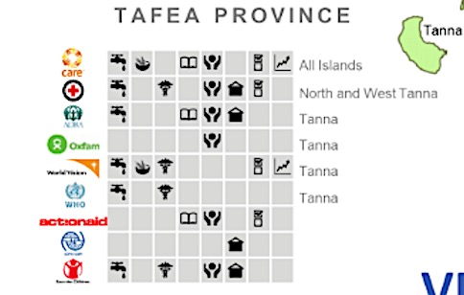

Mt Yasur on Tanna is acclaimed as the most continuously erupting volcano in the world. Large molten bombs and gases can affect those areas in the red zone.

The yellow zone is in danger of fast moving ash, rock and gas flows down the mountain during large eruptions. During heavy rain, all rivers, especially those in the yellow and white zones can generate lahars /volcanic mudflows.

Ashfall can cause food and water security issues to the surrounding villages and can also affect the visibility of trucks, making road transport dangerous on some occasions.

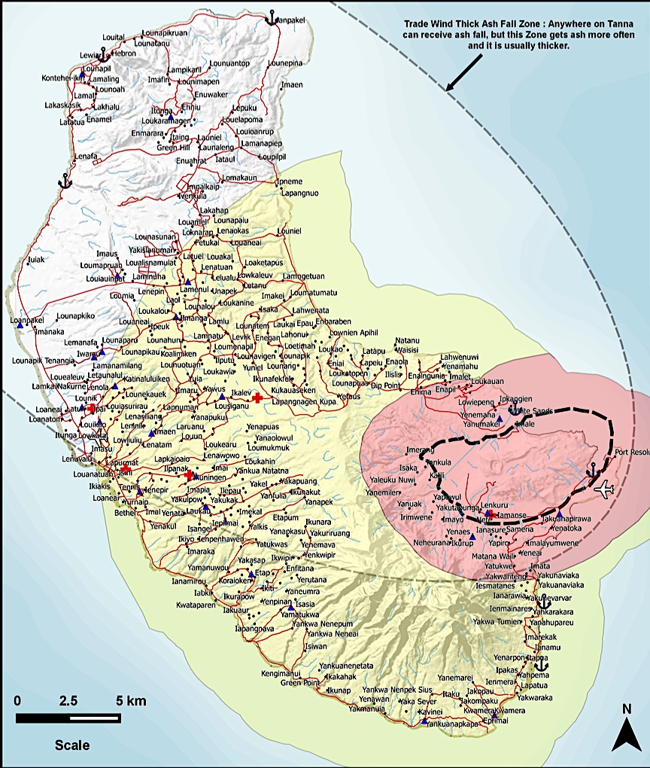

Logistics Context
Tanna hosts the provincial HQ, and is the logistics hub for Tafea province. Whilst it does have an accreditated International airport and is legally a first port of entry for ships, there are several logistical constraints that prevent it from being an effective primary hub for disaster relief. Notably, the lack of capacity at the airport and wharf, and no fuel depot. More details are provided in the section following.

It is recommended for major events that all disaster relief and logistical assets are dispatched from Port Vila, Efate to the islands of Tafea. Tanna can be used as a secondary hub to assist in distribution to the outer islands.

There is no wharf big enough to accommodate international ships carrying relief items. During TC Pam, ships had to anchor offshore and offload on banana boats which is too dangerous during rough seas. A military vessel or barge with cargo carrying and helicopter capability is ideal with Lamenu Stadium providing a suitable helicopter landing site. GPS coordinates 19*31.45S; 169*16.7 E

Air transport
There are airstrips on every island in Tafea and Air Vanuatu has routine flights to all islands twice a week on Tuesdays and Saturdays.

Airports Vanuatu Limited is responsible for managing the Whitegrass International airport in Tanna. The airport capacity is ATR however C130’s underload restriction can land. Pavement Critical Number (PCN) 17. Runway 1230m long.

NOTE: There are no fuel stores at this airport. Air Vanuatu has some emergency fuel drums stored there, however refuelling must be routinely done in Port Vila.

Civil Aviation gives responsibility to the Public Works Department for all domestic and remote airstrips, who contracts maintenance out to local service providers through routine government procurement process. All airports are currently operating, however Ipota Airport on East Erromongo is undergoing land dispute issues. Planes are still going there but there is a risk of them being stopped. This occurred for a few weeks early 2017.

Sea transport
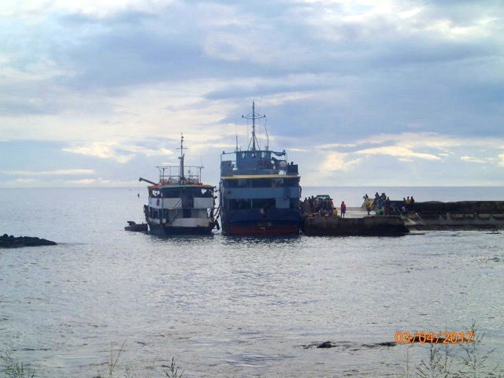
Photo: Lenekel wharf with domestic ship Tauraken 1docked.
International ports
Lenekel wharf has Customs and Immigration officers present, and is used to clear yachts travelling from the South into Vanuatu. The capacity of the wharf is insufficient to handle international cargo ships.

Lenekel Wharf Stevedoring is located in the wharf precinct. Sara Ph 7109766. There is no handling equipment on the wharf. Cargo is predominantly by hand offload only. If container or pallet removal is required, a forklift can be hired from the owner of Touraken 1.

Lenekel stevedoring was unable to provide the draft specs for the wharf however advised that Vanuatu Ferry is unable to dock as it sits too low.

Large military assistance vessels will not be able to dock at the wharf, however could stay out at anchorage and offload on banana boats.

Vanuatu Ferry offloads at the nearby port at Ikamir which has bolards. There is a good bush road from the main road to this port.

International yachts will also call into the safe harbour of Port Resolution on the East side of the island. If the sea is rough or there is a large south or south-western wind blowing, Port Resolution may be a safer offload location.

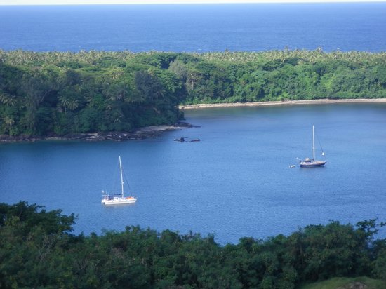
Photo: Port Resolution

Mystery island off Aneityum is a cruise ship destination for Vanuatu. There is one Customs officer present in Tafea, based at Tanna. On days when a cruise ship is due to port at Mystery island, the officer will fly there. Direct relief offload to Aneitym using the sheltered passage between Mystery island and Aneityum is an option.

Inter-island shipping.
The following ships service Tafea Province. Note all ships operate on a weekly schedule from Port Vila to Tanna calling into Erromoango. Only two ships service the southern islands. Island Claws became beached during TC Cook and has not been recovered. Tauraken 1 is currently the only ship servicing the Southern islands on a monthly basis.

Ship name | Capacity | Contact | Other information
MV Touraken 1* and 2 | Big belly ship | 29873/5656689 | Will service outer islands
MV Touraken 2 | 600 tonne | 7777926 | Erromongo and Tanna only
LC Mahalia II |  |  | Erromongo and Tanna only
Vanuatu Ferry | 450 pax 900tonne | 7326999 | Erromongo and Tanna only
Vanuatu Cargo | 200 pax 1050 tonne | 26872 | Erromongo and Tanna only
One People | 600 tonne | 5631604 | Erromongo and Tanna only
MV Lowilan (previously MV Moaika) |  | 7776079; 5456226 | Erromongo and Tanna only
LC Kalyara | Landing craft | 36599/7113657 | Erromongo and Tanna only
LC Urata |  | 5661111 | Erromongo and Tanna only
LC Tiwi Trader | Landing craft | 5722064/5368267  tiwitrader2016@gmail.com | Will service outer islands.
MV island Claws.* |  | 29222/7788510 | Will service outer islands.
* ships that are partially subsidised for fuel costs by the Government, to service the outer Tafea Islands.

Delays and weather can result in a number of ships waiting to unload at Lenekel wharf. Ships arrange docking schedule via mobile phone only. There is no radio. Lenekel Wharf Stevedoring is located at the wharf precinct. Contact Sara on 7109766

Large ships must wait for low tide. If seas are above 1m ships cannot berth as it is too rough. Ships will remain at anchorage until safe, or use banana boat to offload.

There is a beach next to the wharf. Landing Craft can land and unload on the blacksand beach.

Port Name | Location/Coordinates | Type
Tanna
Lenekel Wharf  (SW) |  | Wharf  Main port for inter island shipping  Cannot handle large ships.
Ikamir (SW) | Lat 19.33.3 S  Long 169.16.38 E | Anchorage. Vanuatu Ferry offload.
Ianameh (S) | Lat 19.33.5 S  Long: 169.16.47 E | Anchorage. Must walk goods over rocks and through bush to road.
Khamera (S) |  | Road to Khamera can be impassible after heavy rain.
Port Resolution (SE) |  | Anchorage. Protected bay.
Sulfur Bay (E) |  | Landing Craft in light seas only
Waisisi (Central E) |  | Main port for East Coast. Can handle big ships, and fairly protected.
Lowanpakel (N) |  | Roads are bad, cargo must be walked
Nalpat (N) |  | Roads are bad
Lowanatom (NW) |  | Roads are bad
Ipak (NW) |  | Roads are bad. High wheel base 4WD only from here north.
Erromango
Dillons Bay |  | Anchorage
Ponkil Bay |  | Landing craft in light seas only
Sulfur bay |  | Banana boat offload onto reef in light seas
Ipota |  | Anchorage. Small wharf for banana boats.
Port Narvin |  | Anchorage
Aneityum
Port Patrick (NE) |  | Anchorage
Anelghowat |  | Anchorage for big ships.
Umetch |  | Small boat access. Offload in low swell only

The Chinese road works company CCECC also has large earthmoving and lifting equipment and large trucks to assist with logistics. This can be coordinated through the Public Works Department or the PDO.

NOTE: There is no fuel store or water store in Tanna. Ships must carry enough fuel and water for the return journey.

Banana boat transport is the predominate way to travel around the outer islands, and in areas of Tanna that are inaccessible by road. The cost to hire a banana boat is approximately 20,000vt -30,000vt for Tanna, and For Erromango from West to East is approximately $50,000vt. (Fuel is 250vt/L)

Individual passenger rates may be charged based on distance and number of pax on board for Tanna.

Erromangohas has quite a few boats located at Ipota, approximately 6 at Dillons and one at South River.

Road Transport
Tanna – CCECC project is working on a number of roads to the south, the north and the east.
South Road from Airport
The south road from the airport to Greenpoint is gravelled and passable. During the wet season, the road can become very muddy passed this point. It is only accessible with a good quality 4WD vehicle after heavy rain.
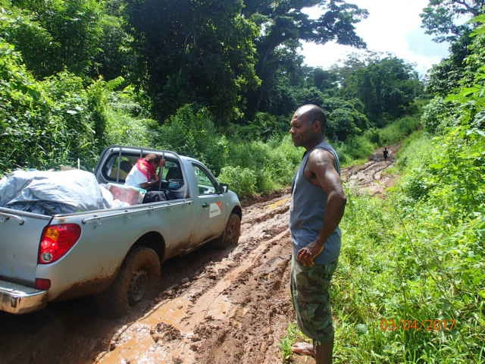
Photo: South road to Khamera port. World Vision assisted to pull out bogged 4WD vehicle.

North Road from Airport.
The French Red Cross advised the roads are in the same condition to the North after Lawanatom. After TC Cook this road was impassable for 4 WD’s with the exception of the Toyota hilux.

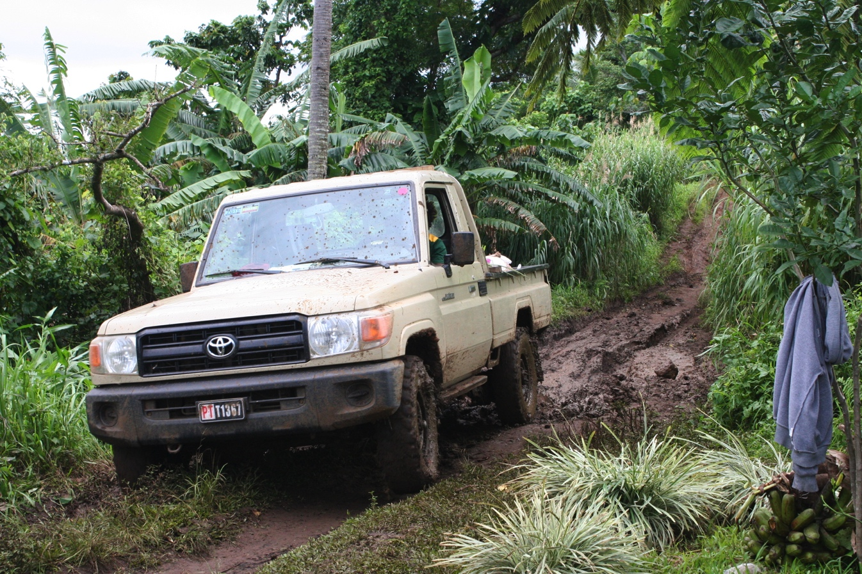

The coastal road to north road is broken between whitegrass airport and Port at Louapau due to flooding and road bridge washaway, but there is a track around which is accessible.

East Road from Lenekel
The road is gravelled up to Snake hill. After the roads require 4WD in the wet season.

Ash from Volcano can block view of windscreen so you must carry plenty of water if travelling in the area.

Public Works Department has 2 good pick ups and 2 old pick ups, 2 big lorries and a bulldozer and backo on Tanna. World vision, Care and Red cross have lorries.

See attached email for registered taxis and private vehicles

Fuel costs Diesel 250vt/L Petrol - 300L for all Tafea islands.

Private transport, minimum 20,000vt /day. Bus fare 500vt, transport to Lenekel to airport 2,000vt. Lenekel to Yasur 8000, Lenekel to Port resolution. 10,000vt Tourist rate/ NGO per person 2,500. Local 500vt.

Aneityum –bush road only must use sea transportation

Erromango- Gravel road from Dillions Bay airport to Dillions bay port which is accessible. All other roads are bush road. No good in heavy rain or cyclone (trees fall down).

Public Works Department has one land cruiser. Ipota has one truck but there are plenty of banana boats located there.

Public Works Department has two tractors, one bulldozer and one landcruiser on Ero.

Fortuna – Ladder footpath around the island. No road. The Public Works Department is planning to build a road at Harolds Bay from the anchorage to the school. The school used as an evacuation centre.
Aniwa - Centre road and circles round to west coast. During heavy rain there is still use of the road but after a cyclone all trees cover the road. There is one truck only on the island. Main transport is banana boat.

Emergency Storage
There are 3 x MSU’s 24 x 10m available located at Tanna. Two are already set up at the wharf.
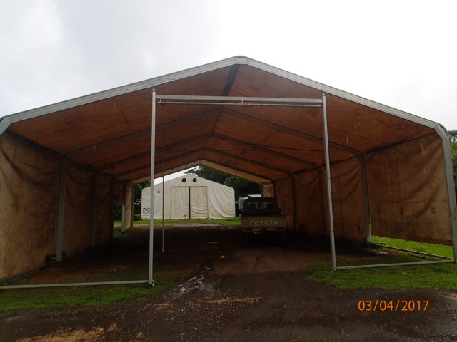

One MSU was donated to Lenekel wharf for their unpaid support with the relief efforts in Tanna for TC Pam. NDMO however, can access the MSU for disaster response if required.

One MSU has been lent to the French Red Cross to store TC Pam recovery items until June 2017, as there is a lack of storage space in Tanna. The third MSU is in the PDO office.

Security is an issue with the MSU’s. Police and private security were hired for TC Pam however this is only partial guarantee.

There is a building on the opposite side of the road to the wharf 10m x 4m that can be used during an emergency.

Two rooms at the PDO office are also available for storage in Isangel.

Prepositioned NFI’s
The Red Cross has the following prepositioned items stored at Isangel, Tanna.

Tarpaulin | 200
Hygiene Kits | 100
Jerry can 10L | 100
Sleeping Mats | 100
Mosquito net | 200
Shelter kits | 200
Kitchen set | 200
Blankets | 100
Solar Lanterns | 100

World Vision has 200 tarpaulins and 200 hygeine kits stored in Tanna.

Emergency Distribution
The NGO’s were used for TC Pam to good effect. There were some issuses in implementing the CDC arrangement predominately as communication on relief supplies and their late arrival caused some unrest. Roads were blocked by some villages preventing distributiom.

The SG called the Chiefs Council together and the tribal system was implemented to assist in distributing goods to everyone.

Significant work has been done since to implement and improve the PDC and CDC system since TC Pam.
Businesses and Community networks
Early Communication of procedures and timely distribution of relief supplies throught the PDC/CDC system with the NGO’s is recommended in the Tafea TC Pam lessons learnt. See the attached excel for PDC, CDC and AS lists from April 2017

Emergency communications
There is currently no HF radio communication in Tafea.

Radio Vanuatu operates in the early morning 8-9am and the evening only and is not available on all islands. Few people have radios to hear the warnings.

There is internet capability in West Tanna only servicing the Provincial HQ and Lenekel areas. This is also the only location where electricity is present in the province.

TVL has a 3G telephone network installed on all islands however there are many “black spots” where phone communication is not possible. Digicel is present in Tanna only.

Satellite phones advised on Tanna from 2016 data collection.

OGCIO
00870776442486 | Isangel | Tanna

Red Cross
Satellite Phone | 698 | 678 | 8816 | 31829959 | VRC HQ | VRCS Tafea branch, Isangel, Tanna

World vision
Jimmy Daniel | Tanna Acting APM | 881631430906

Schools
Get from NDMO file for mapping

Evacuation Centres.
Get from NDMO file for mapping

