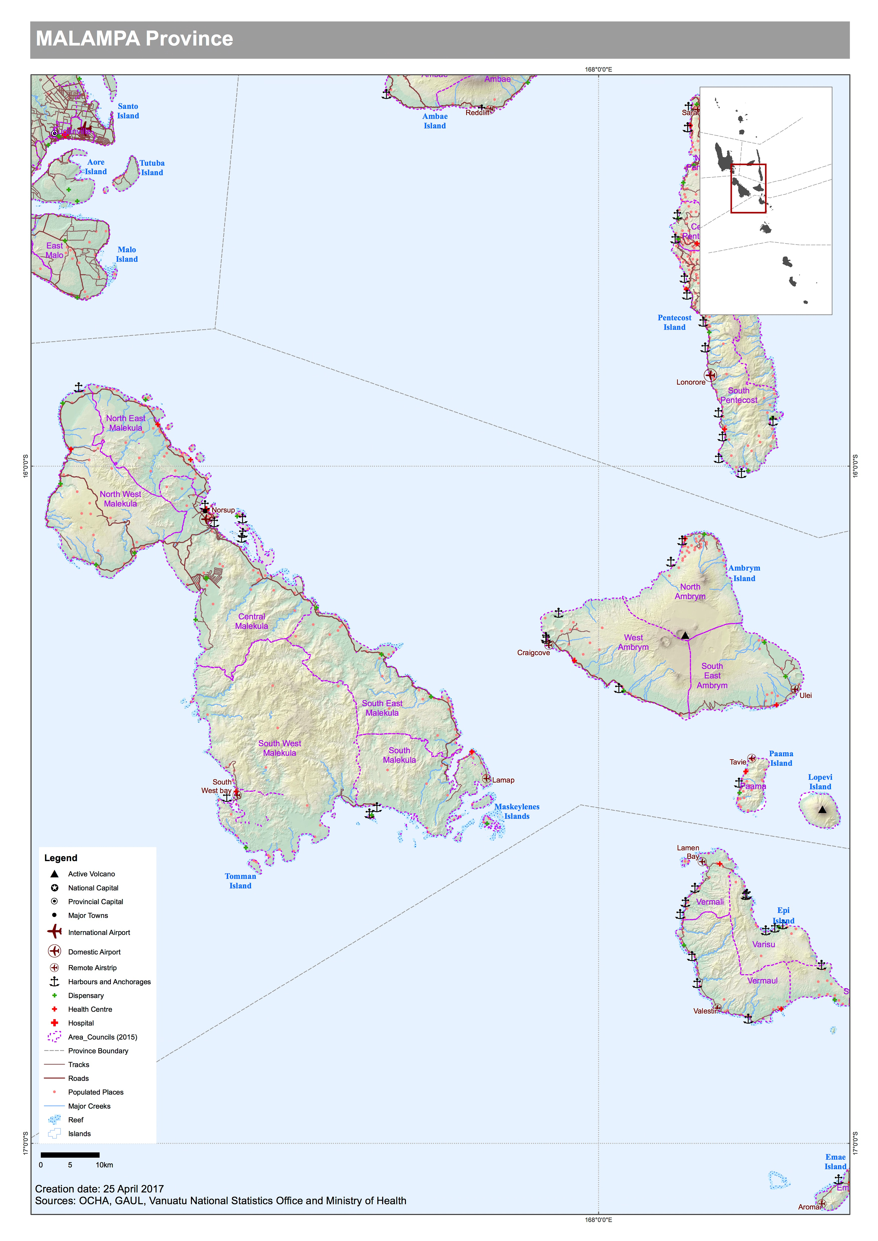

Disaster context
Malampa Province consists of three major islands: Malekula, Ambrym, and Paama, Malekula is the second biggest island in Vanuatu and the third most populated, after Efate and Santo. There are several tiny islands with small populations surrounding it.

Draft population data from Mini census 2016:
Province | Area Council | Male | Female | Not stated | Population | HH | HH size
Malampa | north west malekula | 2276 | 2150 | 4 | 4430 | 949 | 4.7
Malampa | north east malekula | 3047 | 3000 | 0 | 6047 | 1,418 | 4.3
Malampa | central malekula | 2758 | 2781 | 4 | 5543 | 1,241 | 4.5
Malampa | south west malekula | 1746 | 1625 | 0 | 3371 | 738 | 4.6
Malampa | south east malekula | 2565 | 2401 | 4 | 4970 | 940 | 5.3
Malampa | south malekula | 1875 | 1913 | 0 | 3788 | 872 | 4.3
Malampa | north ambrym | 1525 | 1622 | 5 | 3152 | 665 | 4.7
Malampa | west ambrym | 1307 | 1275 | 0 | 2582 | 591 | 4.4
Malampa | south east ambrym | 794 | 758 | 0 | 1552 | 458 | 3.4
Malampa | paama | 709 | 687 | 0 | 1396 | 338 | 4.1

Note: there is a household of 5 people on Lopevi and the Area Secretary of Paama takes responsibility for them.

The Provincial Headquarters is located in Lakatora, Malekula. A Provincial Disaster Office will be built in 2018.

Provincial Disaster Officer | Secretary General | Planning Officer
Abel Abelson  772823 | Palen Ata  pata@vanuatu.gov.vu  774-6405  acting SG Ben Dapi  772823 | Lapi Kalmet  lkalmet@vanuatu.gov.vu  +(678) 542-6499

Malampa has been affected by nearly every type of disaster since 2015, including earthquakes, cyclones, flooding, drought, and eruption of one of the two volcanos on Ambrym. Benbow and Marum are both currently sitting on activity level 2. These volcanos are different to Yasur and bubble in a like formation rather than erupt in the air. However in times of heightened activity, bombs and lava flows can occur.

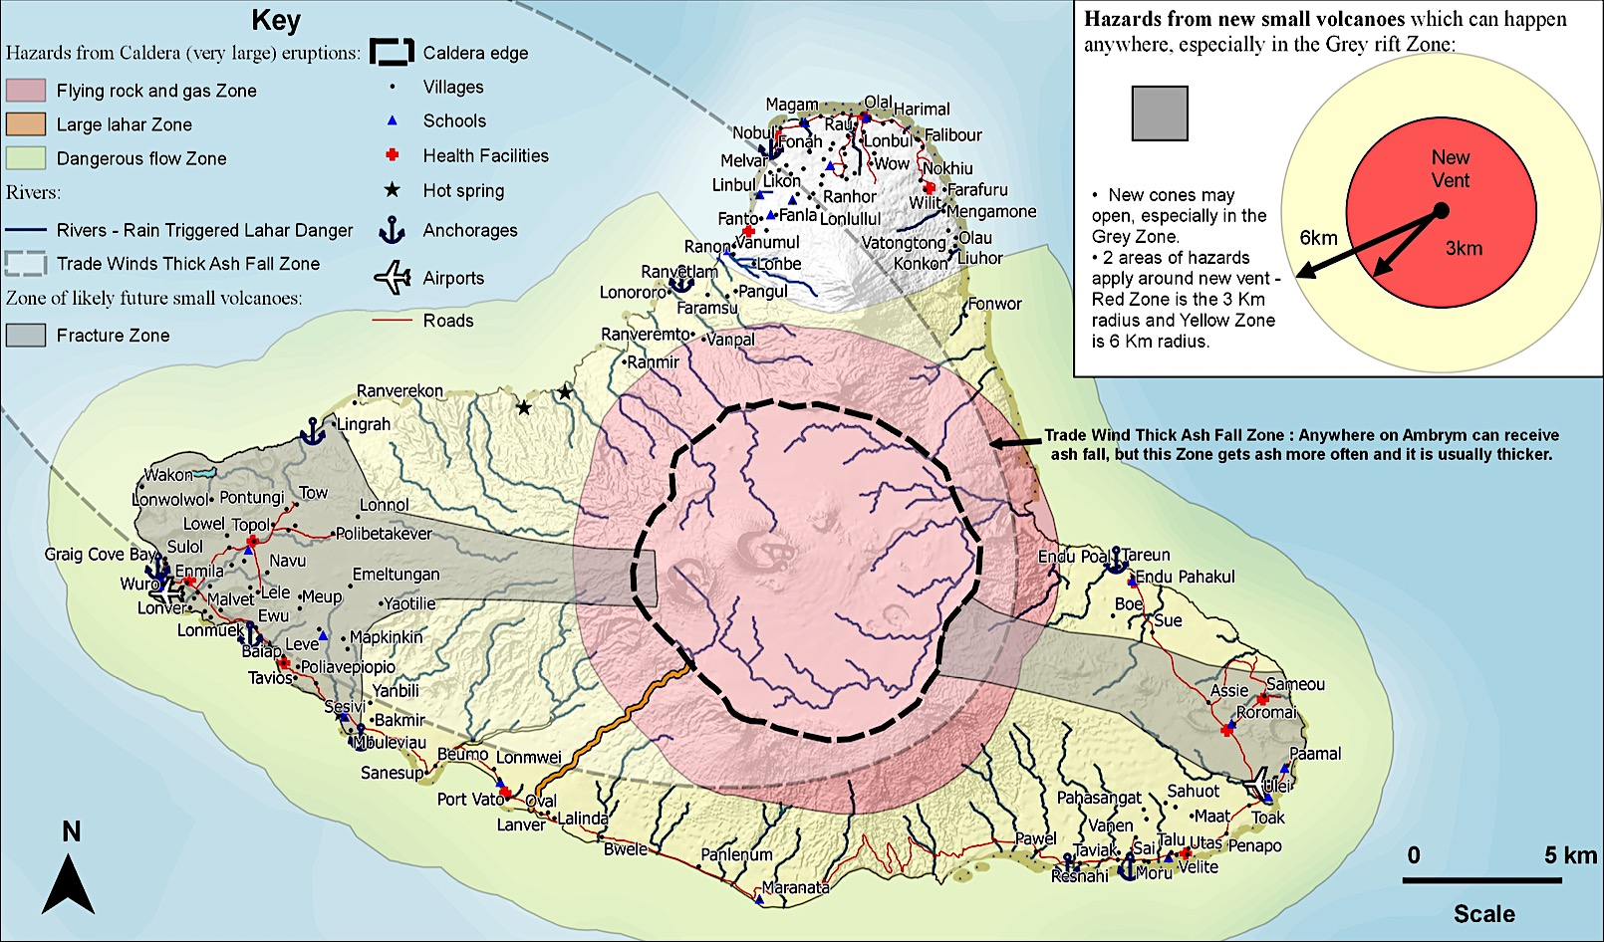

Lopevi is a volcanic island with a single family of 5 members. The eruptions from Ambrym and Lopevi can trigger earthquakes and tsunami’s.

Access to clean water source is a problem on Paama. Springs are scarce and not a reliable source of water. Hand pumps have been installed to access underground water. Water harvesting is important however acid rain can be a problem from the surrounding volcanos.

Logistics context
As the largest copra producer in Vanuatu, ships regularly travel to and from Santo. The regular copra movemments to Santo has resulted in some ships focusing only on the Malekula supply and export route, others service only Ambrym and Paama.

The logistics infrastructure for such a large population and supply route is not ideal, and in need of upgrade and repair.

- There is no airport terminal building. It was destroyed by fire in 2009 over land disputes. Public Works have not rebuilt it as disputes have not been resolved.
- The Chinese (CCECC) project to enhance and pave the roads has faced difficulties. The main roads servicing the aiport, hospital, Provincial HQ and ports in March 2017 were in far worse condition than before works commenced, with large waterfilled potholes and thick mud. 4WD only conditions during the wet season.

Provincial Headquarters are often used as a secondary logistics hub to distribute relief items to all area councils. Given the infrastructure issues it may be better to distribute directly from Santo or Efate to each of the three larger islands.

Coordination and communication

The following image shows the humanitarian partners operating in Malampa province:
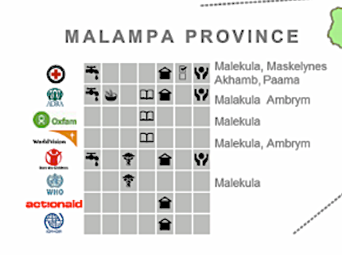
Image: Extract from VHT 3W’s October 2016

Community Disaster Committees have been established but do not cover all areas yet. CDC’s (with representative for Chiefs, churches, womens and youths affairs) utilise the Area Secretaries to obtain and distribute information.

Table 1: Area Secretary contacts in Malampa
Name | Family Name | Area Council | Contact number
Jackson | Willie | North Ambrym | 5937175/5975874
Edwin | Manron | South East Malekula | 5367956
Bule | Malres | Central Malekula
Wesly | Lambi | North West Malekula | 5348814
Lulu | Layman | South Malekuala | 5959552
Cyrus | Willie Hulas | Pamma | 5493887
Kerbie | Norman | South East Ambrym | 5347852
Bong | Masing | West Ambrym | 5902191/ 7756485
Benson | Ben | South West Malekula
Tasso | Kelep | North East Malekula | 7736477
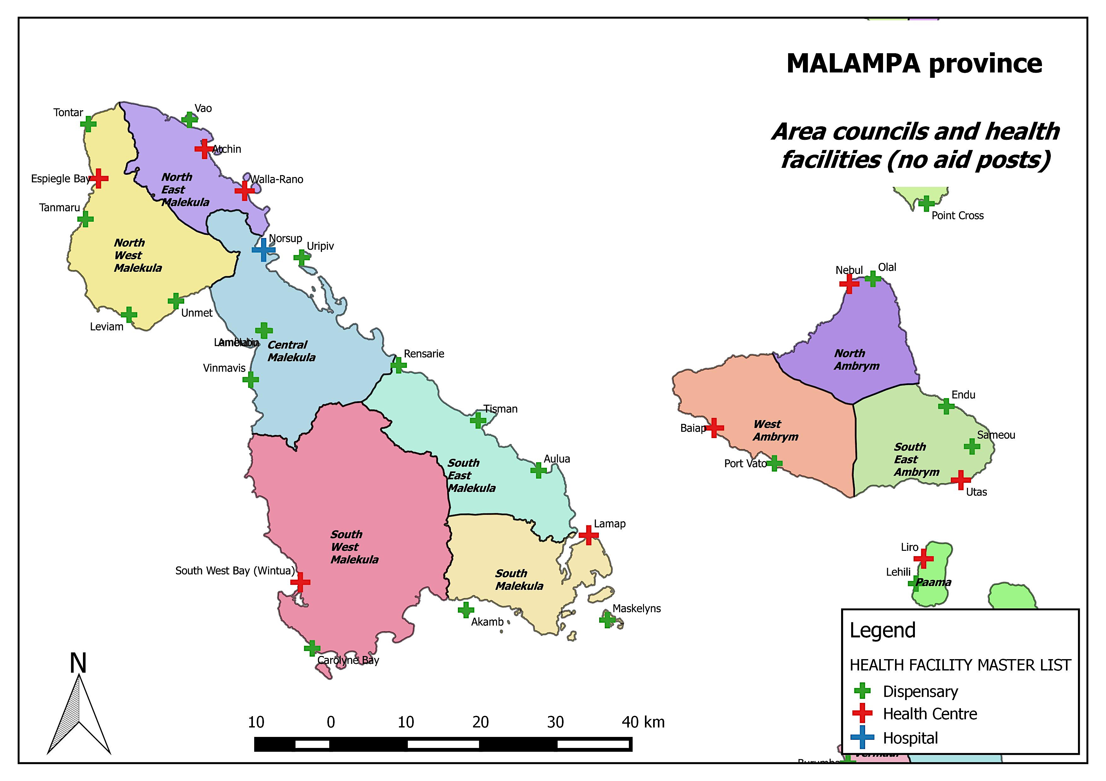

Malekula
The island is predominately inhabited on the East Coast of the island. There are eight small islands just off the coastline to the East and South that are also inhabited.

Copra production provides a significant proportion of employment and income to the island. The two companies are based in the Lakatoro area North East and to the South close to plantations and ports.

The Provincial HQ and markets are also located in Lakatoro. During heavy rains and cyclones the roads can become impassable in a number of areas on the East coast. Meaning evacuation and relief distribution by road may not be achievable from the airports to the south and north. Boat distribution will be required to cover all communities.

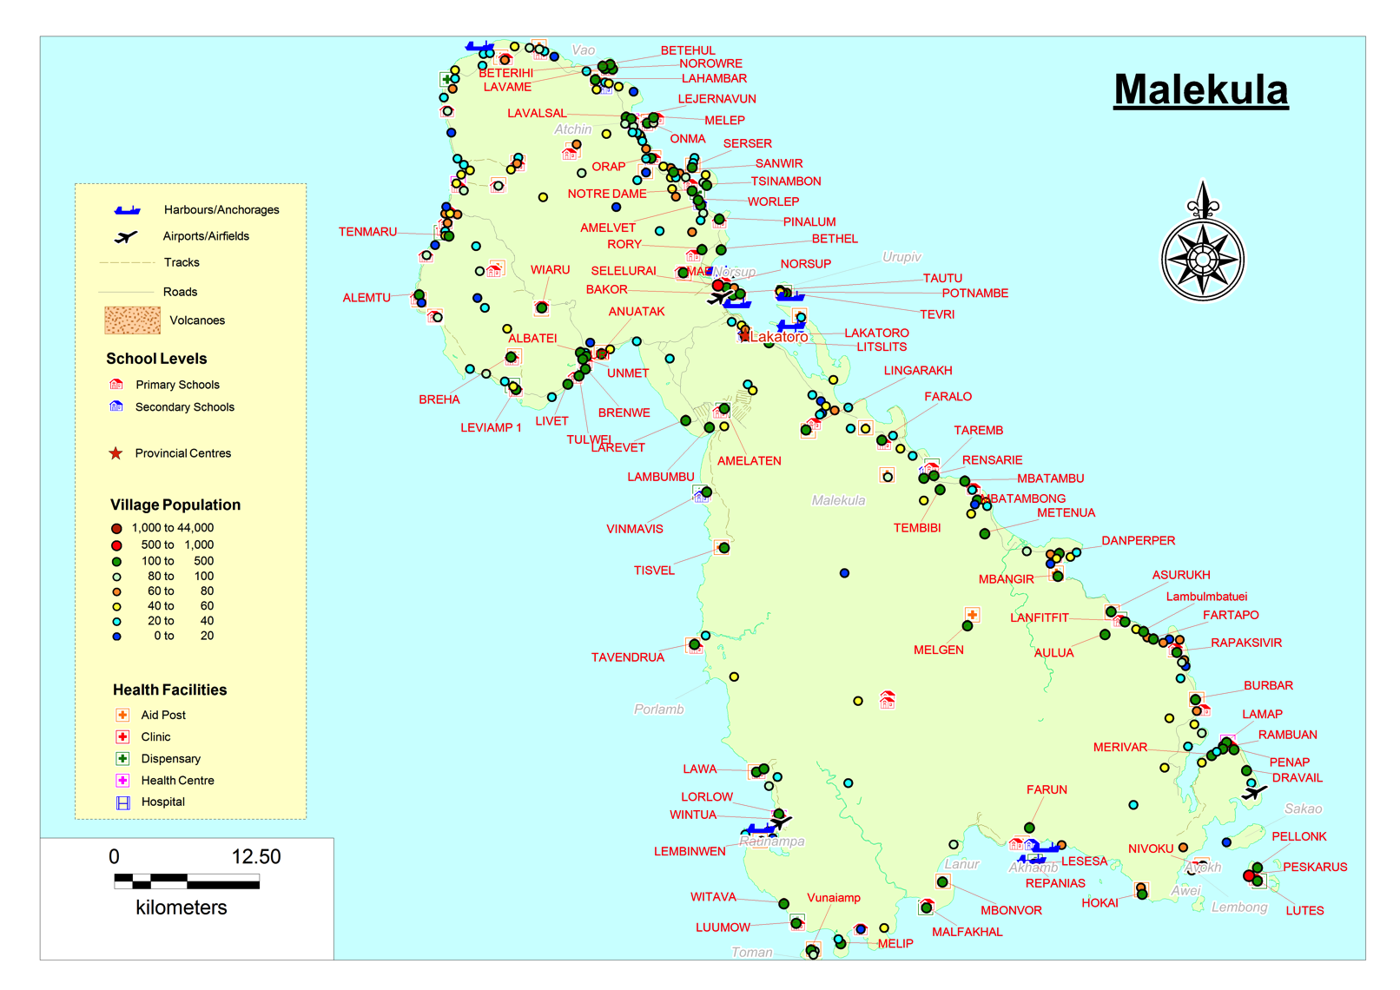

Air Transport

Airport Name | Coordinates | Capacity | Runway
Malekula
Norsup airport | Lat S 16 04 68  Long E167 23 34 | Domestic certified  906m x 15m  Twin otter/islander aircraft  fly 6 days | Asphalt
South West Bay | Lat S 16 16 20 09  Long E167 26 49 | 815m x 15m  Twin otter/islander aircraft  Fly Tue & Thu | Grass on soil
Lamap | Lat S 16 27 54  Long E 167 49 21 | 1190m x 35m  Fly Mon & Thu  Twin otter | Grass on soil

The Public Works Department is the Authority responsible for Norsup airport in Malekula.

The apron is small and only big enough for one aircraft. It is sufficient for a helicopter landing also. If the weather is too bad to land, flights are diverted to Pekoa Airport Santo, which is 15 minutes flight time away.

There are no Avgas fuel supplies in Norsup. Aircraft must carry enough fuel for the return journey and refuel either in Santo or Port Vila.

The Norsup airport terminal building was burnt down during a land dispute around 2009. A brick skeleton without a roof remains. A small toilet block has been rebuilt. Apart from a tiny check in shed, there is limited undercover protection for passengers from the weather, and no storage facilities.

The VHF radio is not operational. The Air Vanuatu agent uses mobile phone to check on flight status and bookings. There are no computer facilities. The airport is not manned unless there are flights.

The road to the airport is dirt and requires a 4WD after heavy rains.

Sea transport
Inter-island ships that service Malekula.

Vanuatu Ferry
Big Sista
MV One People
LC Valerie
Kyanca
Marata
Region

Port Name | Location/Coordinates | Type
Malekula
Norsup wharf  (N) | 16*03.56.69S  167*223.36.72E | Wharf. PRV- privately owned
LitzLitz port  (NE) | Lat. 16*06’ 45.08S  Long. 167+26’37.53E | Main port with wharf, Landing craft
Port Sandwich  (Sth) | Lat.16*27’28.905S  Long. 167*46’38.57 | Private copra wharf
Bushmans Bay  (SE) | Lat 16 19.28.66S  Long 167.43.17.17 | Private Small coral wharf or anchorage for cattle loading at the southern point.  If heavy rain in wet season or cyclone event, road access may be cut to the north and the south
Lambubu  (West) | Lat. 16*08’ 20.98S  Long. 167*18’10.07E | Wharf deteriorated. Anchorage.

Hospital
Norsup hospital has 55 beds including for maternity. There is anchorage close where supplies can be delivered either by banana boat offload or landing craft. If the sea is too rough there is a helipad landing site at the hospital.

Road Transport
The main roads servicing the airport, hospital, Provincial HQ and ports in March 2017 were in worse condition than before the Chinese road works commenced, with large waterfilled potholes and thick mud. Transport is extremely slow going and requires 4WD during the wet season. Fuel average is 180vt/L depending on the area.

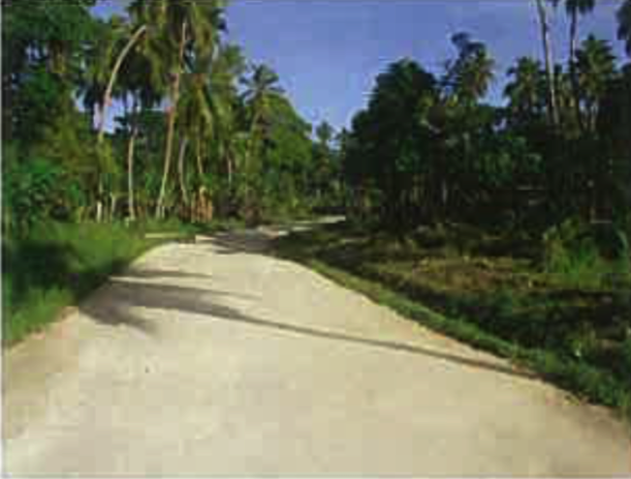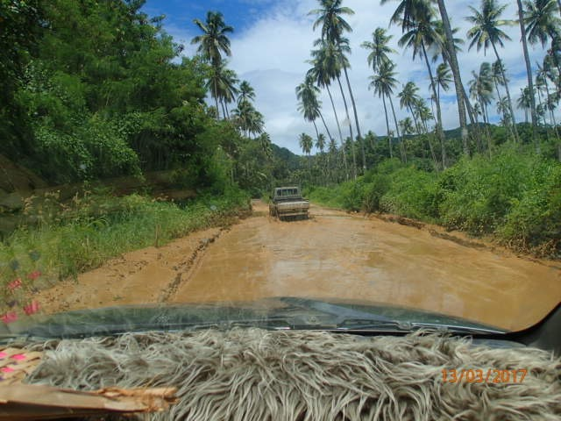
Photo 1: R4D road Norsup-Lakatoro (2012) Photo 2: Same road CCECC works (2017)

The road to the south east is not accessible during floods and storms as the river crosses road. So supplies cannot just be dropped at Litz Litz they must also be sent to Lamap or Lambulmbatuia

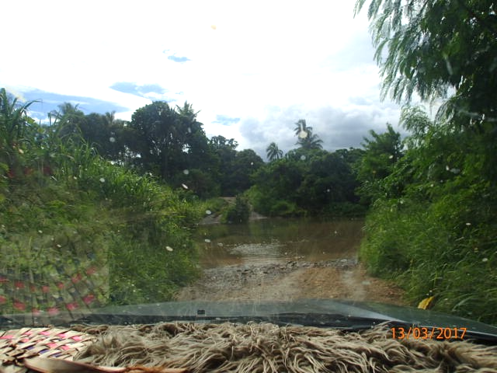
Photo 3: Road from Bushmans Bay port heading up towards Litz Litz. Impassable/unsafe to cross in heavy rain.

Schools and Evacuation Centres.
Refer to document

Emergency Storage and relief items
The commercial centre close to Litz Litz wharf is owned by the Government and was used for relief supply storage in TC Pam. Secondary schools can be used for a short time only.

The Public Works space and in Lakatora could be utilised as well as space within Provincial government buildings.

Copra production facilities are located North West and South and could be called on to determine if their copra sheds could be utilised.

Businesses and Community networks
There are two large copra companies in Malekula (International owned) who employ many of the local population. They have lorries, barges and PRV have their own private wharf in the Norsup area. The copra companies may be willing to assist as their majority owned business relies on the local community members to operate.

Emergency communications
Digicel and TVL reception is available in the Provincial HQ. The Police and airport radios were not working.

Ambrym
Ambryn is divided into 3 inhabited areas areas North/ West/ South East.
The North and the West communities have ports and a road between them but it can be difficult to travel to the South East once on the island as there are no roads and sea transport can be rough.

The volcanoes present in the middle of island provide tourism for the island.
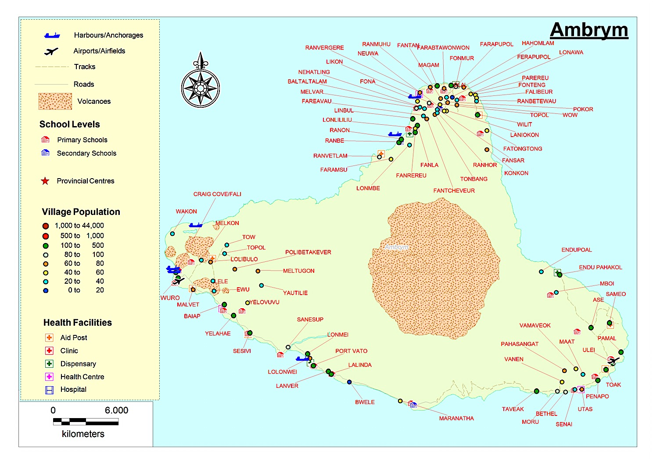

Air Transport

Airport Name | Coordinates | Capacity | Runway
Ambrym
Craigcove | Lat S 16 08 50  Long E167 57 38 | 1200m x 28m  Fly Tue, Thu, Sat, Sun  Twin otter | Asphalt
Ulei | Lat S 16 20 00  Long E168 17 40 | 850 x 22m  Fly Mon, Fri  Twin otter, islander | Grass on volcanic ash

Sea transport

The following ships service Ambrym.

Big Sista
Vanuatu Cargo
One People
Tina 1
MV Freedom
Island Claws

Ports

Port Name | Location/Coordinates | Type
Ambrym
Craigcove  (W) | 16*03.56.69S  167*223.36.72E | landing on beach (wharf destroyed)
Ranon (NW) |  | landing craft
Baiap (W) |  | landing on beach
Port Vato (SW) |  | landing on beach
Taviak (SE) |  | anchorage. (if seas permit)

Road transport

Roads are in the North and West only. To transport goods to the South East you must unload at the West and banana boat across.

As there are no roads to South East Ambrym and there is no port, a big ship must be sent that can sit at anchorage so banana boats can offoad. If the sea is too rough to offload then the only option to get supplies to the South East is helicopter. It can land on the runway.

North roads are only accessible by 4WD in the wet season. Trade winds blow volcanic ash across the west of the island. After heavy rains, the roads on the west side cannot be used as the ground is too soft from the ash. Banana boat transport is generally required in wet season for the West.

Communications
Digicel and TVL are present on Ambrym. Reception in the North is not good.
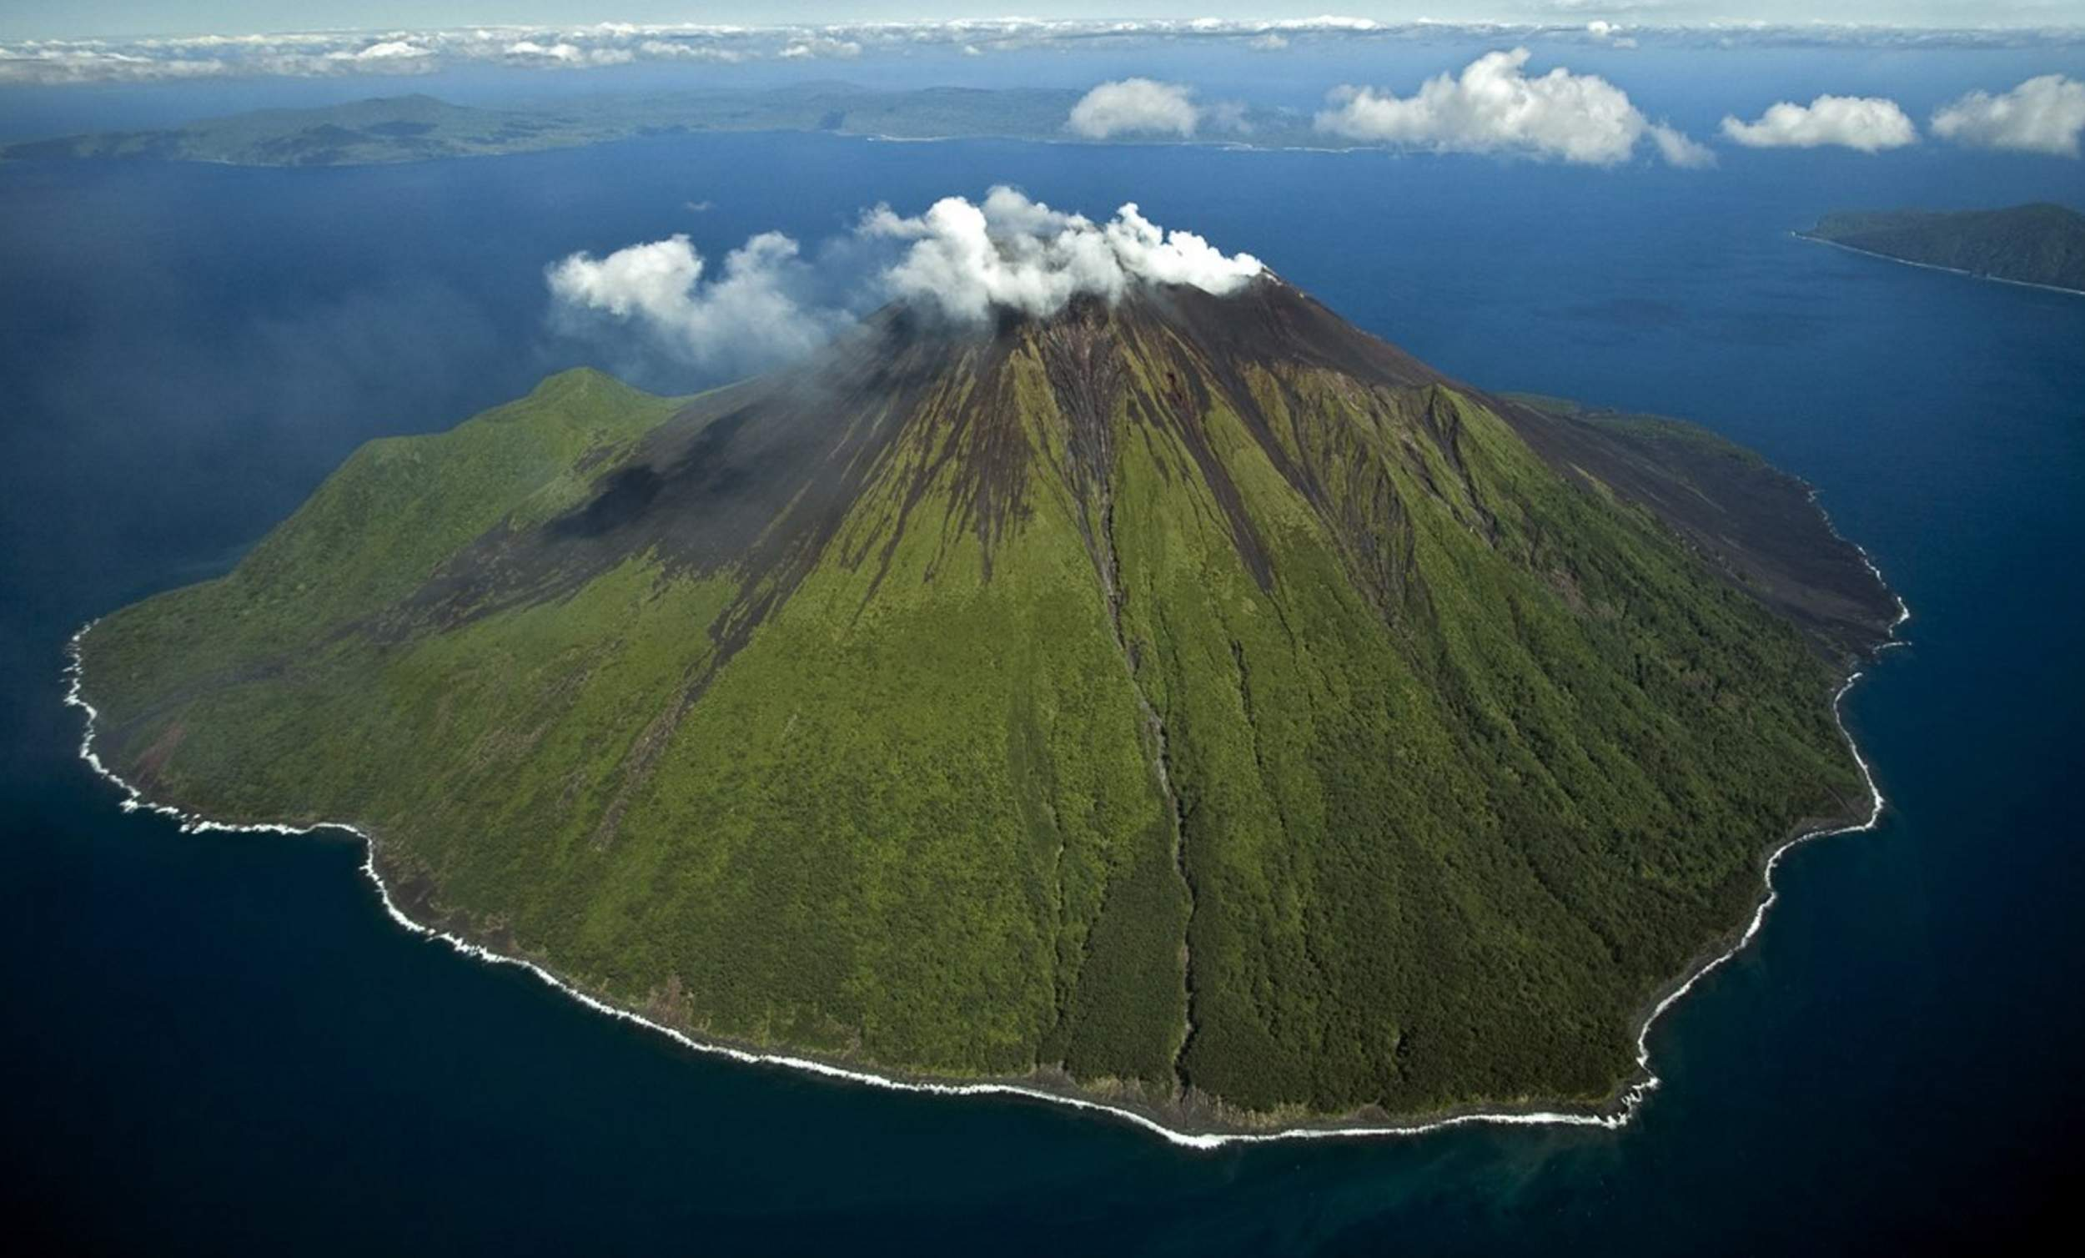
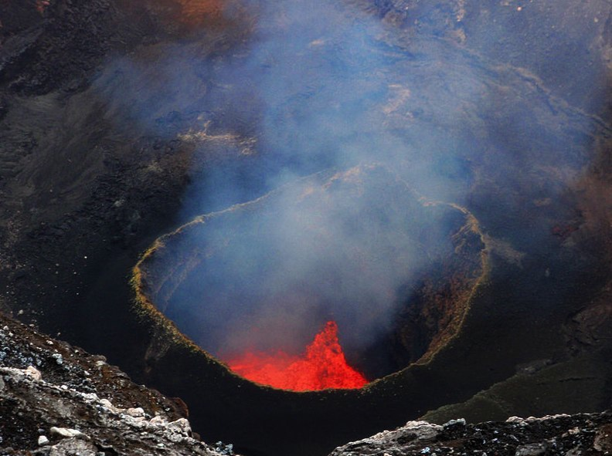

Photos: Images depicting the nature of the volcanos within the caldera on Ambrym at level 2.

Both volcanoes are at Activity level 2. The volcanic activity is likely to remain at the same level for a while but could increase from any of the active craters of Benbow and Marum (including Maben-Mbwelesu, Niri-Mbwelesu and Mbwelesu). The area of risk currently remains in the caldera.

For up to date information contact Geohazards office at the Vanuatu Meteorology and Geohazards Department, telephone 24686 or email geohazards@meteo.gov.vu Website http://www.geohazards.gov.vu/index.php/hazards-updated-events/volcano-alert-status/223-bulletin-nd1-ambrym-activity

Paama
There are few roads and few trucks on Paama. Distribution must be by sea. If seas are too rough to land, helicopter distribution from ship will be necessary. Landing spots are available at the airport, Liro, and Lakelai.

The community centre is based in Liro. There is a health centre and area secretary are based there.
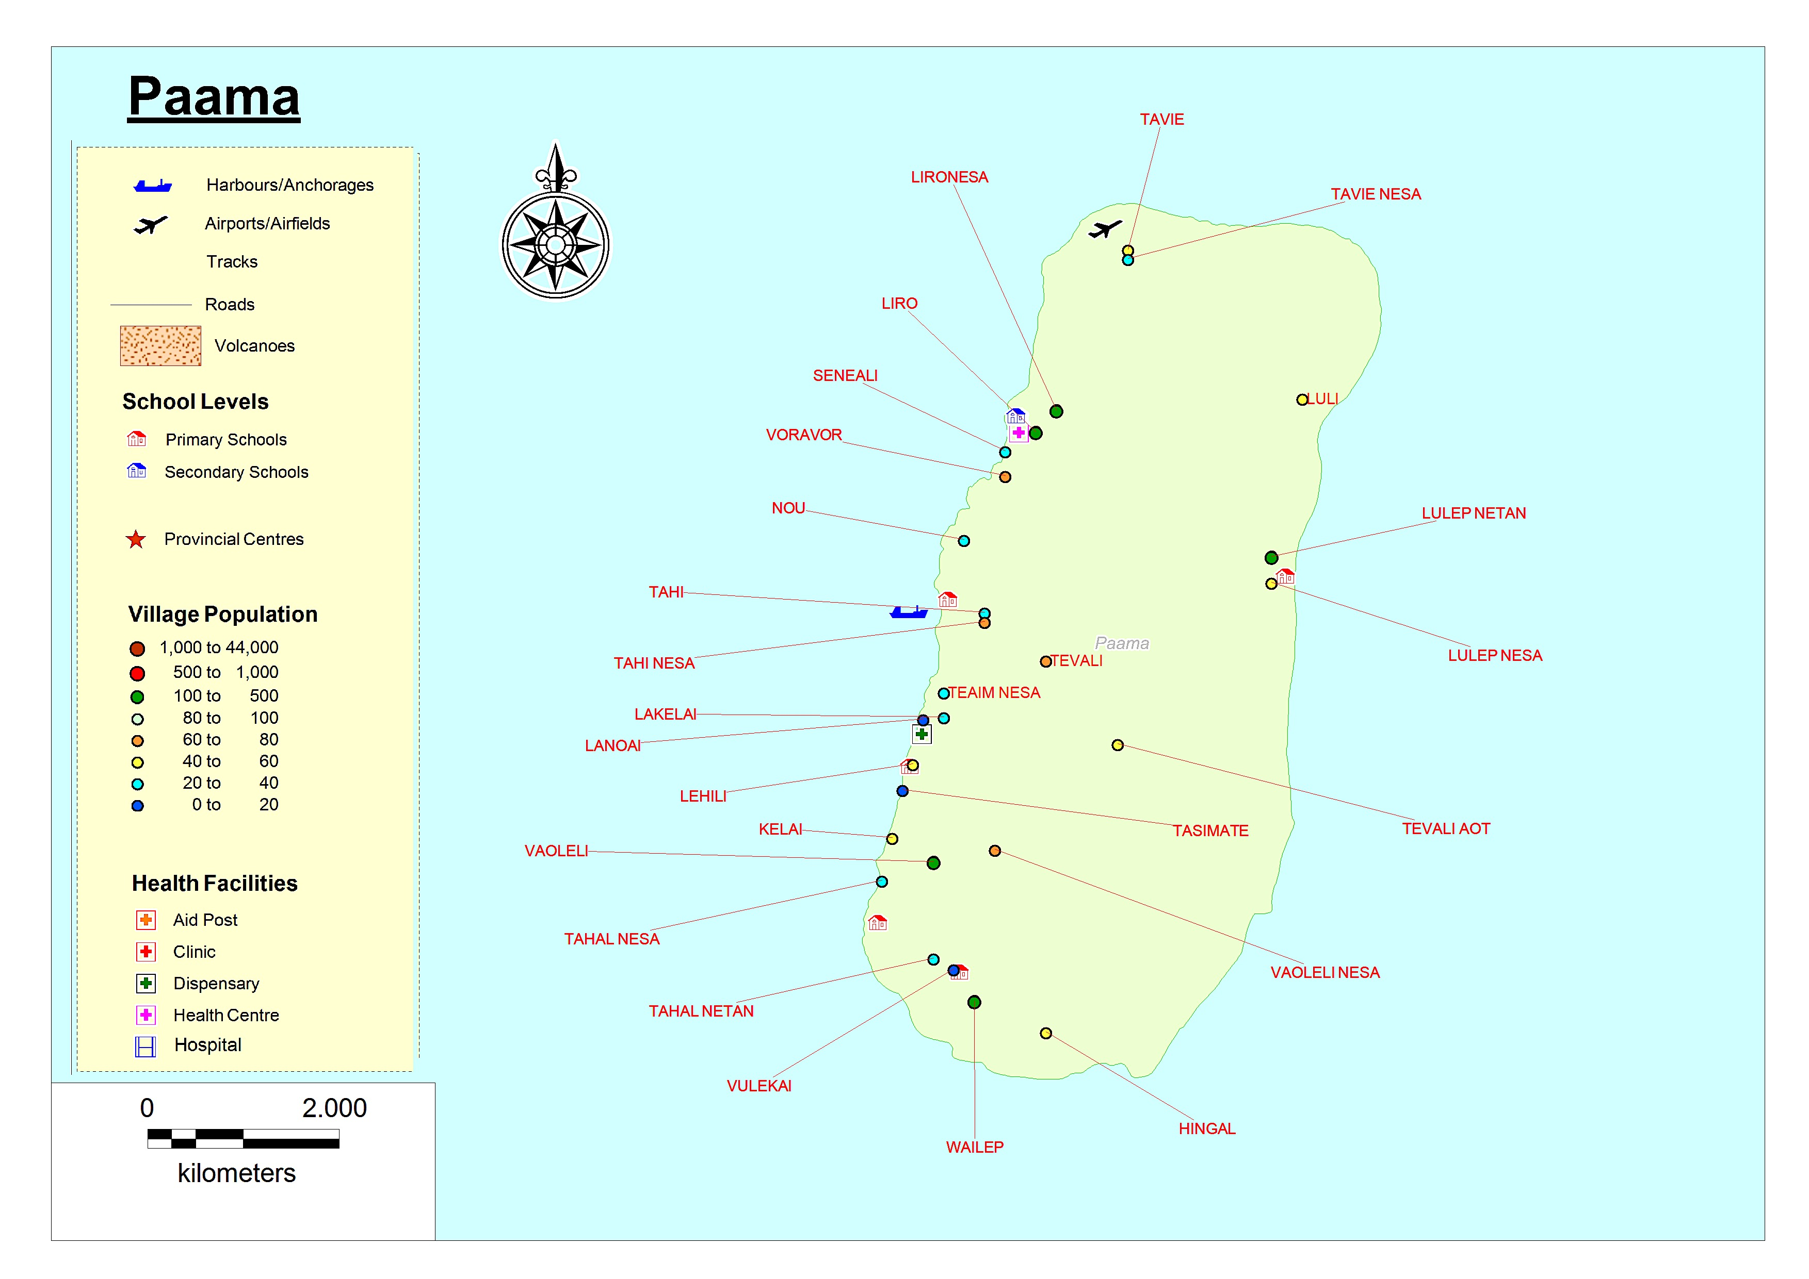

Air Transport

Air Vanuatu and Belair service the island, however Belair will cancel their schedule flight if they have less than five passengers on the Malampa run.

The airstrip can be very difficult and dangerous to land on as it is a small runway and the winds can be unpredictable around the mountains.

Airport Name | Coordinates | Capacity | Runway
Paama
Paama (aka Tavie) | Lat S 16 25 55  Long E168 14 07 | 705m x 30m  Fly Tue, Sun  Y12 only | Grass on soil

Sea Transport

Big Sista
MV Brooklyn
LC Freedom. (out of action)
LC Urata

There are two other anchorage sites that can be used to to drop off relief supplies on the west coast. Liro is the main anchorage, Tahi and Lehili.

Port Name | Location/Coordinates | Type
Paama
Liro |  | Major port, landing on beach
Tahi |  | landing craft on beach
Lehili |  | anchorage
Luli (E) |  | Not an official port but cargo is dropped to reach the community. There is no road and tanks, wood etc must be floated through the surf break and rocks to shore.
Lulep (E) |  | Reef offload. Public works has built a road to

Road transport

There is a road from airport down the west coast to Hingal. If weather is bad, or there have been heavy rains, the road is not accessible by the vehicles on the island.

There is a dirt cross road from west to east from Tahal Nesa to Tulep.
Boat transport or walking is the main souce of transport.
There are three trucks on Paama. Area Secretary, Red Cross and Lulep.
It costs 3000vt from the airport around the ring road to Lulep on the East coast.

Communications
Digicel and TVL are on the island however reception is very poor. IT is best in Liro and Lakelai.

