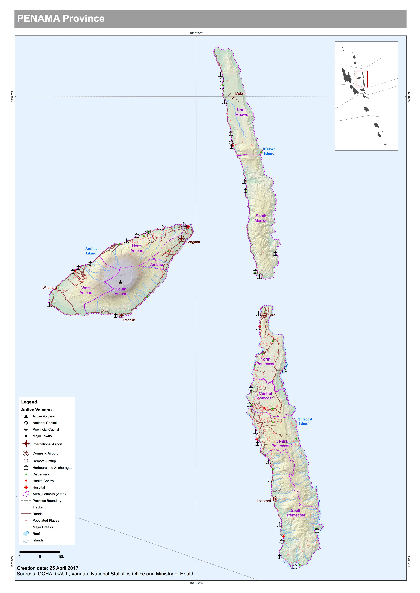

Disaster and logistics context.

Penama province consists of three large islands. Ambae, Pentecost and Maewo.

Draft poulation data from mini census 2016:
Province |  | Area Council | Male | Female | Not stated | Population | HH | HH size
Penama | west ambae |  | 2062 | 1962 | 0 | 4024 | 838 | 4.8
Penama | north ambae |  | 1707 | 1746 | 7 | 3460 | 727 | 4.8
Penama | east ambae |  | 1018 | 838 | 0 | 1856 | 455 | 4.1
Penama | south ambae |  | 762 | 719 | 0 | 1481 | 327 | 4.5
Penama | north maewo |  | 1189 | 1117 | 1 | 2307 | 543 | 4.2
Penama | south maewo |  | 655 | 637 | 0 | 1292 | 275 | 4.7
Penama | north pentecost |  | 2850 | 2649 | 4 | 5503 | 1,162 | 4.7
Penama | central pentecost 1 |  | 1335 | 1274 | 0 | 2609 | 568 | 4.6
Penama | central pentecost 2 |  | 1635 | 1691 | 9 | 3335 | 791 | 4.2
Penama | south pentecost |  | 2431 | 2523 | 3 | 4957 | 1,016 | 4.9

All islands are to the East of Santo, meaning Penama is equally as serviceable from both logistics hubs of Port Vila and Luganville.

The Provincial headquarters is located in Saratamata, Ambae. It is located at the North of Ambae close to the main port of Lolowai and Longana airport.

Provincial Disaster Officer | Secretary General | Planning Officer
Manson Taridenga  mtaridenga@vanuatu.gov.vu  Ph 737-6099; 590-5037 | Georgewin Garae  ggarae@vanuatu.gov.vu  Ph 777-9749 | Augustine Garae  agarae@vanuatu.gov.vu  Ph 773-8069

All islands are regularly affected by cyclones: TC Pam (2015), TC Xena (2016), TC Cook (2017), drought, flooding, earthquake and tsunami. In November 1999 two people were lost in South Pentecost after a tsunami.

Ambae has an active volcano which last erupted in 2005 resulting in the evacuation of all communities to the Northern end of the island. It currently sits at activity level 2 and the ash cloud can affect Pentecost and Maewo in the summer during south westerly winds. Normally the ash affects the west side of the island, which can damage the water taro crops.
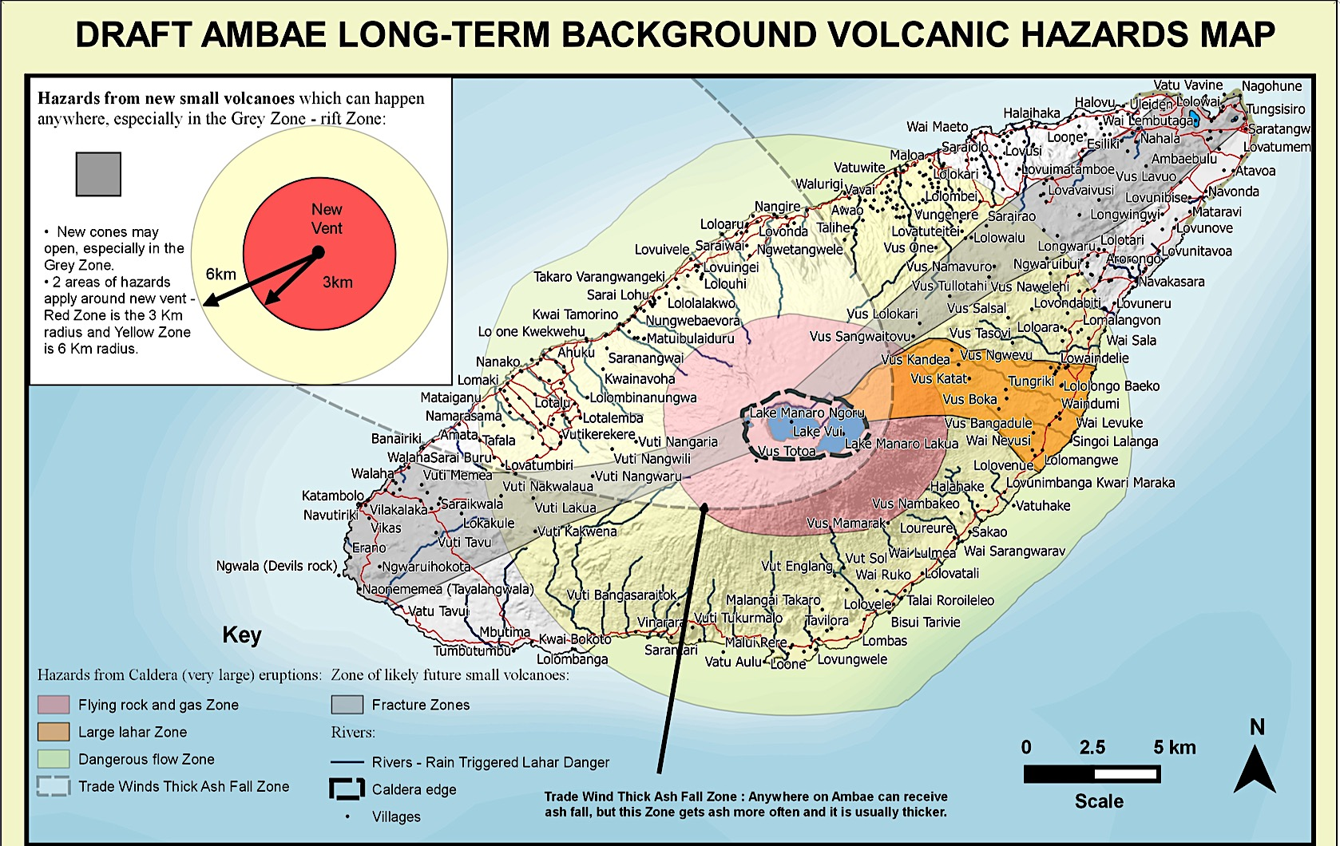

Water shortages are a problem for North Pentecost. TC Pam destroyed water harvesting systems, and springs are located down very steep hills. Roads to the schools are bad and can be impassible after heavy rain. NGO’s have been working to install water pumping systems from the springs but it has been a difficult process due to the land conditions and weather. Water trucking was implemented to three of the major boarding schools in North and Central Pentecost, who ran out of water during the El Nino related drought in 2016.

The following agencies are operating in Penama:
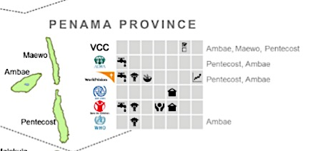
Image: Extract from VHT 3W’s October 2016.

Ambae
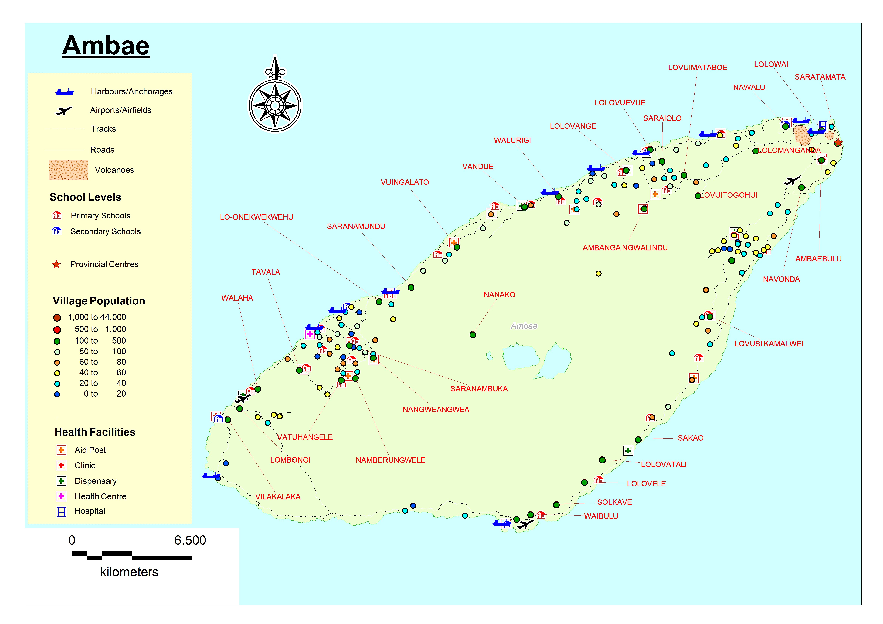
Lolowai port is the main port of Ambae and close to the Provinicial capital of Saratamata. Ships depart Lolowai to Loane in North Pentecost and Asanvwari, South Maewo.

Air transport
Air Vanuatu and Belair provide air transport service to Ambae.

Airport Name | Coordinates | Capacity | Runway
Ambae
Longana | Lat S 15 18 35  Long E 167 49 46 | Twin otter, islander  Mon, Tue, Wed, Sat | 735m x 22m  Grass on soil
Walaha | Lat S 15 24 58  Long E 167 41 02 | Twin otter, islander  Mon, Wed, Fri, Sat | 725m x 35m  Grass

Sea Transport
The following cargo ships service Ambae.
Tina 1/Brisk
Vanuatu Cargo
LC Sarafenua
MV Brooklyn
LC Austrader
MV Makila
MV Kalyara
MV Lepati
MV Keidi

Seaports

Port Name | Location/Coordinates | Type
Ambae
Lolowai  (N) |  | Main Port. Landing craft. Access to St Patricks College
Lone (N) |  | Banana boat or copra ships
Lolopuepue  (NW) | Lat.15*18’33.34S  Long. 168*50’53.98E | Wharf. Access to Tagaga College
Malaloa |  | Anchorage
Walurigi |  | Anchorage
Saranamundu |  | Anchorage
Lone (SW)
Nduidui |  | Wharf
Walaha |  | Access to JSS
Devils Rock  (SW) |  | Landing craft on the beach
Redcliff  (SE) |  | Landing craft
 |  | Access to JSS

Road Transport
There is a ring road that goes around the island of Ambae. After heavy rains the road can be impassible on the North west side between Saranamundu and Vandue as it is very steep, and on the south side between Namberungwele and Redcliffe.

Major Evacuation Centres.
St Patrick College (N)
Tagaga College (NW)
Lolopuepue Catholic church
Navutiriki JSS (SW)
Ambabulu JSS (NE)

Emergency Storage for relief supplies.
Vanuatu Red Cross Society has a small storage room and prepositioned Non Food Items at Saratamata.

Tarpaulin | 200
Hygiene Kits | 100
Jerry can 10L | 100
Sleeping Mats | 100
Mosquito net | 200
Shelter kits | 200
Kitchen set | 200
Blankets | 100
Solar Lanterns | 100

Space may be available at the Provincial HQ has a small storage buildings at Saratamata and Police and publics works offices.

Emergency communications
Lolowai hospital has HF radio, and the airports.

Pentecost
Ships regularly travel to Pentecost which is a major producer of kava. There are several large colleges and boarding schools on the island. Pentecost is very steep in the middle of the island making it difficult to pass from East to West. The majority of the population live on the West coast of the island.

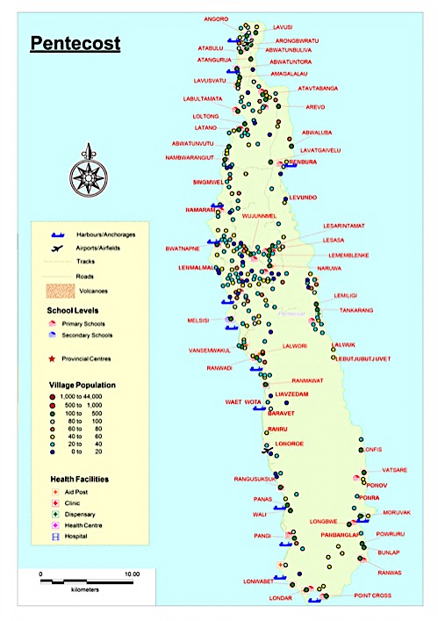

Air transport
Air Vanuatu and Belair service Pentecost.

Airport Name | Coordinates | Capacity | Runway
Ambae
Sara  (N) | Lat S 15 26 16  Long E 168 09 15 | Twin otter, islander  Mon, Wed, Fri, Sat | 600m x 23m  Grass on coral
Lonorore  (SW) | Lat S 15 52 10  Long E 168 09 55 | Twin otter, islander  Mon, Wed, Fri, Sat | 1200m x 23m  Bitumen

Sea Transport

Ships that service Pentecost:

Tina 1/Brisk
Vanuatu Cargo
LC Sarafenua
MV Brooklyn
LC Austrader
MV Makila
MV Kalyara
MV Lepati
MV Keidi

Ports
There are no major ports on the east coast of the island as the seas are too rough and it is dangerous to anchor.

Port Name | Location/Coordinates | Type
Pentecost
Loane |  | Main Port. Landing craft. Access to Walter Lini School.
Abwatontora |  | Landing craft in low seas. Road from West to East from this port
Loltong |  | Good harbour. Main passage for North. Landing craft
Namaram |  | Landing craft. Road to East.
Bwatnapne |  | Landing craft. Access to Bwatnapne boarding school.
Melsisi |  | Landing craft
Waterfall |  | Landing craft. Access to Ranwadi College
Waet wota |  | Landing craft. Access to boarding Primary school.
Panas |  | Anchorage
Pangi |  | Landing craft
Ranputor |  | Anchorage
Point Cross |  | Anchorage
Bay Martelie (SE) |  | Banana boat only

Road transport

There is a road that runs from North Pentecost to south down the middle of the island. The roads in the North in particular are very bad and can be unusable after heavy rain. Cargo transport is predominately via sea due to the treacherous roads and expensive transport prices.

A few cross roads and bush tracks exist from the west coast to the east. One at Namaram port and one at Abwatontora. The middle of the island is very steep, taking all day to walk from one side of the island to the other.

There is a road at the south of the island from Pangi Port to Ranwas, which produces Kava and taro.

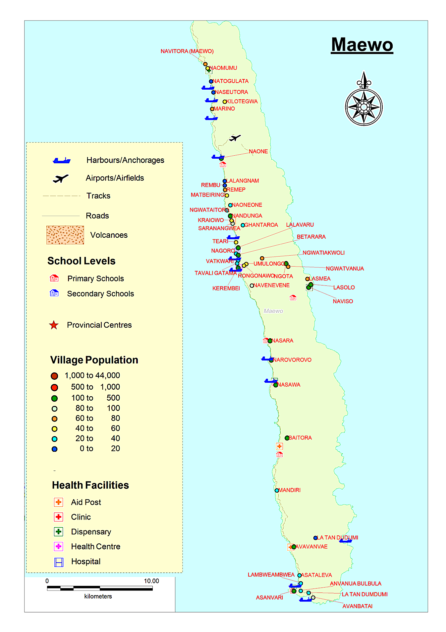

Transport to Maewo is either via the sole airport at the North of the island, or by sea transport from Laone Port, Pentecost or Lolowai Port, Ambae

Air transport
Air Vanuatu and Bel Air service Maewo.

Airport Name | Coordinates | Capacity |  | Runway
Maewo
Maewo  (aka Molalo airport) | Lat S 14 59 48  Long E 168 04 50 |  | Twin otter, islander  Mon, Thu, Fri | 850m x 22m  Grass on soil

Sea Transport
Ships that service Maewo.
Tina 1/Brisk
Vanuatu Cargo
MV Brooklyn
MV Makila
MV Kalyara
LC Sabrina
MV Hula

Port Name | Location/Coordinates | Type
Maewo
Natogulata |  | Anchorage
Kilotegwa |  | Anchorage
Marino |  | Anchorage
Naone |  | Landing craft
Nagoro |  | Anchorage. High tide only. Access to Gumbule boarding school.
Kerembei  (Central W) |  | Main port for North side of Island
Narovorovo |  | Main port for south side. Good landing craft site (wharf destroyed).
Nasawa |  | Landing craft
Asetaleva |  | Anchorage
Asanvwari  (S) |  | Landing craft. Good Anchorage site

Road transport
There is a road from Naomumu in the North West until Baitora towards the South West. It is 4WD only after heavy rain.

A cross road exists from Betarara through the middle of the island past Rongonawo/ Ngota communities, to Naviso on the East Coast.

Health centre has one truck, and 5 private trucks from central to North

Transport from Airport to central Maewo is 3000vt and 5000vt to Nasawa

Major health care facilities and services.
The community centre is located a Kerembei. A health clinic, and police station are located there

Major Evacuation centres
Naone primary school in North West
Gumbule School in Central West
Nasara primary school in South West.
Naviso Evacuation centre on East coast.
Betarara Church East Coast

