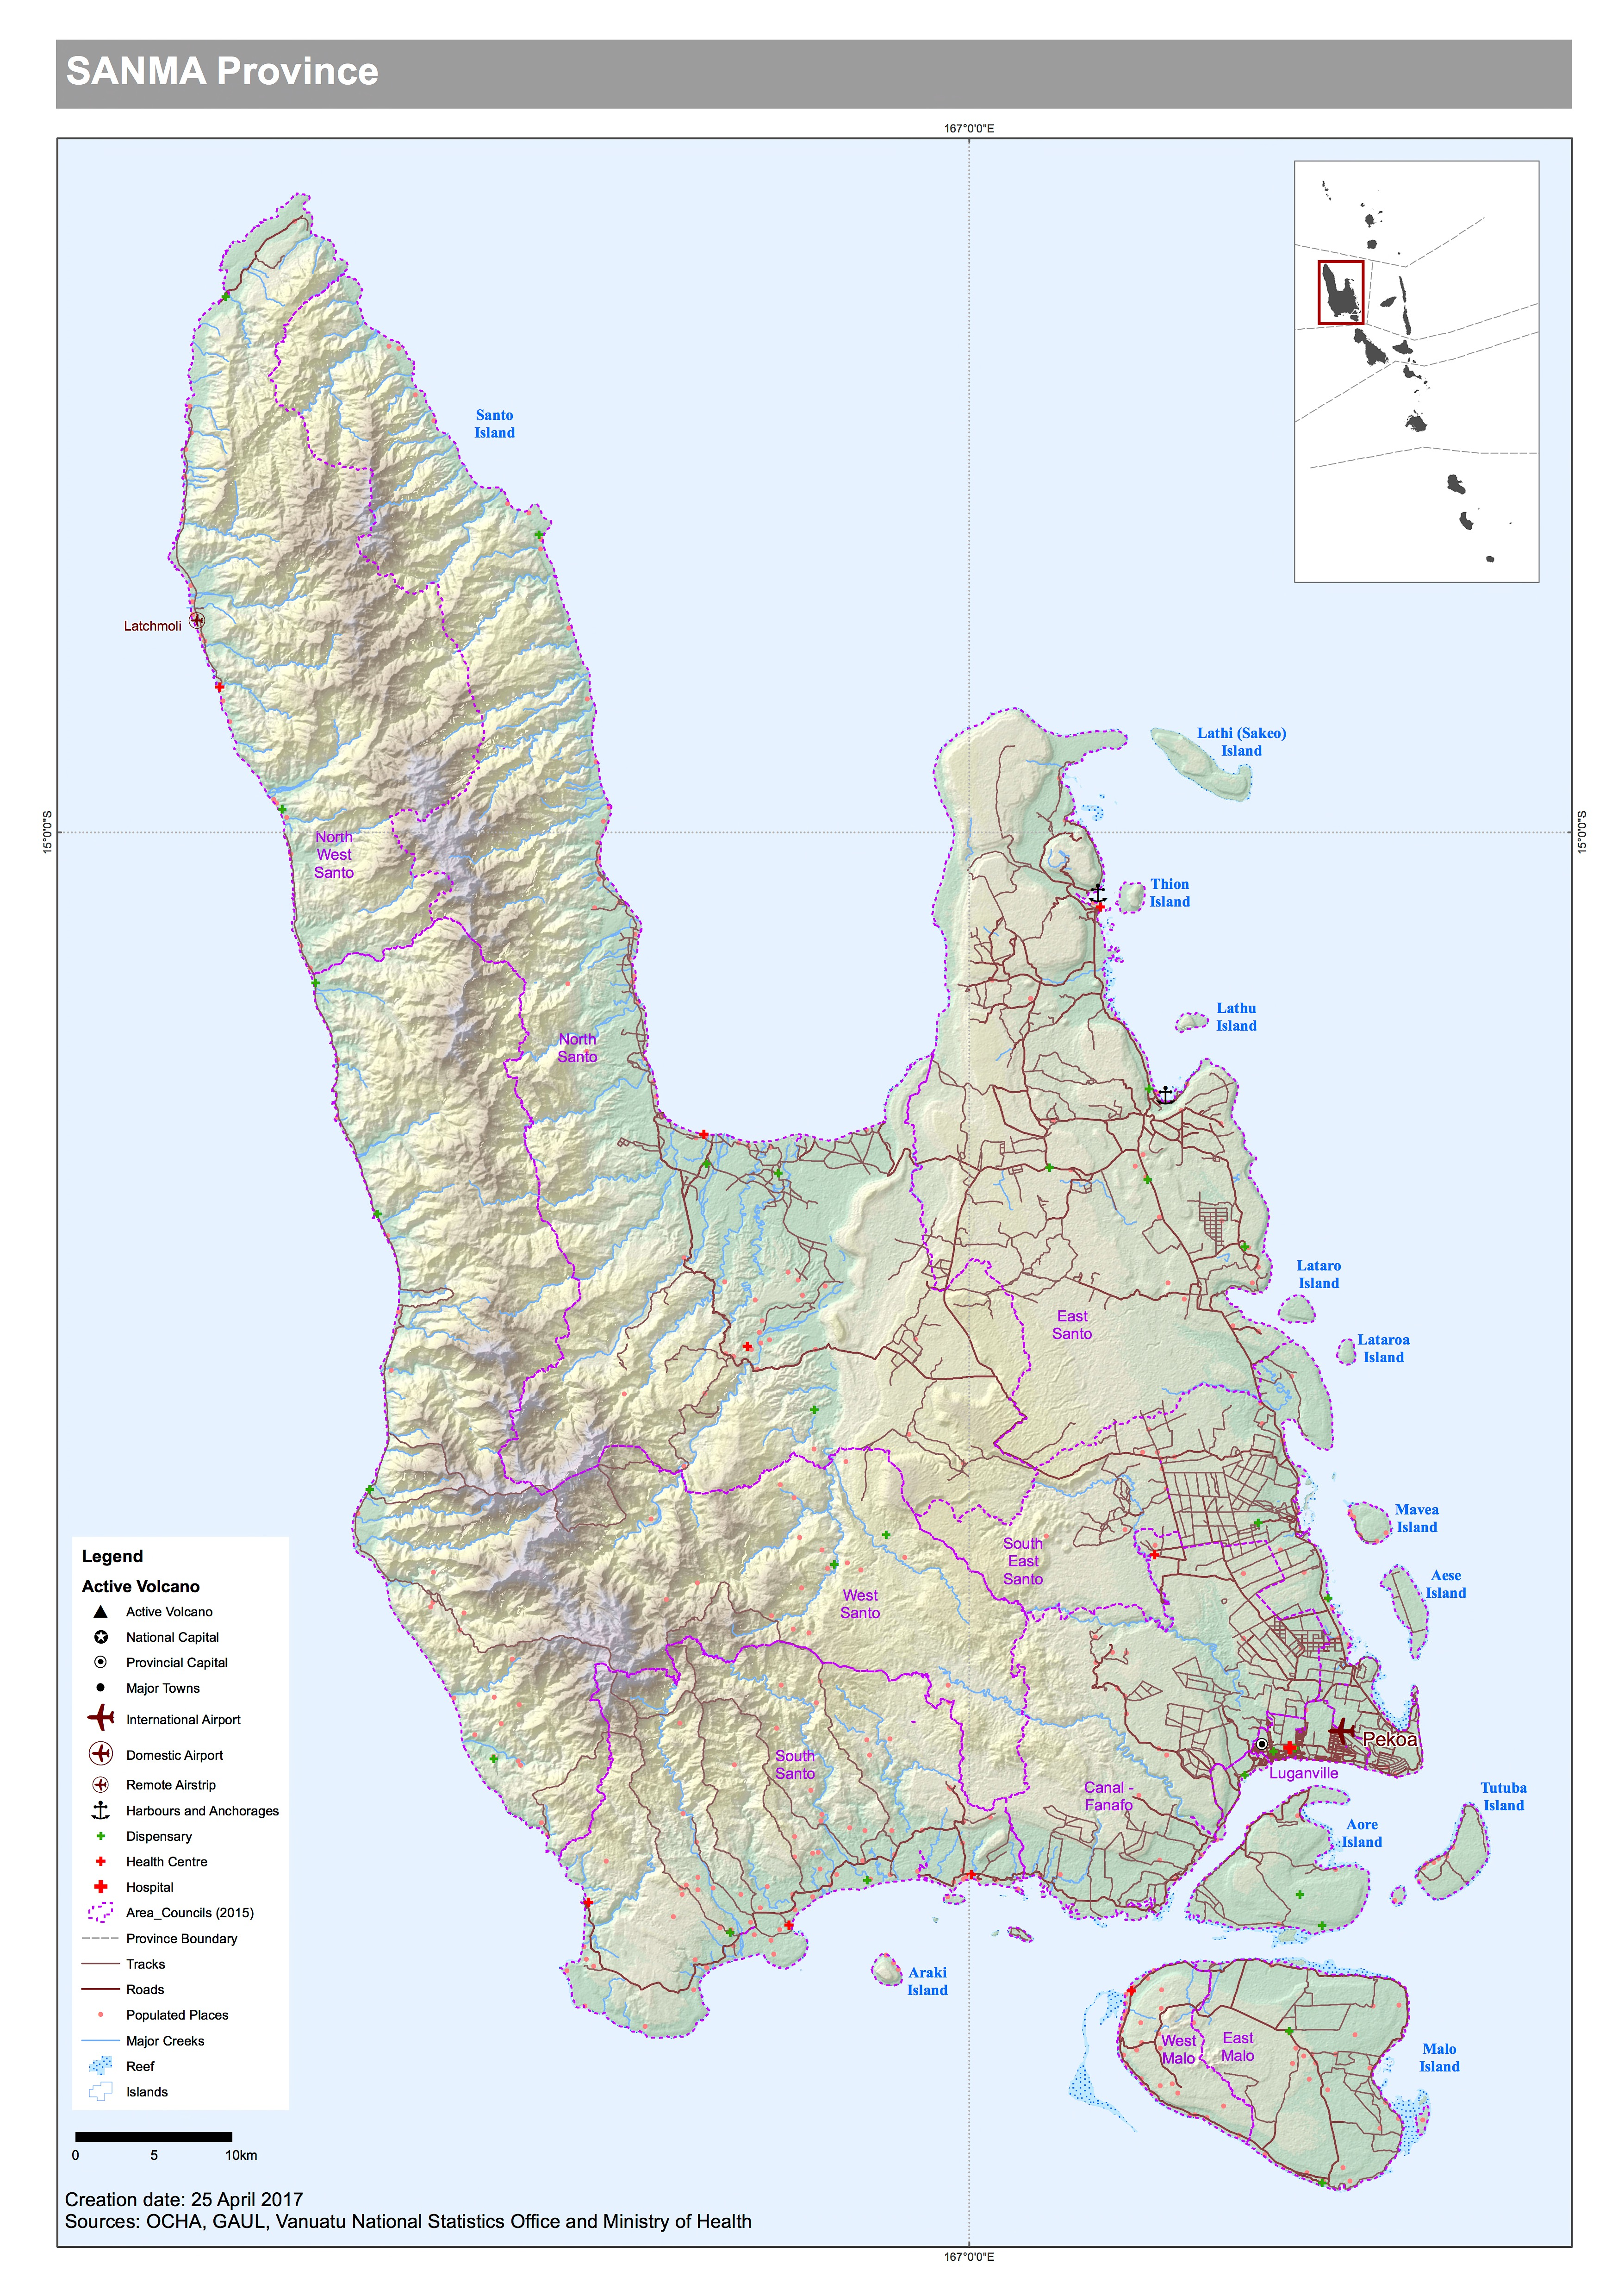

Disaster context
Sanma Province has three main islands. Santo, the largest island and second most populated in Vanuatu, Aore island, and Malo which are both situated very close to the south side of Santo.

The following is the draft population data from the 2016 mini census:
Province | Area Council |  | Sex
 |  |  | Male |  | Female |  | Not stated |  | Total population |  | HH | hh size
Sanma | north west santo | 844 |  | 853 |  | 1 |  | 1698 |  | 338 |  | 5.0
Sanma | north santo | 2437 |  | 2241 |  | 20 |  | 4698 |  | 922 |  | 5.1
Sanma | west santo | 1529 |  | 1521 |  | 11 |  | 3061 |  | 635 |  | 4.8
Sanma | south santo | 4349 |  | 4069 |  | 6 |  | 8424 |  | 1,695 |  | 5.0
Sanma | east santo | 2313 |  | 2220 |  | 5 |  | 4538 |  | 915 |  | 5.0
Sanma | south east santo | 3209 |  | 2996 |  | 3 |  | 6208 |  | 1,276 |  | 4.9
Sanma | canal - fanafo | 2487 |  | 2181 |  | 7 |  | 4675 |  | 919 |  | 5.1
Sanma | luganville | 8264 |  | 7876 |  | 19 |  | 16159 |  | 3,022 |  | 5.3
Sanma | west malo | 1218 |  | 1161 |  | 18 |  | 2397 |  | 572 |  | 4.2
Sanma | east malo | 1027 |  | 941 |  | 3 |  | 1971 |  | 429 |  | 4.6

The Provincial HQ is located in the Luganville area of Santo.
Provincial Disaster Officer | Secretary General | Planning Officer
Not appointed. | Acting SG  Joe Yadi  7718526 | Prosper Buletare  pbuletare@vanuatu.gov.vu  7754532

Santo is prone to large earthquakes. The Luganville precinct is developing fast with larger structures being build to accommodate tourism and commercial business. A large earthquake may effect these structures. Tsunami mapping indicates the Luganville area is in danger of a tsunami event.

Most of the logistics assets, commercial businesses and suppliers, fuel depot, schools etc, are set up along the waterfront on both sides of the main road. High storm surge and rising seas (cyclone, flooding tsunami) may affect the capacity of this infrastructure. As Santo was not directly impacted by TC Pam, it is difficult to ascertain how much protection Aore and Malo islands will provide against storm surge. Disaster plans should consider the logistical constraints that could be faced if the wharfs were not operational, and the schools and businesses could not be used for supplies or evacuation centres.

Logistics context.
Santo is the second largest hub in Vanuatu and plays an important role in providing goods and services to the northern side of the country.

Luganville has commercial businesses, suppliers and logistical services. It has an international airport, and a large international wharf that can accommodate large vessels. There is a fuel depot, and routine domestic flights and inter-island shipping linking with Port Vila and the northern and eastern islands.

A Humanitarian logistical hub is being established on the hill in Luganville in the Sanma Provincial Government Headquarters. Red Cross has a small warehouse and office located in the area. NDMO is in the process of building a Provicial Disaster Office (PDO) , and a humanitarian disaster warehouse is being constructed next to it with the support of WFP. World Vision also has a small office in the area.

The precinct contains a large sports field that could act as a helipad and container storage site in times of emergency. The Chiefs nakamal is located in the same area and could potentially be used as a temporary evacuation centre for tsunamis or relief warehousing.

Overall, a small humanitarian response operation could be run from the Sanma Provincial headquarters area once fully established, or used as a secondary operations centre.
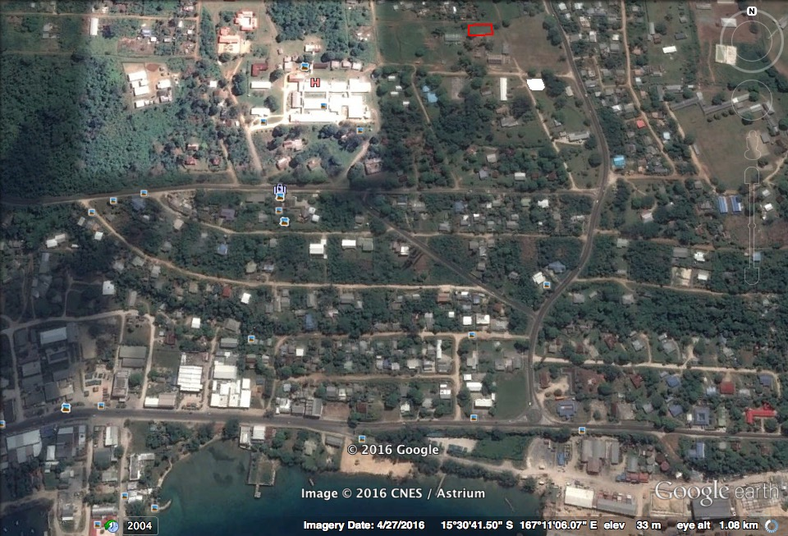
Figure : Santo Logistics Hub for Disaster coordination.
<helipad and container site
Provincial Government HQ>
<Red cross office and WH
<Chiefs nakamal
Proposed PDO and WH site>
WVI office>
International wharf
/
Hospital>

The following humanitarian partners are operating in the Province:
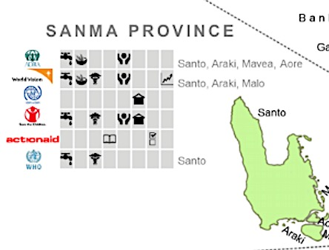
Image: Extract from VHT 3w’s October 2016.

Sea transport
The harbour in Luganville is one of the deepest in the Pacific at 22m depth. The large waterfront area has many commercial and private wharfs for international and domestic cargo ships, ferries, cruise vessels and commercial businesses.

Figure : International wharf -under upgrade (2016 image) and Simonsen domestic wharf,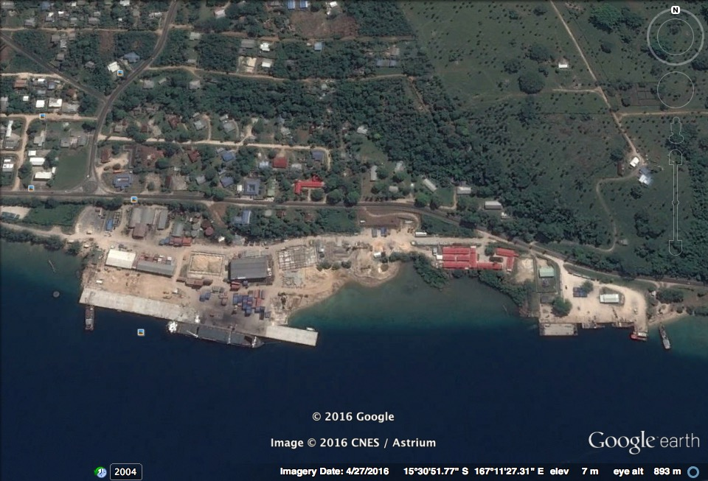
Simonsen wharf
International wharf

International Wharf
The port has one berth that is shared by cargo ships and cruise vessels. The Pacific petroleum company have their own port installation for unloading fuel tankers directly into their storage facilities.
The international wharf is government owned and has recently been expanded to accommodate large cruise vessels. Two cargo vessels can now berth at the same time or one large cruise vessel. A pilot is mandatory for ships over 60m. To arrange the pilot you must contact Port and Harbour in Santo who operate on Channel 16.

Government of Vanuatu procedures for international vessels:
Military ships must notify local High Commisions/Embassies first of arrival schedules and purpose of visit, who will then assist to liaise with the Government of Vanuatu.

All international ships arriving must contact Santo Ports and Harbour 72 hours in advance of arrival to arrange pilot, berthing and international clearance inspections. Information required includes:
- Arrival time,
- Registration
- Passengers and Cargo onboard
- Estimated time in country
- Contacts deatils.
Ports and Harbour can help facilitate arrangements with Customs, Immigration and Biosecurity if necessary. Ports and Harbour contacts: ph +678 36033. Harbour Master-Terry Ngwele: Ph +678 33790; +678 7783338/ 5728816 tngwele@vanuatu.gov.vu
There is a Customs office on the wharf, and Ports and Harbour and Immigration offices are located close by.

International Wharf Specifications:
Wharf front: 239m across, 22 m ocean depth, draft 20m, apron 20m
Container storage: Capacity for 1000 TEU’s on the wharf. There are 18 connections for refrigerated containers (20 or 40ft). The wharf can handle 40 tonne per m3 loading of wharf.
Cargo Storage facilities:
- Construction of two new large purpose built copra warehouses has been completed on the wharf. These are often full awaiting shipment. (see following images)
- An existing 1000m2 cargo warehouse is also on the wharf for palletised and bagged cargo. This has been re-roofed as part of the upgrade.
- A large cruise ship terminal is being built in the wharf precinct area. In times of emergency this could potentially be used to store relief supplies.
Stevedoring:
The Northern Island Stevedoring Company Limited (NISCOL) manages the stevedoring and cargo handling on the wharf. Ph +678 36084; niscol@vanuatu.com.vu
CEO -Phillip Ryan +678 36084; +678 7777121
Unload and handing equipment:
There are no cranes or gantry’s available. Ships arriving must be geared with their own crane at a capacity of 38 tonne minimum.
NISCOL has:
- two 16 tonne tined forklifts,
- two 3.5 tonne forklifts,
- two 38 tonne top loader trucks for container movements.
NISCOL advised it may be possible to hire a 70 tonne grove crane, owned by a Chinese company at Velit bay, if required.

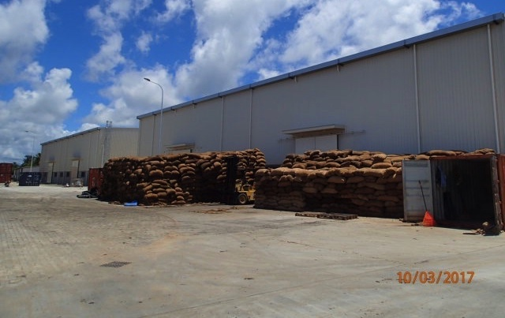
Figure: Two copra warehouses with smaller cargo warehouse in distance.

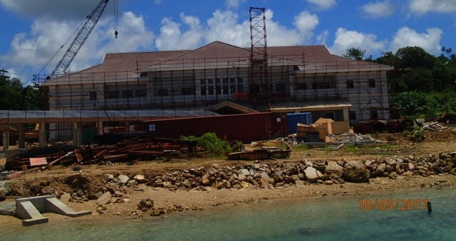
Figure: Cruise ship terminal building under construction.

Shipping ports
Temporary sheet until logistics maps completed.

Port Name | Coordinates | Capacity | Type
Santo
Luganville area.
International wharf | Lat. 15*30’55.14S  Long. 167*11’13.03E | 750 tonne, 239m | Govt, wharf
Simonsen wharf | Lat. 15*30’54.34S  Long. 167*10’49.43E | <500 tonne | Govt, wharf
BP wharf | Lat. 15*30’56.74S  Long. 167*10’49.43E | <500 tonne | Private, wharf
Wong Sze Sing (WSS) wharf | Lat.15*31’36.63S  Long.167*09’21.68E | <500 tonne | Private, wharf
Melcoffe wharf |  |  | Private, wharf
Nicon Wharf | Lat.15*31’30.99S  Long.167*09’20.78E |  | Private, wharf, dry dock
Maritime college |  |  | Govt, wharf
Big Bay
Malao |  | 15m anchorage | Banana boat offload
North West Coast
Wunpuko |  | 10m anchorage 100m out from shore | Banana boat ofload
Mid west Coast
Tasmate |  | Barge | anchorage
South West Coast
Tasariki |  | 10m anchorage, 100m from shore | Landing craft. Road access by truck
Malo
Parkley |  | Barge | anchorage
Aore island
Aore island resort |  | Dive boats and banana boats | Jetty

Inter-island vessels based in Santo
Awaiting Ports and Harbour Santo to provide Santo based ships, routes, contacts and rates.

Air Transport
Airports Vanuatu Limited is responsible for managing the Pekoa Airport.
http://www.airports.vu/about.html

Airport Name | Coordinates | Capacity | Runway Type
Santo
Pekoa International | Lat S 15 30 20 76  Long E 167 13 16 89 | Daily flights  C130 or boeing 737 can land on load restrictions C17 not advisable as it is difficult to turn around. | Asphalt  2000m x 30m;

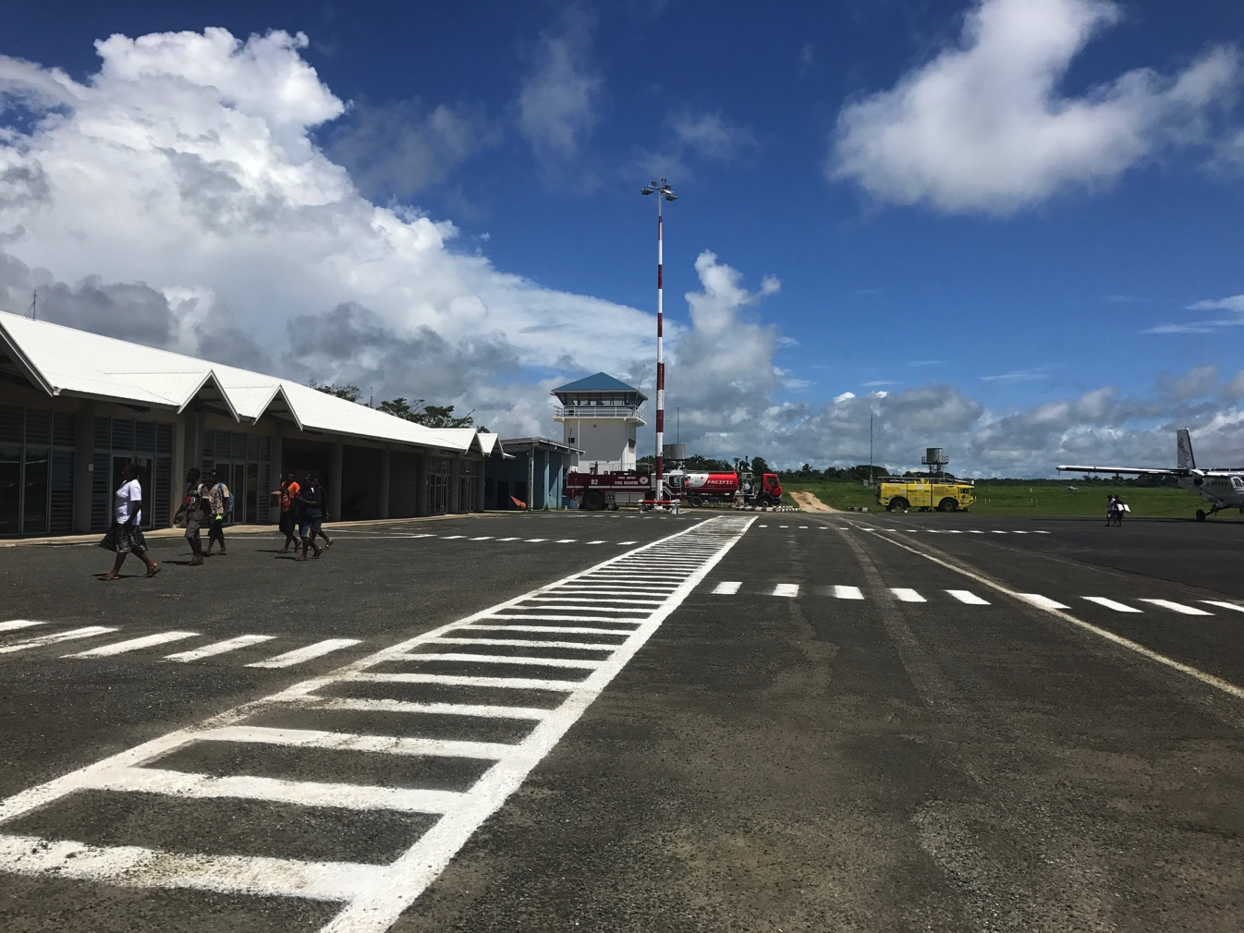

Procedures for International emergency assistance landings
For an aircraft intending to stay and operate in Vanuatu one month or more, registration is required from Civil Aviation Authority of Vanuatu:
Civil Aviation Department, Ministry of Infrastructure and Public Works Utilities
Tel.: +678 22819
Fax: +678 23783
Email: civav@vanuatu.com.vu
Website: www.airports.vu
For emergency medivacs aircraft arriving, 24 hrs notification must be provided to AVL for landing approval.
For aircraft coming to assist with disasters, 72 hours notice of arrival is required for flight approval to AVL. The absolute minimum is 24 hours. This military aircraft, maritime patrol aircraft, cargo planes delivering relief supplies, and VIP dignitaries.
Flight approval requests forms, processes and charges can be found on AVL the AVL website. http://www.airports.vu
Operator aircraft requesting non scheduled landing approvals can be sent to the following email addresses at the AVL Flight Approval Office.
- ats@airports.vu
- gmops@airports.vu
- pascal.alick@airports.vu

The Flight Approval Office will require the following information:
- aircraft type/registration
- aircraft call sign
- aircraft operator
- departure aerodrome
- estimated time of departure and date
- estimated time of arrival and date
- onward flight route from Vila, departure and date
- purpose of flight: tourism/business, private, tech stop etc
It is advisable to arrange a ground handling agent to be responsible for organising and coordinating aircraft arrival and departure times, apron marshalling, organising Customs Immigration, and Biosecurity, and payment of fees. There are two ground handling services in Vanuatu:
- Air Vanuatu Operations Ltd pcarcasses@airvanuatu.vu
- Vanuatu Terminal Services rwane@vts.vu

Fuel Service Charges
AVL provides storage for airlines to put in fuel drums. 44 gallon drums of AVGAS, JET A1. Prior arrangement must be made with the fuel company to order fuel. PPC has reserves for AV only. Request must be made in advance for any other aircraft at the airport. e.g. C17 must make a request a week in advance of fuel needs

Road Transport
Information provided by Santo Public Works Department.

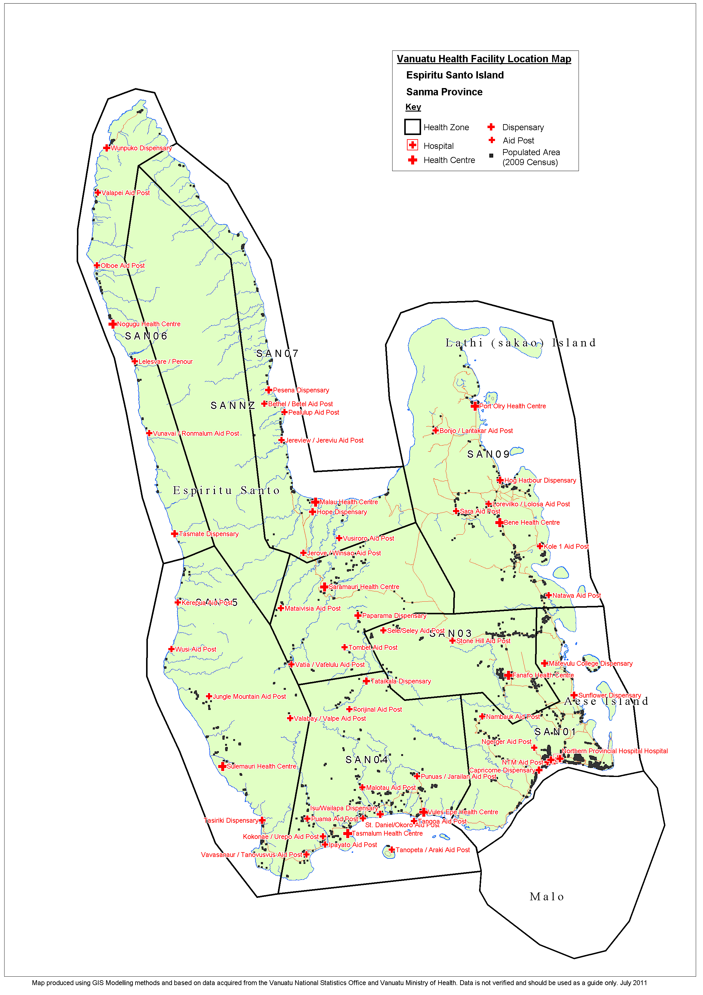

Evacuation Centres
ZCA | Phone | School | Head Teacher | Community name | Phone
 | Number |  |  |  | Number
 |  | Pesenna | Ronnie M.Thérèse | Pesenna | 59 71 293
 |  | Saint Jacques | Imbert Lolia | Puelsope | 5345072
JAMES WILLIAM |  | Tolomako | Imbert Rebecca | Tolomako | 5627990
 |  | Vusiroro | Ailine Tavuet | Vusiroro | 7742203
ZONE 1 & Zone 2 |  | Mataloi | Erick Letlet | Mataloi | 7106909
 |  | Piamatsina | Ella Kavick | Piamatsina | 5447030
 |  | Malores | Sirovulu Thierry | Malores | 54 00 959
53 98 332 |  | Vunakariakara | Emely Boukone | Vunakariakara | 5974352
 |  | Sainte Anne | Pounenarai Francisco | Port Olry | 56 60 167
 |  | Lorethiakarkar | Rite Emerick | Lorethiakarkar | 56 91 312
 |  | Saint Augustin | Augustino Bulememe | Fanafo | 5373949
MARCEL BOMWEL |  | Fanafo | Chalet Jean Pierre | Fanafo | 54 50 241
 |  | Vilvil | Apikel Jack | Fanafo | 33800
 |  | Butmas | Rapouel Oswel | Butmas | 56 94 131
ZONE 2 & ZONE 3 |  | Luganville Est | Marie Vianney Bong | Santo East | 37 188/5957981/7742311
5396427 |  | Sainte Thérèse | Théora Elga | Saint Therese | 5343737
 |  | Saint Joseph Rowok | Robert Tubaga | Solway | 7731005
 |  | Kaméwa Francophone | Imbert Adèle | Kamewa | 36 821/7727405
 |  | Saint Michel | Abton Terong | Saint Michel | 33800
 |  | Nandiutu | Dormant | Nandiutu
 |  | Naviaru | Marie Tambroco | Naviaru | 7740670
 |  | Najarawelu | Julie Walla | Jingnontana
 |  | Ambakura | Tsen Nicole | Ambakura | 5607929
 |  | Tasmalum | Voyate Yvette | Tasmalum
 |  | Namorou | Pierre Louis Tari | Namorou
 |  | Okoro | Fabiola Bubunba | Okoro
MARIE TAVOUSMOLI | 59 79 117 | Ipayato | Vincent Tiroles | Ipayato | 5361294
 |  | Marua | Ruruely Noel | Marua
ZONE 4 |  | Puama/Porema | Valivu Victor | Puama/Porema
 |  | Tcharanavusvus | Judah Voyamerei | Tcharanavusvus
 |  | Mataipevu | Tavulantui Sylviane | Mataipevu
 |  | Valapey | Hilaire Huremoli | Valapey
 |  | Ebenezer French | Serah Mele | Ebenezer | 53 63 523
 |  | Pialuplup | Willie Navis | Pialulup | 5953687
 |  | Malau | Robinson Philip | Malau | 5348228
GEORGES JOSIAH | 53 69 496 | De Quiros | Mackenzie Turan | Matantas | 5374854
 |  | Jordan valley | Jean Paul Daniel | Paparama | No gat
ZONE 5 |  | Lemesi Lape | Ketsy Malon | lape
 |  | Saint Paul – Navele | D.Langrere Manuel | Nawelala | 59 58 044/5552450
 |  | Zion | Micah Aki | Zion | No gat
 |  | Vusvongo | Nelson Tosul | Vusfongo | No gat
 |  | Winsau | Kelly Mathias | Winsau | 59 56 785
 |  | Antioch | Ismael John | Papaone | No gat
 |  | Hog Habour | Pakoa Kalo Thul | Hog Habour | 59 74 235
 |  | Sara | Johnny Yoan | Sara | 5359497
 |  | Lorovulko | Rex Toa | Lorevulko | 5552435
HARKUK VOCOR | 56 74 144 | Lathie | Lolo Yerta Diedre | Lathie | 59 71 033
 |  | Natawa | Paul Rebina Bakeo | Natawa | 77 30 352
ZONE 6 |  | Iethvekar | Anna Joe Fred | Kole | 56 34 499
 |  | Balon | John Harry | Balon | 5675802
 |  | Sakau | Patrick Rav Tosul | Sakau
 |  | Dambulu | Celina Enrel Jack | Mavea | 59 63 856
 |  | Mwast | Dialo Waback | Stone Hill
 |  | Tovotovo | Graham Moli | Tovotovo | 5450382
 |  | Saint Barnabas | Towia Frezer | Turtle bay | 54 69 054
 |  | Sarakata | Susan W. Balesa | Sarakata | 77 58 842
 |  | Vunanbulu | Ireen Ansel Willy | Teporma | 5472584
 |  | Luganville Adventist | Lesly Joseph | Sarakata SDA | 71 02 962
JOPLINE TAMBE | 59 07 909 | Santo East | Evelyne Tugu | Santo East | 77 62 512
 |  | Dombulu | Aiden Molley | Tutuba | 56 24 360
ZONE 7 | 77 43 473 | Kamewa Anglophone | Willie Michael | Kamewa | 7740566
 |  | Tiasia | Sophie Jimmy | Mavunlef | 56 34 463
 |  | Vovlei | Andrew vuti | Nambahuk | 71 07 319
 |  | Banban | Kre William | Banban | 35 629
 |  | Rowhani | Sue Whitely | Rowhani/Sapi | 36 830
 |  | Bernier Bay | Madeleine Ngweta | Aore plantation /George Lini | 77 61 963
 |  | Nasalanvunmol | Velivo Wallie | Narango | 5386793
 |  | Belmol | dormin |  | 5926886
SOCOPOI MELE | 5342353 | Lehilehina | Posava Vemalehi | Araki | 54 03 911
 |  | Tata | Ishmael Rongo | Tata | 33800
ZONE 8 |  | Paiareve (Nasulesule) | Lorres Ninisia | Nasulesule | 77 55 077/5949831
 |  | Ebenezer | Sera Mele | Ebenezer | 53 63 523
 |  | Tavuamai | Steven Walter | Jarailand | 53 58 937
 |  | Venie Mataipevu | Nixon Bani | Mataipevu | 33800
 |  | Menevula | Maybline Path | Wunpuko | 77 34 224
 |  | Day Spring | Ruby Daniel | Olpoi | 54 11 643
 |  | JN Mackenzie | Nelly Roger | Nogugu | 33800
ZONE 9 |  | Selusia | Bae Luke Saul | Vasalea | 33800
 |  | Limarua | Goerge Kaloman | Wusi | 5905178
 |  | Sulemauri | Tamata Garae | Sulemauri | 33800
 |  | Mamara | Edson Nampas | Tasiriki | 33800
 |  | Saletui | Precilla Tasi Aru | Tanovusvus | 7782928
 |  | Ian Livo | Sano Jimmy | Kerepua | 53 59 342
 |  | Jinaure | Amon Roger | Avunarara | 5668475
Jennifer Andrew | 5624263/7792857 | Avunatari | Obed Sumbetovi | Avunatari | 35587
Sebas |  | Amapelao | Betina Charley | Amapelao | 56 51 493
 |  | Kitacu | Vacant | Avunaro | 33800
ZONE 10 |  | Nanuhu | Florah Pakoro | Nanuhu | 5435542
 |  | Taharo | Edmund Vurobaravu | Avunabulu | 5466908
 |  | Alowaru | Bani Enneth | Alowaru | 54 02 682
 |  | Banaviti | Mathrone Suzie Vatu | Avunarani | 53 66 012
 |  | Parker | Selwin Garae | Aore Adventis | 33800

Emergency Storage and prepositioned supplies.
Red Cross have a warehouse newly constructed in the Provincial headquarters area in Luganville.

ADRA have a 6.7m x 5.5 m concrete storage located at Sarakata.

The International wharf warehouses, cruise ship terminal and chiefs nakamal should be considered for emergency storage in Luganville area until the NDMO warehouse and PDO office is constructed.

There are many commercial warehouses in the area, so real estates could be contacted to determine if there are any available facilities.

The Vanuatu Red Cross Society has the following Non Food items prepositioned in Luganville:

Tarpaulin | 200
Hygiene Kits | 100
Jerry can 10L | 100
Sleeping Mats | 100
Mosquito net | 200
Shelter kits | 200
Kitchen set | 200
Blankets | 100
Solar Lanterns | 100

Emergency communications
Commercial Radio networks are available in Santo.

Digicel and TVL are operational in Sanma province.
Ports and Harbour; Customs VHF channel 16

OGCIO Sat Phone
3 | Activated | 00870776442484 | Luganville | Santo

Red Cross Sat phone
No | Description | Sat-Code | Van-Code | Pin -No | Sat Phone Number | Current location | Propose location
2 | Satellite Phone | 698 | 678 | 8816 | 31850246 | Luganville, Santo | VRCS Sanma branch, Luganville, Santo

World vision Sat phone
Vomboe Molly | APM Northern Area Program Santo) | 881631430933

